Supplementary Figure 1. Example of FTIR spectra obtained from water samples collected from the River Thames at Limehouse in November 2019 identified as Polyethylene

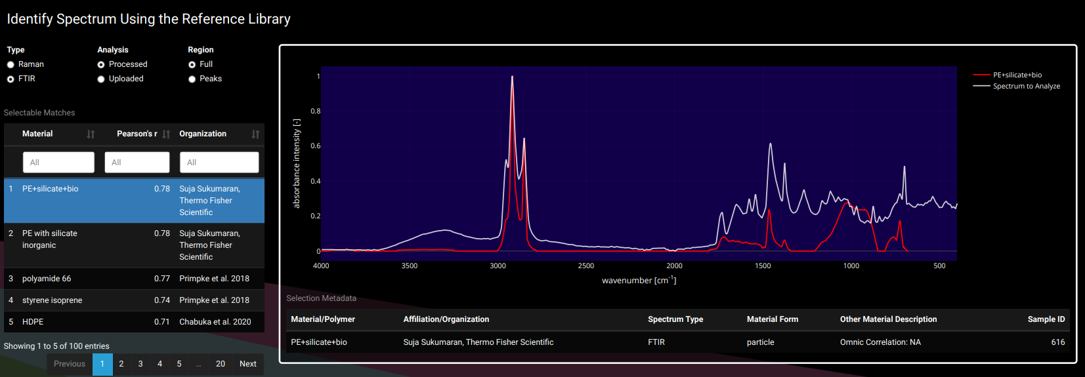

Supplementary Table 1. Atmospheric control – Desk filters (Main study – monthly samples 2019-2021)
Year | Date | Microplastic total (MPT)
2019 | 20th May | 13  (3 blue, 9 black, 1 red)
 | 21st May | 8  (4 blue, 4 black)
 | 22nd May | 4  (1 blue, 3 black)
 | 3rd June | 3  (black)
 | 4th June | 0
 | 19th June | 6  (black)
 | 20th June | 0
 | 24th June | 3  (1 black fragment, 2 black fibres)
 | 25th June | 0
 | 3rd July | 2  (1 black fragment, 1 black fibre)
 | 6th august | 6  (black fibres)
 | 15th august | 6  (2 red fibres, 4 black fibres)
 | 2nd September | 0
 | 25th September | 0
 | 26th September | 1  (black fibre)
 | 30th September | 3  (1 blue fibre, 1 black fibre, 1 red fibre)
 | 2nd October | 2  (1 blue fibre, 1 black fibre)
 | 24th October | 2  (1Red fibre, 1 black fibre)
 | 25th October | 5  (2 red fibres, 3 black fibres)
 | 30th October | 0
 | 2nd November | 0
 | 4th November | 5  (4 black fibres, 1 red fibre)
 | 5th November | 7  (3 black fibres, 3 blue fibres, 1 red fibre)
 | 11 November | 3  (1 red fibre,1 blue fibre,1 black fibre)
 | 21st November | 4  (3 black fibres, 1 red fibre)
 | 24th November | 0
 | 9th December | 2  (1 blue fibre, 1 red fibre)
 | 11th December | 6  (2 black fibres, 4 red fibres)
 | 19th December | 2  (black fibres)
2020 | 16th January | 0
 | 28th January | 9  (8 black frag, 1 black fibre)
 | 29th January | 0
 | 24th February | 0
 | 27TH February | 5  (4 black fibres, 1 red fibre)
 | 28th July | 4  (2 black fibres, 2 blue fibres)
 | 29th July | 0
 | 30th July | 3  (2 black fibres, 1 blue fibre)
 | 3rd August | 0
 | 4th August | 0
 | 5th August | 1  (blue fibre)
 | 26th August | 4  (2 blue fibres, 2 red fibres)
 | 27th August | 1  (black fibre)
 | 2nd September | 2  (black fibres)
 | 10th September | 0
 | 26th October | 5  (4 black fibres, 1 red fibre)
 | 27 October | 1  (black fibre)
 | 3rd November | 4  (blue fibres)
 | 11th November | 1  (black fibre)
 | 18th November | 0
 | 1st December | 0
 | 2nd December | 2  (1 black fibre, 1 blue fibre)
2021 | 26th April | 16  (4 blue fibres, 8 black fibres, 1 black fragment, 3 red fibres)
 | 29th April | 2  (2 black fibres)
 | 5th May | 2  (1 blue fibre, 1 red fibre)
 | 6th May | 1  (Black fragment)
 | 15th June | 2  (1 Black fibre, 1 red fibre)
 | 16th June | 4  (2 blue fibres, 2 red fibres)
 | 20th June | 1  (Black fibre)
 | 24th June | 2  (Black fibres)
 | 28th June | 6  (1 blue fibre, 5 black fibres)
 | 29th June | 4  (3 blue fibres, 1 red fibre)
 | 2nd July | 2  (1 blue fibre, 1 black fibre)
 | 6th July | 3  (1 Black fibre, 2 red fibres)
 | 7th July | 3  (2 black fibres, 1 blue fibre)
 | 8th July | 3  (Black fibre, blue fibre, red fibre)
 | 12th July | 1  (Black fibre)
 | 14th July | 3  (2 Blue fibres, 1 black fibre)

Supplementary Table 2 Contamination controls conducted from 2019-2021, including distilled water kept in 500ml bottles, as well as controls to test for possible contamination via the sampling equipment (bucket and Lamotte horizontal water sampler).
Control | Microplastic per replicate | Mean MPT | Average length (mm)
Distilled water kept in 500mL bottles  21/11/19 – 14/6/21 | 0 | 0 | -
 | 0
 | 0
500mL distilled water passed through the sampler | 2 black fibres  1 black particle | 1.3 | 1.57
 | 0
 | 1 black fibre
500mL distilled water passed over the rope (sampler) | 3 blue fibre | 3 | 2.89
 | 4 white fibre
 | 2 black
500mL distilled water rope soak (sampler) | 1 black fibre  1 blue fibre  1 red fibre  3 green fragments | 3.7 | 1.95
 | 3 white fibres
 | 1 blue fibre
500mL distilled water inside the bucket | 7 black fibres  2 blue fibres  2 pink fibres  1 green fibre | 5.67 | 4.63
2 pink fibres
1 black fibre
2 blue fibres
1 white fragment
 | 0
500mL distilled water passed over the rope (Bucket) | 0 | 1 | 2
1 black fibre
1 orange fibre
1 yellow fibre
 | 0
500mL distilled water rope soak (Bucket) | 1 blue fibre  1 black fragment | 1.67 | 1.28
2 black fibres
1 transparent fibre
 | 0

