A Narrative Study of First-Time Parenthood in the Information Age

Sarah Suter

A thesis submitted in partial fulfilment of the requirements of the University of East London for the Professional Doctoral Degree in Clinical Psychology

May 2015
Words: 25’200

ACKNOWLEDGMENTS

I owe my gratitude to a number of people and services who have made this narrative research project possible. My deepest gratitude goes to six wonderful women and mothers who shared their amazing stories with me. I would also like to say a big thank you to Dr Paula Magee, my research supervisor, for all her insightful comments and support.

I am also deeply indebted to my brilliant friend Kate. Finally, a special thank you to two remarkable men, David and Corey, who reminded me what life is really about.

TABLE OF CONTENTS

ACKNOWLEDGMENTS 1
TABLE OF CONTENTS 2
ABSTRACT 6
CHAPTER ONE – PARENTHOOD 7
1.1 A Conceptual Overview 7
1.2 Theories 8
1.3 Search Methods 9
1.4 Parenthood: Conceptualisation 10
1.5 Implications of the Construct on Psychological Well-Being 11
1.6 Antenatal/Postnatal Classes and Professional Support 13
1.7 Research into the Lived Experience 15
1.8 Cyberspace 19
1.9 Conclusion 22
1.10 Aim of the Study 22
1.11 Research Questions 22
CHAPTER TWO – METHODOLOGY 23
2. 1 RESEARCH METHOD AND DESIGN 23
2.1.1 Rationale for Narrative Research 23
2.1.2 Epistemological Position 23
2.2 PARTICIPANTS 24
2.2.1 Sampling 24
2.2.2 Sample Size and Demographics 24
2.2.3 Recruitment Strategy 25
2.2.4 Recruitment Criteria 25
2.2.5 Invitation to participate 26
2.3 PROCEDURE 27
2.3.1 Consent 27
2.3.2 Participation 27
2.3.3 Narrative Interviewing 28
2.4 ETHICAL CONSIDERATIONS 29
2.4.1 Ethical Approval 29
2.4.2 Research Participants’ Well-Being 29
2.4.3 Confidentiality and Data Storage 29
2.4.4 Participant Feedback 30
2.5 NARRATIVE ANALYTIC PROCEDURE 30
2.5.1 Introduction 30
2.5.2 Transcription and Interpretation 30
2.5.3 The Analytic Framework 31
2.5.4 Evaluation of Data Analysis 33
CHAPTER THREE – THE FINDINGS 34
3.1 INTRODUCTION 34
3.2 CASE STUDY ONE: “MAKE IT [PARENTHOOD] YOUR OWN” [256] – KATY’S STORY 35
3.2.1 About Katy 35
3.2.2 Katy’s Narrative 35
3.2.3 Katy’s Feedback 39
3.3 CASE STUDY TWO: “DON’T PLAY THE GAME” [352] – ANNA’S STORY 40
3.3.1 About Anna 40
3.3.2 Anna’s Story 40
3.3.3 Anna’s Feedback 45
3.4 CASE STUDY THREE: “LEARNING THROUGH TRIAL AND ERROR” [27] – LILY’S STORY 46
3.4.1 About Lily 46
3.4.2 Lily’s Narrative 46
3.4.3 Lily’s Feedback 48
3.5 CASE STUDY FOUR: “YOU JUST GONNA HAVE TO FIGURE IT OUT ON YOUR OWN” [298] – EMMA’S STORY 49
3.5.1 About Emma 49
3.5.2 Emma’s Story 49
3.5.3 Emma’s Feedback 54
3.6 CASE STUDY FIVE: “FOLLOWING MY INSTINCTS” [423] – ISABEL’S STORY 55
3.6.1 About Isabel 55
3.6.2 Isabel’s Narrative 55
3.6.3 Isabel’s Feedback 59
3.7 CASE STUDY SIX: “I THINK THERE IS SOMETHING UNIQUE IN NOAH” [546] – ROSE’S STORY 60
3.7.1 About Rose 60
3.7.2 Rose’s Narrative 60
3.7.3 Rose’s Feedback 64
CHAPTER FOUR – CONCLUSIONS 65
4.1 DISCUSSION IN THE CONTEXT OF THE LITERATURE REVIEW 65
4.1.1 The Global Impression 65
4.1.2 About the Lived Experience of Motherhood 66
4.1.3 Connectedness and Support 67
4.1.4 The Influence of Cyberspace 67
4.1.5 Reframing Society’s Concept of the Good Mother 69
4.1.6 Professionals’ Role in the Lived Experience of Motherhood 70
4.2 CLINICAL IMPLICATIONS 71
4.2.1 Reaching Out – A PPIMHS Website 72
4.2.2 Talking about Talking 73
4.3 RESEARCH IMPLICATIONS AND RECOMMENDATIONS 74
4.3.1 Recruiting Mothers and Fathers 74
4.3.2 Future Research 75
4.4 QUALITY OF ANALYIS 77
4.4.1 Narrative Research and Validity 77
4.4.2 Transparency 77
4.4.3 Participant Feedback 78
4.4.4 A Systematic and Consistent Approach to Data Analysis 78
4.5 CRITICAL REVIEW 79
4.5.1 Limitations 79
4.5.2 Personal Reflections – Doing Narrative Research 79
4.5.3 Co-Construction 79
4.5.4 Research as an on-going Learning Process 82
4.5.5 Conclusion 82
REFERENCES 84
APPENDIX A – ETHICS LETTER 91
APPENDIX B – INVITATION TO PARTICIPATE 93
APPENDIX C – CONSENT FORM 96
APPENDIX D – INTERVIEW SCHEDULE 97
APPENDIX E – TRANSCRIPTION KEY 98
APPENDIX F – TRANSCRIPTION SAMPLE 99
APPENDIX G – INVITATION TO FEEDBACK 100
APPENDIX H – EMAIL PARTICIPATION LETTER 101

ABSTRACT

Background: The subjective lived experience of early first-time parenthood remains an under-researched area. The literature highlights a need for storied experiences that portray the “normal” experiences and reactions of becoming and being a parent.
Objective: The purpose of this narrative study was to capture how a parent’s interactions with their family, the wider society, media and cyberspace shape their understanding of early parenthood.
Method: A narrative framework embedded in a social constructionist epistemology was adopted. Participants’ narratives were obtained either through face-to-face interviews or via email correspondence.
Participants: Six mothers chose to share their powerful and candid stories about first-time parenthood. The research involved a considerable amount of self-selection. Consequently, all participants were female, partnered, and the mothers chose to have a baby. The participants described themselves as White British or White Eastern European. The babies’ age range was between three months and 17 months.
Findings: Each story was treated as a case study and findings are presented in summary and story form. The journey to making motherhood their own appears to be the thread that runs through each narrative. The thread seems to portray a transition from idealised motherhood to de-mythologised, meaningful, lived experience. Overall, the experience of urban first-time parenthood has been constructed in a positive light.
Conclusions: The narratives highlight the pervasive and powerful influence of both cyberspace and social scripts about what a “good mother” does. Early parenthood is a critical time for professionals to engage with first-time parents to normalise their experiences and to provide reassurance and support. The participants’ narratives underscore the need for strengthening first-time parents’ sense of competence. They also suggest a unique opportunity for Perinatal Parent-Infant Services to offer virtual support by creating a psychologically-informed, compassionate website about becoming and being a parent to an infant.

CHAPTER ONE – PARENTHOOD

1.1 A Conceptual Overview
Our experience and understanding of parenthood is deeply social, contextual, and uniquely personal. From a traditional viewpoint, parenthood is intrinsically linked to marriage and reproduction. The emphasis tends to be on family constellation (McClain & Cere, 2013) and biological/genetic connection (Meyer, 2006). Alternative understandings of parenthood reflect the diversity, fluidity and elasticity of the term parenthood, for example placing more emphasis on the quality of the caregiving relationship, or on the plurality of parenting arrangements (Stacey, 2013).
The inherent complexity of sociocultural, religious and legal frameworks, dominant stories and ideologies that guide our understanding of parenthood have a profound impact on the everyday parenting experience. The transition into parenthood is a life-changing event. Adjustments on a practical level are made, and changes in self, identity, roles and relationships are experienced.
There is no universal understanding of parenthood, and the definitions of father and mother are not uniform across cultures. The terms parenthood/motherhood/ fatherhood represent a continuum of approaches that shape their conceptualisation as well as the ensuing socially constructed debates (Wood, 2013). These terms are therefore inherently difficult to conceptualise. Throughout this dissertation, the terms parent/father/mother were used liberally to describe an individual who is responsible for a dependent child while the concepts of parenthood/fatherhood/motherhood refer to the context in which this responsibility is enacted. In that sense, I perceive the idea of parenthood as socially constructed, while becoming a parent and caring for an infant represents a reality.
Furthermore, the temporal definition of the term “transition to parenthood” appears tricky. A literature review revealed considerable variation in the conceptualisation and interpretation of this transitory phase with some studies extending the transition phase to one year postpartum (e.g. Lawrence, Cobb, Rothman, Rothman, & Bradbury, 2008) while others confined it to the period of pregnancy (e.g. Houts, Barnett-Walker, & Paley, 2008). For this dissertation, I have defined the nature of the transitory phase as being more continuous, dynamic, and fluid. This nature is fundamentally shaped and constructed by each parent’s unique social, cultural, familial and individual contexts. Consequently, my definition of this transitory phase has no arbitrary start and end date.

1.2 Theories
A number of frameworks including the social role transition theory (Burr, Leigh, Day, & Constantine, 1979), family life cycle frameworks (e.g. Carter & McGoldrick, 1989) and contemporary adult attachment theories (e.g. Trillingsgaard, Elklit, Shevlin, & Maimburg, 2011) have been proposed to elucidate the psychological and social processes that mediate the experience of early parenthood.
Burr’s et al. (1979) role transition framework is based on the notion that perceived role strain plays an influential role in how the transition to parenthood is experienced. Parents who have to fulfil multiple roles are predicted to experience greater strain than parents who for example, can solely dedicate themselves to the care of their infant. In addition, experiences during pregnancy, labour and birth of the child are all thought to affect parental psychological well-being during the antenatal and postnatal period. Burr’s et al. (1979) framework is fundamentally informed by principles of social learning positing that parental beliefs, values, attitudes and expectations as well as societal norms significantly impact on both parents’ perception of the parent role and ease of transitioning into the role.
Carter and McGoldrick’s (1989) family life cycle model rests on the notion of a continuous growth and development process that shapes families with a particular focus on the impact of intergenerational stressors such as family myths, patterns, and traumas. Using the model, a parent’s experiences are affected, shaped and supported by a number of circles of influence taking place at different system levels (e.g. extended family, community, work setting, friends) and each of these systems are in turn impacted by their unique social, cultural, political, and economic contexts. The framework then considers the effects of developmental life cycle transitions such as parenthood, as well as unpredictable stressors, such as loss (Carter & McGoldrick, 1989). While the model is useful in considering the various contextual influences during the transition process from couplehood to parenthood, its stage approach to a phase which is inherently continuous, fluid and dynamic as well as the model’s initial focus on dyadic mother-father families have been widely criticized.
Attachment approaches are central to the many studies on the psychological effects of first-time parenthood. Attachment patterns formed during childhood have long-term consequences across the life span. They play an influential role in the formation of attachment styles in adult relationships (Cere, 2013). Attachment patterns are believed to be intrinsically linked with the quality and quantity of social support available to first-time parents looking after a baby (Alexander, Feeney, Hohaus, & Noller, 2001). Parents who feel supported have been found to feel less anxious about looking after a child under the age of five years which in turn facilitated greater developmentally appropriate interaction between parent and child (Green, Furrer, & McAlister, 2007). Furthermore, studies into attachment theories and early parenthood have consistently shown that parents with anxious attachment styles tend to experience greater psychological distress during the transition process to parenthood (e.g. Wilson, Rholes, Simpson, & Tran, 2007).
How parents regulate their own emotional experiences during early parenthood is also at least partly the product of their own childhood relational matrix. Consequently, attachment frameworks have become influential in our understanding of the emotion regulation strategies applied by new parents. For example, Behringer, Reiner, and Spangler (2011) reported that the manifestation and resolution of anger is fundamentally influenced by the mother’s attachment patterns developed during childhood, whereas present secure attachment styles with their partner is associated with facilitating the voicing of sadness and anxiety experienced during the transition to motherhood.

1.3 Search Methods
For Chapter One, a systematic search of the literature published between 2000 and 2014 was conducted using the CINAHL, PubMed, PsychINFO, PsycARTICLES, and EBSCOhost databases. The focus was on qualitative studies published in English to ensure that the search strategy is congruent with the narrative research method chosen for this project. The characteristics of qualitative research include participant-led data collection to facilitate participant-generated meanings (Willig, 2008). The focus was on the lived experience of becoming and being a first-time parent. Since experience is not quantifiable, my research questions were best explored through the use of a qualitative methodology and qualitative literature. Therefore, the keywords motherhood, fatherhood, parenthood, transition (to parenthood) and first-time mother(s), father(s), and parenting were used. The search terms cyberspace, Internet, virtual media, and information were also used to include studies looking into the impact of information on the individual construction of parenthood, and the lived experience itself.
A broader search strategy was employed during the design process of the presented study. The search produced a large body of both quantitative and qualitative literature discussing a broad range of topics related to my research questions, such as a randomized control trial on antenatal education (e.g. Bergström, Kieler, & Waldenström, 2011) or the transition into parenthood in the presence of specific psychiatry illnesses (e.g. Keeton, Perry-Jenkins, & Sayer, 2008).

1.4 Parenthood: Conceptualisation
Parenthood is a heuristic and intrinsically relational construct that describes a wide range of ever-evolving sociocultural, legal, medical, and educational norms, narratives and ideologies as they relate to and shape everyday parenting experiences (Cere & McClain, 2013), whereas parenting is defined as the daily practices and responsibilities of parents (Weille, 2010).
Parenthood in general, and motherhood in particular, are embedded in cultural mythology and religious stories, often romanticising motherhood as a joyful, blissful and rewarding experience (Pusse & Walter, 2013). Arendell’s (1997) conception of parenthood and parenting is derived from social constructionist ideas of social processes, meaning parenthood is learned from the community, and consequently shaped by socio-cultural understandings and beliefs about parenthood and childhood. These beliefs are located within the structural realities that fundamentally shape family realities and parenting differences, such as a family's origin, economic realities, socioeconomic class status, and ethnic or minority group membership. Parenting and parenthood is therefore conceptualised by Arendell (1997) as dynamic and mutable subject to context and time.
Over the past decades, a move towards an egalitarian model of parenting has fundamentally re-defined many Western discourses concerning parenthood (Lupton, 2000). According to Sevon (2011) the trend towards shared parental responsibility is driven by arguments of gender equality rather than by an ideology around the wellbeing of child and mother. The role of fathers has moved beyond providing financially for their families to being involved in caring and nurturing the infant (e.g. Deutsch, 2001; Miller, 2011). While the role of the provider remains a dominant influence on the way many fathers perceive themselves (Kushner, Pitre, Williamson, Breitkreuz, & Rempel, 2014), the emerging plurality and fluidity of their identities is apparent in the literature. Fathers described themselves as providers, nurturers, carers, role models, disciplinarians, co-parent, mentor, and a friend to their children (e.g. Harrington, Van Deusen, & Ladge, 2010; Eerola & Huttunen, 2011; Miller, 2011).
The assumption of the glowing mother-to-be is deeply embedded in social and cultural forms where motherhood is equated with happiness. Women are culturally expected to both experience a sense of fulfilment and joy in nurturing and bonding with their new-born baby. The same scripts also imply that women have innate knowledge about how to care for a baby (Maher, 2005). These implicit socio-cultural scripts can be a significant source of anxiety and guilt for a new mother/father as many parents liken parenthood to being under a magnifying glass where they are constantly scrutinised by family and the wider society (Weille, 2010). Parents often find themselves labelled as “good”, “bad” or often in the case of fathers “absent/uninterested” (Marks & Palkovitz, 2004) or “useless” (Featherstone, 2003). Many decades ago, Winnicott (1960) recognised the adverse effects on parents’ psychological wellbeing caused by striving to achieve the unrealistic ideal of flawless parents. It is for this reason that Winnicott (1960) introduced the idea of “good enough mothering” to describe a socially acceptable level of parenting and to alleviate some pressures on mothers in particular (but parents in general).
Women (and men) not meeting these assumptions are at risk of having their diverse experiences of motherhood/fatherhood pathologised. The medical explanations often imply that they are victims of hormones and neurological processes. The dominant deficit model of medicine and psychiatry therefore tends to position women (and men) as passive beings to which parenthood happens, in spite of them being very much active participants who construct their own social and psychological worlds.

1.5 Implications of the Construct on Psychological Well-Being
While many women and men are able to negotiate and resist the social and familial pressures stemming from current and historical discourses, there remains a considerable risk that these powerful narratives impact both on parental mental health and on the lived experience of early parenthood. Mothers/fathers who experience antenatal/postnatal depression, anxiety, anger toward the baby, or delayed bonding with the baby often delay seeking help from professionals out of fear of societal disapproval/rejection.
New parents continue to experience a sense of pressure to conform to the social ideals of a “good” mother/father/parent (Lupton, 2000). The NHS campaign to increase breastfeeding rates across England represents one contemporary social ideal of what a good mother does (Lupton, 2000). In an attempt to conform to society’s expectations and thus pursuing the idea of a perfect mother/father, many parents, but especially mothers, can feel pressurised into wearing a facade in public (Mauther, 1989). The resulting discrepancy between both their own lived experience and emotional states and society’s ideals of motherhood/fatherhood often creates a psychological vulnerability of feeling under-prepared and overwhelmed (e.g. Choi, Henshaw, Baker, & Tree, 2005; Fägerskiöld, 2008) which in turn gives rise to self-doubt and feelings of inadequacy, blame and guilt (e.g. Weile, 2010). In addition, parents especially mothers, and to lesser extent fathers, face a significant risk of having their experiences and emotions of parenthood pathologised by the dominant medical and psychiatric models used in healthcare services. The notion that some degree of low mood could be seen as a “normal” a response to a life-changing event is often only considered on the periphery of medical science. As a consequence, some parents, and perhaps more so women, are struggling to re-narrate their stories of parenthood in a fashion that is meaningful and beneficial to them because alternative stories are not readily available (Lafrance & Stoppard, 2007). Still, it has been noted that social norms not only define and constrain parenthood, they can also offer a sense of containment. Shelton and Johnson (2006) argued that social norms can provide new parents with a sense of security, achievement, and belonging. To conclude, the presented arguments both highlight and reinforce the embodied subjectivity, diversity, and temporality that underpin the social construct of parenthood, and shape the lived experience of first-time parenting.

1.6 Antenatal/Postnatal Classes and Professional Support
The influential role antenatal/postnatal classes can play in demythologising parenthood by providing balanced information about the rewards and challenges of early parenthood is evident in many research studies (e.g. Delmore-Kro, Pancer, Hunsberger, & Pratt, 2000). In the same vein, professionals such as midwives and health visitors can act as a positive and supportive resource for parents-to-be or new parents providing them with factual knowledge and choices as well as strengthening the parents’ sense of competence (e.g. Tarkka, Paunonen, & Laippala, 2000; Turner, Chew-Graham, Folkes, & Sharp, 2010).
Few studies have explored the experiences of British first-time mothers and/or fathers of antenatal classes and even fewer ones are recent (e.g. Kowlessar, Fox, & Wittkowski, 2015). In addition, a Cochrane Intervention Review by Gagnon and Sandal (2007) concluded that further evidence was needed to establish the effects of antenatal classes on the experience of birth or parenthood. Studies from abroad as well as anecdotal evidence from parenting forums and clinical practice seem to indicate a tendency for parents to feel dissatisfied with their antenatal classes for a multitude of reasons. Perhaps in recognition of this sentiment, the National Childbirth Trust, commonly known as NCT, has been developing a new approach. The proposed content for their antenatal programme called “preparing for pregnancy, birth and beyond” consists of six themes. In addition to conventional topics such as labour, birth and infant care, the programme also explores maternal health and well-being as well as emotional, social and financial support (Gore, Newburn, & Garrod, 2011). Coincidentally, the research literature suggests that such classes must go beyond the antenatal period. In a recent Australian study by Eronen, Pincombe, and Calabretto (2007), 27 mothers and one father with infants aged 21 weeks or less attended focus group interviews to explore parental well-being and support needs. Eronen’s et al. (2007) findings reveal a need for on-going reassurance and normalisation of parents’ postnatal experiences by professionals. Many participants reported feelings of loneliness, isolation and worry, and some participants described feelings of guilt and confusion because their expectations of parenthood did not match their parenting experiences. Conflicting information and advice by health professionals was also identified as a particular source of stress and confusion to new parents (Eronen et al., 2007).
The positive role antenatal care can play during the transition to parenthood is highlighted by Swedish researchers Andersson et al. (2012). 28 mothers and fathers explored their experiences of group-based antenatal care. The female participants felt that the group was helpful in normalising pregnancy, whilst the fathers-to-be reported feeling less anxious. The year-long group consisting of two-hourly sessions increased the participants’ levels of confidence and offered positive experiences of support (Andersson et al., 2012). Interestingly perhaps, the researchers reported that while the parents felt better prepared for childbirth, the same did not apply for parenthood (Andersson et al., 2012). It is not known whether Adersson et al. (2012) considered to offer a group-session of postnatal care.
Notable in the narratives of fathers-to-be is a sense of exclusion from antenatal/postnatal classes (e.g. Deave, Johnson, & Ingram, 2008) and experiences of mother-centrism (Kowlessar et al., 2015). In a British interview study by Kowlessar et al. (2015), first-time fathers (n=10) experienced their antenatal classes as tailored to preparing pregnant women for labour and birth. Fletcher, Silberberg, and Galloway (2004) found that over half of the 120 surveyed Australian fathers (59%) would have signed up to postnatal classes if they had been offered outside office hours. A lack of father-specific information (Deave et al., 2008), a condescending teaching style (Bradley, Mackenzie, & Boath, 2004) and a focus on skills deficits (Roggman, Boyce, Cook, & Cook, 2002) have been identified as barriers to fathers accessing antenatal classes.
There are some studies suggesting that for mothers-to-be the inclusion of their partners in antenatal classes is of importance. An Australian pilot study on women’s experiences of group-based antenatal sessions by Teate, Leap, Schindler, and Homer (2011) found that many of the female participants valued their partner’s presence in the group, while some of the women who had been assigned to the control group wished their partners could have attended the group.
In summary, it could be argued that the existing research shows that many parents feel ill-prepared in spite of the provision of antenatal classes. With the focus of many antenatal classes on pregnancy, labour and birth, parents appear to feel fairly well informed in these particular domains. However, findings indicate that parents felt under-prepared in the domains of relational and lifestyle changes, and coping with the emotional, psychological and physical experiences of looking after a newborn. Extending antenatal classes to the weeks after birth could thus provide valuable support and reassurance to new parents. Furthermore, the timing of these classes and greater attention to content covering the psychological impact and lifestyle changes of early parenthood as well as a greater sensitivity to existing parental skills and competencies appear to be crucial components to be considered during the design and delivery of antenatal classes.

1.7 Research into the Lived Experience
Women’s and men’s subjective experience of early parenthood remains a neglected research area. The focus of the existing literature tends to be on the experience of the pre-birth/perinatal transition phase often set in the context of antenatal classes, or pregnancy, labour and birth. There is also considerable research dedicated to the exploration of psychiatric/psychological distress during the transition process (e.g. Keeton, Perry-Jenkins, & Sayer, 2008; Leahy-Warren, McCarthy, & Corcoran, 2012).
There is a strong tendency in the research literature to frame the lived experience of parenthood as a time marked by stress and turmoil (Don, Biehle, & Mickelson, 2013), intermittent sleep, and uncertainty about one’s ability to care for an infant (John, Cameron, & McVeigh, 2005). Weille (2010) described the transition into parenthood as “a project in re-working the self” (p. 18). Evaluating the studies, the medical model of parenthood dominates many publications portraying the adjustment process to parenthood as a period of psychological vulnerability to antenatal and postnatal depression and anxiety (e.g. Grant, McMahon, & Austin, 2008).
There is however emerging research, such as the longitudinal study by Mckenzie and Carter (2013), that challenges these assertions. The study’s findings suggest that the arrival of a baby can lead to improvement of mental health and a decline in psychological stress in first-time parents, however partner status and socioeconomic factors are influential variables in the adjustment process. For many new parents, the experience of parenthood tends to be a positive one (e.g. Brady & Guerin, 2010). Importantly perhaps, a longitudinal study by Australian researchers Leach, Olesen, Butterworth, and Poyser (2014) found no evidence that expectant or early fatherhood presents an increased risk of developing mental health problems. While fewer in numbers, these accounts paint a portrait of positive parenthood. Roy (2014, preface vii) described parenthood as “life’s greatest journey”, and Nelson et al. (2013) postulated the idea that children are associated with more joy than misery. The first-time fathers in John’s et al. (2005) study recounted the early weeks of fatherhood as a period of wonder coupled with a sense of completeness and contentment. Chin, Daiches, and Hall (2011) found that fathers on paternal leave experienced the postnatal period as a “bubble” or a “cocoon”; a safe and protected space to spend precious time with their partner and to bond with their baby.
Thus, a tendency to dichotomise the lived experiences of parenthood can be observed in studies, whereas undoubtedly the lived experience is associated with both positive and negative events. Researching parenthood and evaluating studies has its unique challenges due to the diversity and uniqueness of individuals, families and the formative influences of their communities. The bulk of existing research adopts the traditional and dominant Western construct of parenthood occurring within a (married) male and female dyad. While fewer in numbers, there is a growing body of studies that approach parenthood differently, for example narrating the experiences of becoming parents from the perspective of gay men and lesbian women (e.g. Goldberg & Sayer, 2006), and adoptive parenthood (McKay & Ross, 2010).
The lived experience of parenthood is often documented from the perspective of either the mother or father. This approach to research is based on the notion that the transition to parenthood is experienced in unique and individual ways depending on a wider range of variables, including gender. Miller (2007) looked at the experiences of a small group of first-time mothers (n=17) over a period of one year with the first interview conducted when the participants were seven to eight months into their pregnancy. Their accounts suggest the presence of a dominant rhetoric within English society implying that mothers instinctively ought to know how to look after a newborn. Their stories document the confusion and distress that arose when their own experiences didn’t match this social preconception. However, the women’s narratives further suggest that these feelings of confusion and distress can act as a powerful catalyst for challenging both the good mother ideology and the myth of perfect motherhood (Miller, 2007). The pervasive and adverse impact of the construct of the “good mother” on support-seeking behaviours was captured by Choi et al. (2005) who interviewed twenty-four English mothers. They found that mothers who thought that their mothering does not meet the societal’s idea(l) of good motherhood not only felt inadequate but were very ambivalent about seeking help and support (Choi et al., 2005).
There is emerging research documenting the lived experience of men becoming first-time fathers. As with women, their transition is often framed in a deficit model. In addition, Hofferth and Goldscheider (2010) noted that the experiences of early fatherhood for men who do not live with their partners (or former partners) is different because the majority of infants born into single households continues to be raised by their mothers rather than their fathers. The findings of Deave and Johnson (2008) suggest that some of the men's experiences of the transition to fatherhood is dominated by a sense of exclusion and frustration due to the medical and social focus being on the expectant/new mother resulting in some fathers feeling useless during pregnancy, and helpless during labour (Deave & Johnson, 2008; Draper, 2002).
For many first-time fathers, Kowlessar et al. (2015) reported, the adjustment process to parenthood is experienced with a sense of helplessness while the new fathers tried to figure out their baby’s needs. Over time, the fathers noticed how they started to feel more competent and confident in their new role as fathers. Interestingly, the fathers’ narratives also suggest an implicit assumption that their wives (who were first-time mothers) somehow not only knew how to look after a baby, but were also more able to care for their infant (Kowlessar et al., 2015).
The experiences of parenthood in a dyadic context are considered to be intrinsically interlinked due to gendered behaviour patterns and very limited paternity leave (e.g. Miller, 2011; Kushner et al., 2014). Research based on the exploration into experiences of parenthood adopting the traditional Western perspective of a mother-father dyad draws attention to the influential role of the quality of the couple's relationship on how the transition is experienced. Don, Biehle, and Mickelson (2013) reported that first-time parents who had invested time in becoming a parenting team with shared ideas about how to raise their child felt less stressed, and also experienced greater enjoyment from being a parent, while reporting higher levels of couple relationship satisfaction. A number of studies (e.g. Allen & Daly, 2007; Eerola et al., 2011; Kowlessar et al., 2015) have consistently found greater paternal involvement in the nurturing and care of their infant in fathers who experienced their relationship with their partner as strong and positive. First-time fathers also developed a greater sense of skills competence when the mother was perceived as encouraging fathers to learn and engage in infant care (Kowlessar et al., 2015). Similarly, a study by Eerola et al. (2011) exploring the accounts of first-time fathers in Finland reported that mothers were experienced both as gatekeepers to caring for the infant and as supportive co-parents by first-time fathers. Furthermore, short paternity leave also appears to have the potential of a negative impact on fathers’ confidence levels. Miller (2011) argued that upon returning to work from paternity leave, some fathers start to experience more anxiety in relation to caring for their infant because they feel less attuned and more out of touch with their baby and the baby’s constantly evolving needs and developments.
While the quality of a couple’s relationship has no doubt an influential role on the transitional process, the experience of early parenthood is fundamentally shaped by the parent’s sense of social connectedness. Family, friends and peer support from other new mothers and fathers are central to the psychological well-being of first-time parents (e.g. Darvill, Skirton, & Farrand, 2010). Feeling connected and having opportunities to meet other mothers/mothers-to-be and sharing experiences has been shown to play a key role in maternal mental health (Meadows, 2011). Peer support and peer validation of mothers’ experiences and feelings are associated with increased psychological well-being during early motherhood (Wilkins, 2006). In an English study by Deave et al. (2008) 24 first-time mothers and 20 partners were interviewed before birth and 3-4 months postpartum to explore their support needs during pregnancy and early parenthood. Many of the interviewed women identified their own mothers and friends as invaluable in providing practical and emotional support. In contrast, fathers felt they had fewer sources of support, and stated that they mainly relied on their partners, and for some, on their work colleagues (Deave et al., 2008). Similarly, a Swedish study by Fägerskiöld (2008) investigating the changes experienced by first-time fathers (n=20) found that many of the fathers talked about turning to their male work colleagues and work-related friends for support and advice as well as for sharing experiences of fatherhood.
These narratives seem to suggest that for many working parents-to-be building a local support network can be difficult because antenatal classes and baby activity classes tend to take place during the weekday. Since parenthood is increasingly expressed, debated, and blogged about in cyberspace, many mothers and fathers turn to the Internet to seek support, advice, and information. Gibson and Hanson (2013) noted that there is emerging evidence for parents to use virtual social support, especially where parents’ social contacts are mostly work-related.

1.8 Cyberspace
Many adults experience parenthood in an increasingly interconnected world due to a readily available cyberspace that spans across the globe. While there is a growing trend among parents in industrialised countries to access the Internet to obtain information and to seek peer support (Daneback & Plantin, 2008), Sarkadi and Bremberg (2005) were surprised to find that Swedish fathers made less use of online parenting forums than mothers. Brady and Guerin (2010) reported a gender bias and described an Irish Parenting website as a predominantly female environment. While parents from socio-economically disadvantaged backgrounds are still less likely to have access to the Internet at home (Kind, Huang, Farr & Pomerantz, 2005), Sarkadi and Bremberg (2005) found no evidence to support their hypothesis that socio-economically privileged parents would proportionally be the largest group represented in an online parenting forum.
Putting the influence of virtual social networking sites in context, Mumsnet for example, (set up in 2000) claims to be the UK’s largest network for parents with over 70 million page views and 14 million visits per month (Mumsnet, 2015). Other equally popular online communities include Netmums (2015), and the BabyCentre (2015), a virtual network reportedly connecting 35 million mums across the world in eleven languages. It therefore feels important to consider the influence of cyberspace (including social media) on parental well-being and also its impact on the social construct of parenthood/motherhood/fatherhood.
The trend of online information searching and accessing virtual communities related to pregnancy and parenting is likely to continue. Daneback and Plantin (2008) argued that navigating the sheer amount of online information can be challenging for some parents, and they found some of the reviewed information to be inaccurate, ambiguous, or contradictory. Mungham and Lazard (2010) argued that online information can be experienced both as prescriptive and as narrow mirroring social dynamics and expectations. It can be empowering by normalising experiences of parenthood (Drentea & Moren-Croos, 2005; Madge & O’Connor, 2006) and liberating by providing access to experience-based rather than expert-based information (Eriksson & Salzmann-Erikson, 2012). In an American focus group study exploring the use of the web among mothers (n=20), Bernhardt and Felter (2004) found that while the Internet was used by most participating women to obtain information about their pregnancy, more frequent site visits were reported by pregnant women transitioning into first-time parenthood. Many of the women reported that they were particularly interested in finding online information about foetal development, and information pertaining to their due date and stage of pregnancy. Postpartum, the Internet was often accessed to research baby-related medical symptoms. The mothers’ accounts suggest that they consulted a wide range of websites, including commercial websites (e.g. the BabyCentre), academic websites, and websites hosted by charities and medical providers (Bernhardt & Felter, 2004).
There is growing evidence to suggest that online parent communities can reduce social isolation in new mothers (e.g. Gibson & Hanson, 2013), often leading to an increase in psychological well-being and confidence in one’s parenting skills (Madge et al., 2006). Brady and Guerin (2010) reported “a strong community sense to the discussion boards” (p.19). The accounts recorded by Bernhardt and Felter’s (2004) study paint a portrait of cyberspace as a social portal to virtual communities bringing mothers-to-be together. Consequently, websites such as the BabyCentre were particularly favoured by first-time mothers because of their design as a source of information and a platform for social networking with other mothers (Bernhardt & Felter, 2004).
While the flood of, often contradictory, online information can present unique challenges to new parents, cyberspace can also be a powerful conduit for self-help removing dependency on experts, and enabling access to alternative stories, interpretations, and ideas. Overall, the world of cyberspace is another environment where gendered and socio-cultural ideas of parenthood are both preserved and contested. It appears, online forums and discussion boards are mostly experienced as safe, positive and supportive platforms by parents (e.g. Madge & O’Connor, 2006; Fletcher & St. George, 2011; Eriksson & Salzmann-Erikson, 2012). There are however accounts of tension and arguments (e.g. Brady & Guerin, 2010). Threads analysed by Drentea and Moren-Croos (2005) suggest the existence of an explicit code of communication based on an underlying assumption of being kind to one another. When the code is violated, the perpetrator is reminded of the forum’s etiquette, and when that failed to reinstate a supportive environment, the mothers relied on forum moderators to address the issue (Drentea & Moren-Cross, 2005). Another netnographic study exploring the online threads posted by fathers about caring for a baby revealed the three-fold nature of communicated support available online. Support expressed in the form of reassurance, validation, and advice, allowed fathers to become experts in their own right, and to assume the role and status of a skilled father within the forum (Eriksson & Salzmann-Erikson, 2012).
Upon becoming a mother or a father, many parents experience loss of self-identity and the emergence of a socially constructed, gendered role identity enmeshed with the public idea of “good” mother/father. For the mothers in Gibson and Hanson’s (2013) study, online communities, blogs, and other forms of social media (e.g. Facebook) offered crucial opportunities for self-expression and “a form of therapy” (p. 318). To be more than “just” a mother and to have an identity as a person in their own right was fundamental to the experience and preservation of one’s pre-mother self (Gibson & Hanson, 2013). Their accounts underscore the importance of exercising their non-mothering mind and self (Gibson & Hanson, 2013), and also introduce the idea of parenthood as an activity rather than an identity (Maher, 2005). In fact, the narratives of Australian women interviewed by Maher (2005) portray the nature of being a parent as fluid, temporal and contingent and very much activity-dependent (as opposed to identity-dependent). Finally, it appears that smartphones played a central role in the mothers’ emotional wellbeing, allowing them to stay connected with the wider social world and giving access to online games such as Sudoku. These activities provided the mothers with a sense of productivity, intellectual stimulation, and mental satisfaction Gibson and Hanson
(2013) argued.
In summary, with contemporary parenthood being increasingly shaped and impacted on by cyberspace, the Internet seems to play a key role in both maintaining and contesting discourses of parenthood and parenting practises. Cyberspace offers seemingly endless opportunities to co-create meanings and virtual relationships with other parents. Parenting forums in particular appear to be key contributors in normalising motherhood/fatherhood/parenthood through posts depicting both positive and negative experiences of parenting thereby dispelling the myth of the textbook parent/child (e.g. Brady & Guerin, 2010). To Mungham and Lazard (2010) cyberspace has the potential to be a dynamic and influential vehicle for diminishing the dominance of both the romanticised ideals of motherhood, and of expert advice.

1.9 Conclusion
There are many contextual factors that shape early, first-time parenthood. With readily available and easily accessible information, a decline in extended family support paired with constant sociocultural change, early discharge after childbirth, austerity measures in the NHS and changes in midwifery and health visitor practices there appears to be an even greater need to explore the lived experience of first-time parents. The small number of studies, and the even fewer number of British investigations, provide a limited understanding of current contextual variables that impact on early parenthood. First-time parents’ stories of their lived experience of becoming and being parents to an infant provides invaluable insight into the social meanings and constructs that shape parents’ perspectives of their experiences and needs in early parenthood.

1.10 Aim of the Study
The goals for this exploratory study was to develop a better understanding of the current context-dependent ideas of early parenthood in relation to a parent’s interactions with the wider society, family, media, and cyberspace. The study aims to develop a more current understanding as to the storied experience of being a first-time parent to a baby in order to inform clinical practice and raise awareness of the challenges parents face in an increasingly interconnected world.

1.11 Research Questions

1) What are the contextual influences on a parent’s understanding of early parenthood?

2) What are the sources of support and the barriers to enjoying life with a baby?

3) How can these narratives of parenthood be used to inform clinical practice and to normalise parenthood?

CHAPTER TWO – METHODOLOGY

2. 1 RESEARCH METHOD AND DESIGN
The study used the qualitative methodology of narrative research embedded in a social constructionist epistemology. I obtained participants’ narratives either through face-to-face interviews or via email correspondence.

2.1.1 Rationale for Narrative Research
Narrative approaches are considered powerful mediums to give meaning to experience (Esin, 2011). The pluralism of narrative research is reflected in the different approaches to data analysis, each concentrating on particular features within the participants’ stories. Depending on the lens adopted, these features can be for example identified as structure, content and performative (e.g. Mishler, 1996).
Narrative research is based on the idea that narratives (or stories) are means for individuals to talk about their world, lives and selves. Narrative approaches acknowledge that stories are the product of social interactions between individuals, and consequently, are not privately authored (Smith & Sparks, 2008).
Central to the narrative approach is an interest in empowering research participants (Elliot, 2005) by creating space for the participant to influence the introduction and flow of their own narratives (Mishler, 1986) and thereby allowing participants to talk about themes that are salient to them (Elliot, 2005). In narrative research, the interviewer is considered both audience and co-narrator (Mishler, 1986).
As the aim for this research was to explore the uniqueness of parenthood from the perspective of first-time parents while considering the context-dependent variables that shape their lived experience, narrative research was considered the most appropriate method.

2.1.2 Epistemological Position
Narrative approaches to research have their origin in a social constructionist epistemology (Elliot, 2005) based on ideas of hermeneutic or interpretative principles. Social constructionism maintains that the social world and the knowledge we have about ourselves is constructed, implying that knowledge is shaped and regulated through social experience. These everyday social interactions reflect a shared way of making sense of the world (Gergen & Gergen, 1986).

Consequently, the underlying epistemological assumptions of social constructionism are defined by the idea that the researcher and the participant find themselves in a dynamic, changing and interlinked relational reality where meaning is created through the process of research. The social constructionist framework therefore maintains that reality is personal, subjective and unique, a view that is in contradiction to the traditional scientific approaches that understand reality as something that is objectively observable and tangible (Cohen & Manion, 1992). Consequently, a narrative approach enables participants to share with the researcher how they perceive, experience and interpret the subjective social world of human experience.

2.2 PARTICIPANTS

2.2.1 Sampling
I employed purposive sampling targeting first-time mothers or fathers living in an urban environment with a child between the ages of one day and 18 months. The child’s age limit of 18 months was chosen as an arbitrary cut-off point for the purpose of sampling only. This cut-off point was chosen for two reasons:

- Eighteen months was considered to be a broad enough age range to achieve data collection within the limited time available (i.e. two months)
- It was felt that parents would still be able to reconnect with the memories of their journey to becoming and being a parent

Therefore, this age limit is not a reference to the temporal definition of the term transition to parenthood as discussed in Chapter One, Paragraph 1.1.

2.2.2 Sample Size and Demographics
Six female participants chose to share their narratives of first-time parenthood. Small sample sizes are a characteristic of narrative research (Kohler Riessman, 2008). The sample size is considered acceptable because the narratives represent a large quantity of extremely rich data.

I intentionally collected limited demographic details. After much deliberation, I chose to remove demographic information from this section and instead provide the reader with a little bit of information about each participant at the beginning of the participant’s story (see Chapter Three – Findings). Such an approach introduces the reader to each story’s protagonist and her family at the beginning of each story, thereby setting the scene for the participant’s narration of the lived experience of first-time parenthood.

Participants were encouraged to choose a pseudonym for themselves and their baby.

2.2.3 Recruitment Strategy
While the aim was to recruit a maximum of seven participants, I concluded data collection at the End of February 2015 due to time constraints.
Word-of-mouth recruiting was used via the following channels:

- Two Clinical Psychology Prof.Doc. cohorts
- One Counselling Psychology Prof.Doc. cohort

Additionally, I contacted the following organisations to invite them to support my study by allowing me to attend their parent-toddler groups or by distributing the invitation packs on my behalf.

- Playgroup for dads and toddlers (North London) – No reply
- Playgroup for dads and toddlers (South London) – No reply
- Children’s Centre (North London) – No reply
- Children’s Centre (East London) – Replied - Participated

2.2.4 Recruitment Criteria
Participants needed to be fluent in spoken English. The focus of narrative research is on the construction of meaning (Mishler, 1986). Language has a dual function of both expressing meaning and influencing how meaning is constructed. Therefore, translating narratives is problematic, time-consuming, and costly. Translation bears a significant risk of both diminishing the richness of the stories and its nuances. Translating quotes from one language to another is also problematic because the quote no longer represents the participant’s own words (e.g. Van Nes, Abma, Jonsson, & Deeg, 2010).

Participants needed to be first-time parents. The lived experience of becoming and being a parent for the first-time is thought to be more challenging for most new parents because of limited pre-existing knowledge about parenting and lack of previous exposure to the demands of parenthood.

2.2.5 Invitation to participate
Word of mouth recruiting: I cascaded my invitation to participate via email across three cohorts on the Doctorate courses in Clinical Psychology/Counselling (see Section 2.2.3). I asked the trainees to forward my invitation to any person they knew who might be interested in participating. Attached to my email invitation was the participant information sheet (see Appendix B) and the consent form (Appendix C). Printed invitation letters containing the above documents as well as a pre-stamped return envelope were available on request.

Play groups: I contacted the Manager of the Children’s Centres first by email introducing myself and describing the study and inviting the centre to participate. The participant information sheet was attached for their information. The email invitation was shortly afterwards followed up with a telephone call. The Manager of one Centre expressed interest. I met with the Centre’s Manager and the Lead of a mother and toddler group, presenting my study and answering any questions. Upon obtaining permission to attend the group, I visited the Centre on a pre-agreed day at a pre-agreed time (towards the end of the group session as requested by the Lead). The Lead pointed out to me a few first-time mothers and fathers who might be interested and I approached these parents, introducing myself and briefly exploring whether they might be interested in participating in my research. When interest was expressed, more information about the study was provided, any questions were answered, and they were provided with the invitation pack (containing the consent form, participant information sheet, pre-stamped return envelope) with my contact details.

2.3 PROCEDURE

2.3.1 Consent
Participants interested in the study were asked to return the signed consent form either using a pre-stamped envelope addressed to the School of Psychology or by emailing me the scanned form.

Where the participant had scanned the form, I asked for the original signed form on the day of interviewing. The consent form was revisited just before the interview started to reiterate key points such as voluntary participation, withdrawal from the study. I recorded all interviews with the written consent of the interviewees (see Appendix C).

2.3.2 Participation
Together with the consent form, the participants returned an “expression of interest form” (see Appendix B). The form gave me the permission to contact the participant using their preferred method of communication (telephone or email). I called/emailed the participant to discuss participation, to answer any questions, and to determine the respondent’s preferred method of participation (interview vs email).

Five participants chose to be interviewed, and one participant shared her story via email correspondence.

All participants - regardless of their form of participation - received the first three broad interview questions (see Interview Schedule Appendix D) in written format once they had expressed interest in the study. They were given the interview questions in advance in order to make an informed choice whether to participate in the study. The questions they received were:

- “What has influenced your understanding of parenting and your relationship to being a parent?”

- “Can you share with me how information has shaped how you feel and think about being a mother or father?”

- “What is it like to use the internet to seek advice or google for information about life with a baby?”

The participant who chose to share her story via email received the same information and instructions.

The interviewee chose the interview location (e.g. participant’s home), day and time. Two participants wished to be interviewed in their local coffee shop. I ensured that participants understood the implications of a public space on confidentiality. For home visits, a research safety protocol was observed.

Participation was voluntary and unpaid.

2.3.3 Narrative Interviewing
At the heart of narrative interviewing lies a discursive, interactive and dynamic process of storytelling. Typically, non-narrative interviewing techniques use a pre-determined interview schedule prone to creating alienation in interviewees (Mishler, 1996). In narrative interviewing, the participant co-influences the flow of the story and the topics shared with the interviewer. Thus, the researcher assumes the role of both the “…interviewer and a listener-to-a story” (Mishler, 1996, p. 102) thereby creating space for the participant to be the driving force behind the storytelling process while the researcher keeps in mind a broad interview schedule (see Appendix D). This approach to interviewing was communicated clearly to the participants. The women were therefore encouraged to contribute their own salient topics and I emphasised that it was up to the participant to choose a starting point for their story. Participants were also reminded of the three broad research questions I was interested in. They had already received these questions in writing once they had expressed interest in the study.

The interview length varied between 40 minutes and 1 hour and 17 minutes.

The participant who chose to write her story received a letter via email explaining narrative research and participation by email (see Appendix H). The letter also provided the participant again with all three research questions and informed the participant that once the story had been received, I would most likely be in touch to follow up some strands of the written story in order to develop and deepen our shared understanding.

2.4 ETHICAL CONSIDERATIONS

2.4.1 Ethical Approval
The study obtained ethical approval from the University of East London Research Ethics Committee on 5th November 2014 (see Appendix A).

2.4.2 Research Participants’ Well-Being
The risk of emotional distress was considered to be low. However, early parenthood can be a time of mixed emotions. I anticipated that while sharing their story about first-time parenthood, some participants may touch on sensitive or potentially difficult areas. Each participant received a list of organisations that can offer support and advice to parents. Subjectively, no interviewee appeared distressed during or after the interview. I encouraged participants to reflect on their experience of participating in the study.

2.4.3 Confidentiality and Data Storage
After each interview, the audio file was transferred to an encrypted memory stick (DataTraveler® Vault Privacy) and deleted from the voice recorder. The narrative sent by email was also transferred to the same memory stick and deleted from the University email account.

Participants were encouraged to choose a pseudonym for themselves and their baby. Where the participant declined, a pseudonym was allocated by me. During transcription, any identifying references were removed and the transcripts featured the participants’ pseudonyms only.

Upon receiving written confirmation from the University that I have passed my viva voce, all audio files (and emailed narrative) will be deleted permanently. The transcripts will be kept as password-protected files on a University owned, password-protected computer for three years. The responsibility for their safe storage lies with the Director of the Studies.

2.4.4 Participant Feedback
Participants received a copy of my interpretation of their story and were invited to provide feedback (see Chapter Three - Findings).

2.5 NARRATIVE ANALYTIC PROCEDURE

2.5.1 Introduction
The analysis of stories is fundamentally guided by principles of lived life and told story. Lived life is understood in the sense that stories both describe experiences and the realities from which they arise, whereas told story portrays the narrator’s meaning-making process of events and reflects the interpersonal and contextual influences of the interview itself. Based on a narrative framework, interviews are understood as a data collection and a data production process as well as a collaborative exploration of the narrator’s meaning-making process (Elliot, 2005).

2.5.2 Transcription and Interpretation
Therefore, the transcription and interpretation of the stories presented in this dissertation were critically shaped by the researcher who is perceived by Elliot (2005) as an active agent both in the production and interpretation of narratives. In Chapter 4, sub-heading “Co-Construction” (p. 79) I reflected on my influence in the co-construction of the narratives. Namely:

- How did my positioning as a researcher working as a trainee clinical psychologist in a Perinatal Service, and my gender influence the development of the narratives, and their interpretations?
- How did I influence the development of the narratives, and their interpretations?

Consequently I systematically transcribed all of my speech and the participant’s speech as well as other vocal sounds (e.g. laughter, audible sighs), uncompleted words or self-interrupted speech (e.g. but she didn’t like- I don’t think she), repetitions of words, long pauses, and interruptions by the baby (see Appendix E for transcription symbols).

I further acknowledge that the transcripts contain words and sentences which could not be transcribed due to being drowned out by background noise (e.g. baby shaking a rattle). With mixed success, the software Audacity® was used to remove some of the background noise. However, despite my best intentions, it is safe to assume that some words are missing and some were transcribed incorrectly.

In summary, and as highlighted by Mishler (1996), “transcripts are only a partial representation of speech” (p. 48).

2.5.3 The Analytic Framework
The transcription, coding and interpretation of narratives is fundamentally shaped by the lens or lenses the researcher adopts. It is important to note that I viewed each interview in its entirety as the story.

Considering the research topic and questions, I strongly felt that there should be no artificial divide between content and context. Thus, the holistic-content approach of Lieblich, Tuval-Mashiach and Zilber (1998) and the wider context approach of Weatherhead (2011) were combined to systematically guide my analysis of the co-constructed and meanings expressed during the storytelling. This approach created space and flexibility to follow the different narrative strands that run through the story. They were sensitively linked together into a global impression and coherent and meaningful themes while simultaneously they remained embedded in their relevant contextual frames.

A sample page of a transcript can be located in Appendix F.

On the following page, Diagram 1, illustrates the narrative analysis matrix I created for analysing each transcript in a structured, systematic and methodical manner.

Diagram 1: Narrative Analysis Matrix
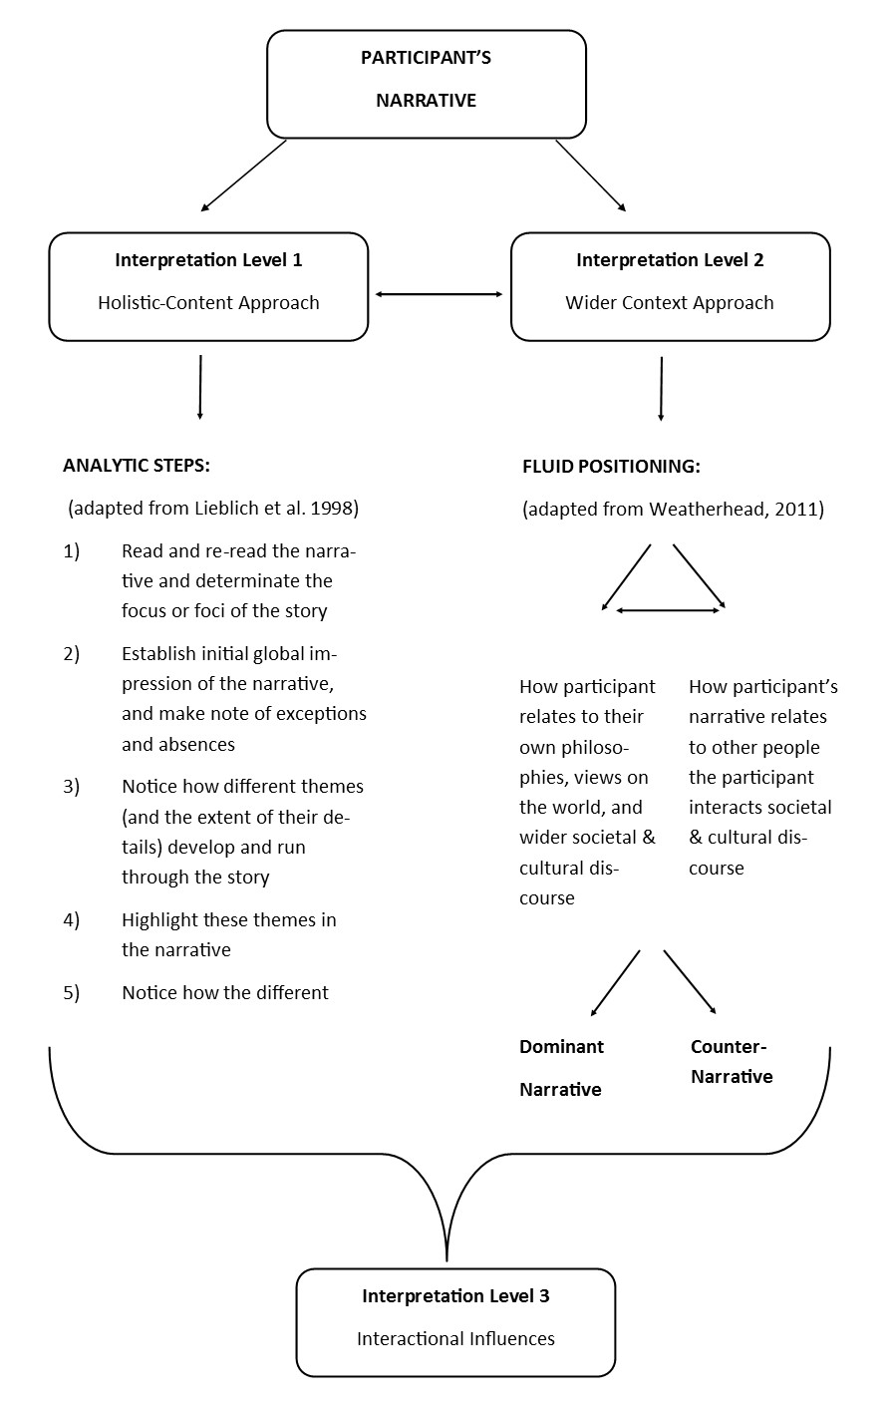

2.5.4 Evaluation of Data Analysis
Many narrative researchers, including Kohler Riessman (2008) and Lieblich et al. (1998) argue that parameters such as validity and reliability traditionally used to evaluate the quality of analysis are reliant upon a realist epistemology and are therefore incongruent with narrative research. Both Kohler Riessman (2008) and Lieblich et al. (1998) have proposed alternative parameters such as transparency, pragmatic use, and feedback on the interpretation to evaluate the quality of data analysis. Therefore, participants received a copy of my interpretation of their story and were invited to provide feedback (see Chapter Three - Findings).

The process of evaluation is described in Chapter Four, section 4.4 Quality of Analysis (p. 76).

CHAPTER THREE – THE FINDINGS

3.1 INTRODUCTION
Each interview is treated as a case study as recommended by Lieblich et al. (1998). In keeping with both narrative research and case studies, the findings are presented in summary and story form. Interpretations are supported by evidence from the transcripts. Line numbers are used following each quote for easy reference of the quote’s location in the transcript.

The two main forms of analysis – holistic-content and wider context – have been combined to maintain the integrity of the entire story and its context.

I intentionally moved away from the conventional approach of the disembodied researcher traditionally used in quantitative research and therefore, used “I” instead of “the interviewer/researcher” in the narratives presented in this chapter.

Following the tradition of narrative research, readers are encouraged to choose their own lens or lenses to interpret each case study and to reflect on the influence of their own unique social contexts upon the interpretations.

3.2 CASE STUDY ONE: “MAKE IT [PARENTHOOD] YOUR OWN” [256] – KATY’S STORY

3.2.1 About Katy
Katy is in her early twenties and at the time of interviewing her baby girl Ella was 11 months old. Prior to Ella’s arrival, Katy worked in the Hospitality Sector. She identified herself as White British and raises her daughter together with her partner.

3.2.2 Katy’s Narrative
The global impression of Katy’s story about parenthood is that of a creative, individualistic process. Throughout her pregnancy and following Ella’s birth, Katy’s account details how she was trying to navigate her way through a complex information and expectation landscape. Over time Katy came to perceive parenthood as “lots of things” [255] leaving her with a feeling that ultimately “you have to make it [parenthood] your own” [256].

Katy’s story of parenthood suggests three significant themes that appear to have fundamentally shaped both her understanding of parenthood and parenting itself.

- Cyberspace
Katy starts her account by expressing her ambivalence about the usefulness of the internet, saying “the thing that I found quite interesting that’s either helped or hindered me is the different information and the Internet” [10-11]. The use of the conjunction either reinforces the possibility of the Internet as both a form of support and a barrier. She continues by telling me that she found parent forums unhelpful, emphasising her statement by using the adverb really [14]. Hence, the first perspective about the Internet’s mixed usefulness is voiced very clearly in Katy’s introduction.

As she continues to describe the impact of the Internet on how she feels as a parent, Katy narrates how the wealth of conflicting information and experiences gave rise to confusion. Her narrative then switches to a more personal tone by talking about her experiencing self-doubt because the advice and experiences posted by users seem to be accepted by everyone as the norm.

Katy positions herself as someone who has never posted anything and throughout her narrative, she conveys the sense of a silent participant suggesting the presence of a paradox: Katy seems to be searching for reassurance both from experts based on their lived experience of motherhood or expertise through profession-based training, yet she repeatedly stresses the unhelpfulness of these expert opinions. Simultaneously, assertions of autonomy and non-conformity to dominant narratives about parenthood are abound in Katy’s story. In the context of forums, she stated “I don’t… like that kind of thing” [37]. She concludes her exploration by wondering whether these forums are populated by “very… pushy” [31] people, questioning the credibility of their messages in light of the anonymity of the authors. Katy re-visits this idea further along in her account, positioning these mothers as “quite stressed and worried” [53]. Towards the end of her story, Katy positions herself as someone who through Ella’s presence has “become more kind of relaxed” [311].

Katy used Google a lot throughout her pregnancy and also after Ella’s birth and dedicates a large part of her story to the kind of information she would almost compulsively look up. Google it appears seems to be a vehicle for Katy to obtain factual knowledge historically obtained from professionals such as midwives. Katy for example talked about googling for information about signs of labour, affirming her drive for autonomy. When she had arrived at the hospital about to give birth, they [the professionals] told her “oh, you should have come a bit earlier” [156].

Before Katy concludes her story, she describes how Skype is connecting Ella with her wider family. Skype with a webcam seems to help Ella to remember the faces of family members living further afield. The positive influence of Skype appears to be evident in Katy’s narration in the sense that she frequently Skypes her parents and says “that’s really good” [348].

Before the interview was abruptly ended when Ella started crying, Katy offers her conflicted view about putting photos of Ella online. Before Ella’s birth, Katy had decided not to post any photos online worrying about the intentions of people who might download pictures of Ella, and also feeling hesitant about sharing her life online. Her love for Ella is clearly communicated in her story. Her narrative suggests Katy was grappling with how safe it would be to post Ella’s photos online while proudly wanting to show her off to families and friends. Her account implies that by sharing photos of Ella online, her family and friends can be part of Ella’s development and in that way, online photo sharing can create a sense of belonging and connection. Perhaps she felt the need to justify to herself (and/or to the interviewer) her decision to put photos online by arguing that “everyone wants to look at her pictures” [354-355].

- Assumed expectations and their implicit impact on making parenthood your own
Katy’s story demonstrates that her lived experience of first-time motherhood was, and still is coloured by assumed expectations made by society on Katy. She talks about being “worried what other people thought when you are out and about” [289] and this concern resulted in Katy walking everywhere with Ella instead of catching a bus. Underlying her explanation appears a sense of lack of control over Ella’s behaviour and fear of judgement as a bad mother. Reflecting on her avoidance of buses, Katy tells me that she was “scared that she [Ella] would start crying” [292] implying perhaps a fear that should she not be able to soothe Ella, the passengers might consider her an unfit mother. She finishes her reflection by stating that “now I don’t care that much and I think that was quite an important experience for me” [292-294]. Katy chose not to elaborate on her transition from avoiding buses to not caring. In keeping with Lieblich et al.’s (1998) approach, occurrences of non-elaboration are considered meaningful and therefore, worth documenting. Katy’s statement seems to assert again her autonomy and non-conformity by highlighting the value of this experience to aid the process of making parenthood your own.

In her account Katy also touches on the implicit expectations on mothers-to-be to attend antenatal classes. Katy’s narrative suggests that for some mothers these classes can be beneficial for making friends. Significantly, she didn’t feel a need to attend these kind of classes stating that “I don’t… really like stuff like that” [230]. Katy attended a one-day antenatal class with her husband and whilst she didn’t enjoy the class, she chose not to elaborate on her experience nor on her husband’s experience. Katy is candid about the implicit pressure to conform to antenatal education saying “I felt like I should go”. Deviation from what Katy thinks is the dominant viewpoint of society is depicted as a positive act which is congruent with her ideas about parenthood. She states “it’s the… realisation that you actually don’t have to do it if you don’t want…” [238-239].

Perhaps her attempts to make parenthood her own is partially shaped by her philosophy of autonomy and partially driven by a fear of not meeting assumed expectations? This fear is implied later in her account when Katy talks about the fact that she has only ever attended a baby massage class. Katy tells me that she felt quite scared about meeting other parents because of “what was kind of expected” [272-273]. It is not clear whether she referred to expectations by other parents or by the staff running mother and baby classes.

Her elaboration suggests that she attended the baby massage class because it was skills-based as opposed to a play session. The class’ focus created a pressure-free environment for Katy which is evident in her declaration “I mean you could just sit there and not talk to anyone if you wanted to” [282-283]. Her autonomy from mother and baby groups is further manifested by going to art galleries “and things like that” [268] with Ella.

Linking Katy’s earlier comment about NCT classes being good for some mothers for making friends, Katy’s lived experience of parenthood is clearly embedded in nurturing relationships with friends and family. This condition perhaps has created space for Katy to confidently follow her own ideas and views about parenthood.

- Support and Expectations by Professionals
Katy’s story portrays both the positive and negative influences of professionals’ interactions on Katy’s lived experience of motherhood. It is interesting that while she describes the midwives as “really nice” [148] she expands on her feeling by adding “you know they were not scary, like people shouting at you” [148-149]. The origins of this assumption about midwives is not explored further but perhaps reflects anecdotal stories she has heard. While at the hospital, Katy found it “disconcerting that every single time a midwife came in, it was a different one” [178-179]. The lack of continuity in care had a profound impact on Katy. She felt patronised and worried because every time a midwife came in and Ella was crying, the midwives told her to feed Ella. In her story, her choice of words appears to reflect her growing frustration, worry over being perceived as a bad mother, and a need to justify herself. She said she responded to one midwife’s demand to feed Ella with “I am not being mean, I have just fed her” [184]. Katy dedicates a good part of her story to narrate the negative implications of the dominant narrative surrounding breastfeeding. In her account, Katy expresses concerns about the negative impact of society’s preoccupation with breastfeeding on how mothers might feel about themselves and talks about an acquaintance who had to stop breastfeeding for medical reasons. She said her acquaintance upset was because of society’s focus on breastfeeding. Katy feels that professionals want mothers to breastfeed, saying “it feels like it’s so pushed on you” [200]. Katy was not impressed with either the length of the breastfeeding class (3 hours) or its content. The teaching favoured breastfeeding to the extent of excluding a more holistic approach. There was for example no information on how difficult breastfeeding can be for some mothers because “they don’t want to put you off and I think that’s really bad” [208-209]. Katy concludes this part of her story by stating “luckily I could breastfeed” [224] conveying a sense of relief and perhaps achievement.

Towards the end of the interview, Katy briefly returns to this theme of support saying that she didn’t get much professional support post-discharge, wondering whether more visits from health visitors would have been beneficial. This reflection was not further explored due to the baby interrupting the interview.

3.2.3 Katy’s Feedback
While Katy acknowledged the receipt of my interpretation, she chose not to provide any feedback.

3.3 CASE STUDY TWO: “DON’T PLAY THE GAME” [352] – ANNA’S STORY

3.3.1 About Anna
Anna is in her thirties and at the time of interviewing, her baby boy Leo was eight months old. Prior to Leo’s arrival, Anna worked in journalism. She identified herself as White British and raises her son together with her partner.

3.3.2 Anna’s Story
The global impression of Anna’s story captures parenthood as an intriguing and challenging adventure that involves finding ways to tame her knowledge- and reassurance-seeking mind. While resisting the lure of cyberspace proved to be tricky at times, Anna’s analytical mind seems to act as a buffer against society’s ideology of “this hallowed good mother” [347]. “I found myself reacting against this” [350] Anna declares, and peppers her narrative with anecdotes of resistance against implicit and explicit views and expectations of others, and wider society in general. Her story evokes a strong sense of Anna’s ownership of her own motherhood and affirms Anna’s resistance in participating in the dominant game of parenthood.

Anna’s story of parenthood suggests four major themes that appear to have fundamentally shaped both her understanding of parenthood and parenting itself.

- Conception & The Coldness of Professionalism
Anna chooses Leo’s conception as the starting point for her narrative and she dedicates a substantial amount of her story to the anxieties and worries that emerged as a result of her desire to become pregnant. She describes how seven months of trying to conceive “felt forever” [12]. This impression was heightened by memories of being told during her teenage years “that you are incredibly fertile” [16]. Interestingly, Anna uses the pronoun you as if perhaps recalling society’s focus on preventing teenage pregnancy rather than a personal experience. After a roller coaster journey punctuated by fertility herbs, medical tests and a scan that suggested Anna might be carrying a non-viable baby, her relief at seeing her baby’s heartbeat after an anxious 2-week wait is palpable when she says “that was just amazing” [65]. The use of the adjective just further accentuates how welcome this piece of good news was.
Anna describes how her own excitement during her 12-week scan was somewhat dulled by the professionals’ pragmatic testing approach describing the professionals as “being quite cold” [101]. She experienced these medical tests as pressure on her to perform well saying “you sort of feel like you’ve got to pass all these tests and you sort of worry about passing them” [111-112]. Underlying her narrative is maybe an implicit sensitivity to assumed fertility expectations from the wider society and also from friends and acquaintances. Anna reflects on the unspoken pressures she experienced while trying to get pregnant saying “if I just said to people ‘we are trying but just don’t ask any questions’ I wouldn’t have felt so pressurised” [79-81]. Once her pregnancy was confirmed, Anna started to notice changes in her behaviour. She describes herself as “pretty gung-ho usually in life” [134] and then tells me how she became “cautious about everything” [135], affirming the preciousness of baby Leo.

- Cyberspace
Anna’s account is interspersed with references to the Internet. While her husband was reading baby-related books, Anna said she felt trusting her instincts “will be fine” [140], yet she is candid about almost compulsively googling for information to the point where “it became a bit addictive <laughter> definitely” [181-182]. While waiting for her 2-week scan to learn whether her baby was viable, she turned to the Internet in search for reassurance only to discover that even the more balanced messages offered no relief to her. She wonders why she wasn’t able to curb her urges to google, saying “you’d just sort of googling till you find your worst nightmare” [158-159].

In her story about cyberspace, Anna reflects on the need to filter both the websites and information itself in order for the internet to be a source of support. She points out that mothers tend to be opinionated perhaps suggesting that some of the messages posted online needed to be taken with a pinch of salt. She talks about how valuable the internet is to find “lots of useful information” [166] and “brilliant answers” [200]. Although Anna likes information grounded in science, she feels that “child development is not an exact science” [176] which means that often she can’t find the answers she had hoped for.

For Anna, the online parent forums are helpful and she describes them as offering “a sisterhood” [222] of supportive women who share the strategies that have worked for them in a predominantly sensitive manner. She acknowledges with a laugh that of course there is always one mother who “really thinks they have the answer and will push it quite strongly” [224-225]. Interestingly, her focus is on other mothers who are part of this virtual community which implies an absence of participating fathers in the forums she visits. While Anna positions herself as someone who has never posted any questions or answers, she clearly interacts with the threads and messages other mothers create, saying that she is “trying to sift through” [218] their contributions but ultimately is wanting “to work it [parenthood] out myself” [286].

- The Lived Experience is a Different Story
Anna tells me that she “had brilliant support” [435] in the first few months after Leo was born. Her narrative conveys a sense of inner strength and an all-embracing attitude towards change brought about by motherhood. How precious Leo is to her permeates her entire story. Anna describes how she gave herself permission to just be, saying “I wasn’t trying to achieve anything… that was my achievement” [437-438]. This affirmative and confident mind-set seems to have helped Anna cope with Leo’s eight months of vomiting caused by acid reflux. Despite Leo “screaming the place down” [379] and in his early life only falling asleep in his parents’ arms which left Anna wondering whether they “will be awake for their rest of our lives” [475], there appear to be no references in her whole narrative to suggest she was negatively affected by these experiences. Anna seems to have taken his sickness in her stride and with a laugh told me how she would respond to Leo’s reflux with “I love you even when you vomit” [342].

For Anna, her own experience of early motherhood did not resemble the idealised mothering she had seen being portrayed in the media. Everywhere you go, she recounts, every baby product you buy shows pictures of happy and smiley babies alluding to a universal phenomenon of the contented baby. For Anna, her lived experience could not have been more different. She tells me that Leo “was just not a happy baby” [387] and that because of this dominant depiction, she found herself sometimes worrying that people would attribute his unhappiness to her doing something wrong, that somehow she was at fault.

The lived experience of motherhood also appears to have left its marks on Anna’s feminist ideology. Her prepartum view on childcare was that raising an infant should be equally shared between the father and the mother. “I didn’t quite realise how time-consuming feeding was” [523-524], Anna tells me. Her narrative suggests that her 50/50 childcare philosophy wasn’t translatable into practice because of how much time was taken up by feeding. In telling her struggle to have a semblance of 50/50 childcare, she seems to voice her frustration by saying “I feel I always have to say ‘can you do this, can you do that’” [532] and concludes that she reluctantly found herself in a position where she was now responsible for the bulk of infant care. Her new position as a full-time mother is perhaps accentuated by the fact that the baby monitor is placed next to her at night and while she appreciates that her husband needs his sleep, she asks with a laugh “why am I doing this?” [538].

- Bad Mother(s) vs Good Mother(s) & Health Visitors
Different parts of her narrative about parenthood are dedicated to the dominant views of motherhood. Her account paints a picture where society’s ideology of a good mother appears to be reinforced both by professionals and members of the public. Anna talks about “the pressure to be a good mum” [404-405] and stresses that a good mum “is not a kind of fictional thing, people are actually acting on it” [405-406]. Anna found herself berated by a member of the public for carrying her son in a sling. Her friend was reproached for not attending to her crying baby while she was at a supermarket till paying for something. Although clearly irked, Anna again seems to have taken this experience in her stride. She tells the interviewer that she replied to the woman saying “thank you for your advice but…” [402]. On the other hand, the experience left her friend shaken, saying “she was so upset, poor thing…” [414]. Anna’s story provides evidence for how highly judged the role of a mother is by society.

When Leo was only about seven weeks old, Anna’s mothering skills came under the spotlight by a health visitor. She dedicates a considerable amount of space to narrate what had happened when she went to have Leo weighed and was bluntly told off for briefly turning her back on him. She exclaims “there was absolutely no way he could have rolled off, he was only 7 weeks old anyway” [246-247]. Anna is candid about how she had felt, saying I “felt like I was being told I was a bad mother” [253-254]. In her narrative, Anna’s inner strength and confidence surfaces again because she decided to challenge the health visitor for rebuking her, emphasising that there was no chance her 7-week old infant could have fallen off the table. Anna tells me that her health visitor resorted to telling her “he could choke” [258]. She challenged her reply by highlighting that even with her back turned to him, she surely would be able to hear him choke. The health visitor then advised Anna “just keep your eye on him” “even when you are loading the dishwasher” [261-262]. Anna perhaps sensing her exasperation brought back by these memories asks me with a laugh “how do you actually get physically anything done” [263-264] if you can’t ever turn your back to your infant. She concludes that this experience “was “just a nightmare” [267], saying that the health visitor “wasn’t using common sense” [267-268].

For Anna, another salient experience was what she called the health visitors’ checklist approach to mothers’ well-being. She recounts how one health visitor repeatedly asked her during the same visit how she was feeling without further exploring Anna’s answers. Anna says she remembers how she had become increasingly irritated and eventually snapped at the health visitor declaring “I am not stupid” [298], before asking the health visitor to be more explicit about the reason behind the question. While the narrative does not provide us with any background information about the health visitor, Anna’s story conveys a sense of a health visitor who perhaps was viewing postnatal depression as a taboo subject not to be named; a perspective that was once widespread in society.

3.3.3 Anna’s Feedback
Anna was invited to share her thoughts on my interpretation. She chose not to reply.

3.4 CASE STUDY THREE: “LEARNING THROUGH TRIAL AND ERROR” [27] – LILY’S STORY

3.4.1 About Lily
Lily participated by email. Lily is in her twenties and at the time of writing her story, her baby boy Oliver was three months old. Prior to Oliver’s arrival, Lily worked as a teacher. She identified herself as White British and raises her son together with her partner.

3.4.2 Lily’s Narrative
The global impression of Lily’s story about parenthood suggests a venture into the unknown, where anxieties and worries co-existed with excitement. With Oliver’s arrival, parenthood became more concrete and surrounded by helpful professionals and virtual and local support communities, Lily relaxed into her role as a mother. She allowed herself to follow her own ideas about parenting guided by her son’s unique developmental needs and with growing confidence started to share tips and strategies with other first-time mothers.

Lily’s story of parenthood suggests three themes that appear to have fundamentally shaped both her understanding of parenthood and parenting itself.

- Embracing the Unknown of First-time Motherhood
Lily’s account paints a portrait of first-time parenthood as a “very daunting and overwhelming” [3] journey which over time led her to trust her own instincts. As her confidence increased through experience, Lily writes about how she came to recognise that “using my own initiative for what is right for my baby is more valuable” [31-32] rather than feeling pressured to strictly follow all the parenting advice given to her by professionals.

Lily dedicates a large part of her story to learning about infant care. It appears, Oliver was very much a wanted baby and Lily wanted to do well in her new role as mother. Her account suggests that because of the lack of previous experience of caring for a baby, Lily might have felt under-prepared. Underlying her story seems to be an implicit expectation by society on women to instinctively know how to care for an infant. Lily was clearly setting very high standards for herself. While pregnant with Oliver, she recalls how she was feeling saying “I needed to ensure that I followed all the guidelines set out by the NHS” [16-17] leaving her feeling “nervous” [12] and presumably worried and pressured to be a good mother who does everything the “right” way.

Maybe the guidelines, advice and information she received felt a bit like an anchor to Lily helping her to feel more in control and feeling assured she was doing the right thing for her unborn baby? After Oliver was born, she writes how she came to appreciate that “every baby is different” [38] and how she started to view Oliver as a unique human being who was developing at his own pace. She narrates that through her lived experience of looking after Oliver, Lily noticed how she was slowly re-positioning herself and her ideas about parenting, gradually moving towards a viewpoint where information and advice given to her could be regarded as guidance rather than actions to take. She describes how she became more flexible and more confident in developing her own parenting practices. She illustrates this passage by telling the reader that while her [antenatal] teacher recommended a weekly bath, she felt comfortable in deciding that a daily bath was best for her son.

- Evaluating information
In her narrative, Lily reflects on the extent to which antenatal classes can be helpful. While she values the tips and different strategies she was given on how to care for her baby, she queries the usefulness of learning to change a doll’s nappy. Lily initially relied on Google to provide her with answers to any concerns or symptoms she was experiencing during her pregnancy. Google proved to be rather unhelpful though due to the amount of search results she would receive. With regard to the flood of information online she remarks “I would usually end up very scared about something I had read!” [52-53]. Lily now uses the NHS website to look up information and writes that she prefers face-to-face advice from health professionals as opposed to opinions communicated through Google. Her story implies that she trusts her health visitors and values their help. She seems to have built a good rapport with her health visitors and plans to attend their weaning classes. Lily believes that when she reaches the weaning stage with Oliver, she will complement her knowledge from the weaning classes with information obtained through Google.

- Forming Connections through Social Media
For Lily, cyberspace allowed her access to both virtual and local parent communities. She signed up to a Facebook group and found the answers and questions posted by mothers “helpful and [I] have learned a lot through them” [76]. Interestingly perhaps, Lily does not elaborate on her learning. Lily positions herself as a passive participant of this Facebook group, never writing any messages herself but still actively reading the threads. Poignantly perhaps, a parent forum has helped Lily to find other local mums to meet up with and to arrange playdates. The Facebook group and the forum seem to have played a positive and perhaps crucial role in Lily feeling connected, perhaps getting a sense of belonging, comfort and reassurance through reading about shared experiences of motherhood. By meeting other local mums, Lily found herself in a position where she can also “share tips and strategies with other mums” [80]. This position has perhaps allowed her to become an expert in her own right and maybe has helped her to assume the role of an experienced and skilled mother. She concludes her narrative writing “I generally feel happier and more relaxed when I talk to other first-time mums” [81-82].

3.4.3 Lily’s Feedback
Lily responded to my invitation to feedback and wrote:

“I really enjoyed reading your interpretation of my story and it did make me a bit emotional! […] I feel your interpretation is correct, especially about the overwhelming feelings I had during my pregnancy. Your story also interprets my views on the support from the NHS which is accurate.

Overall, I feel everything you mentioned in your interpretation sums up the feelings and emotions of my experience as a first time mother”

3.5 CASE STUDY FOUR: “YOU JUST GONNA HAVE TO FIGURE IT OUT ON YOUR OWN” [298] – EMMA’S STORY

3.5.1 About Emma
Emma is in her twenties and at the time of interviewing, her baby girl Ava was eight months old. Prior to Ava’s arrival, Emma was studying for an undergraduate degree. She identified herself as White British and raises her daughter together with her partner.

3.5.2 Emma’s Story
The global impression of Emma’s story conveys a sense of a special and wonderful mother-baby bubble which is however not immune from societal influences. Emma’s story constructs parenthood as evolving and interactive both in the sense of caring for Ava and her interactions with the outside world. At one point in the narrative, Emma uses the word “whirlwind” [65] to describe what her life has been like since Ava’s arrival. While not further elaborated, whirlwind appears to be an apt description to depict the influences on Emma’s experience of first-time motherhood. By telling her story, Emma shares both the happiness and guilt that has come with motherhood, she talks about the challenge of uniting her mother self with her pre-baby self, and reflects on how motherhood attracts unhelpful advice while the advice she had been hoping for from professionals didn’t materialise. Her experiences seem to have led Emma to conclude that while her own understanding of parenthood is something she has to work out by herself, she can also rely on both virtual and local support to aid the sense-making process.

Emma’s story of parenthood suggests five major themes that appear to have fundamentally shaped both her understanding of parenthood and parenting itself.

- Positively Different
Emma begins her story of parenthood with the couple’s wish “to be young parents” [26]. She reflects on their dilemma of pursuing parenthood versus building financial stability. For Emma, the current challenging economic climate stood in the way of her dreams of doing “things the correct way, you know, buy a house, getting married, then have children” [21-22]. Undeterred, they decided to try for a baby and to her surprise and delight she became pregnant within a month.

Throughout her narrative, Emma tells a story of parenthood as a journey that was, and still is, positively different from what she had imagined it to be and heard about. “My experience of being pregnant was easy, not what I thought it was going to be” [44-45], Emma says. Emma experienced no morning sickness or cravings which made her sometimes wonder whether she was indeed pregnant, even asking herself “what can I do to make myself feel more pregnant?” [613-614]. She had thought she would put on weight and was surprised to find that even with her bump, she did not look big. Some of Emma’s ideas about pregnancy seem to have come from television as she reflects on how positively different her lived experience was from what was portrayed on TV. Her account also indicates influences from the dominant medical narrative of pregnancy. She dedicates a good amount of space to describing Ava’s complication-free birth, saying she went into labour after a good night’s rest, with her partner by her side “who was trying to give me I think the control back” [274] and while giving birth was challenging, “it was all perfect” [62].

Being a mum to Ava was another experience that was positively different from what she had thought it would be. She describes how she had imagined feeling shattered and how to her surprise she found a rich well of energy inside herself. Emma concedes that occasionally she does feel tired in the morning, however the moment she sees Ava “and she [Ava] is smiling” [628], it makes Emma feel reinvigorated.

- Baby Bubble & Me
In the first few weeks of Ava’s arrival in Emma’s life, Emma’s whole world revolved around the baby. Emma recounts with a laugh how most of her conversation would centre on Ava because the baby “is the biggest thing that has ever happened to you” [92]. Through her narrative, Emma creates a sense of this baby bubble resembling a cocoon; a safe and protective bubble of love and joy. She recalls that in the initial weeks she was not keen on leaving “the safety of the flat” [316-317]. She is candid about how hard it was to move on from this baby bubble and to take steps towards uniting her new mother self with her pre-baby self. Emma found it “really hard” [85] to go out of the house without Ava, meeting friends and trying not to talk about her baby. Through socialising again, Emma recounts how she realised that there are other first-time mothers who live in a similar baby bubble. Her narrative suggests that by going out of the house for coffees and baby groups, Emma’s social self was gradually reawakening. She reflects on this transition phase saying “I wouldn’t say you find yourself through that but you do start to go back to what you were like before” [194-195] you had the baby.

- The Perfect & The Good Mother
Society’s powerful narrative of the selfless and perfect mother seems to pervade Emma’s story of parenthood. Early in her account, Emma explains how in the first few weeks of Ava’s life she felt that being a mother required being selfless, saying she felt like she had “to put all her [Ava’s] needs first” [134]. Reflecting on the unfeasibility of meeting this implicit societal expectation, Emma declares “you can obviously only keep that up for a certain amount of weeks until you start… to go mad” [135-136].

In her narrative, Emma identifies different motherhood-related pressures she had experienced and gives the impression of feeling scrutinised and monitored from diverse sources. She talks about professionals putting “so much pressure on mums to breastfeed” [766-767]. While Emma wanted to, and was able to breastfeed Ava, Emma’s account portrays the negative impact of society’s preoccupation with breast-feeding on a mother’s emotional well-being. “Whether you breastfeed or don’t, you feel guilt, and it’s pressure, and that’s the hard part” [787-788], Emma tells me. Emma also narrates the potential detrimental impact of what Emma called the breast-feeding agenda on a baby’s well-being. Talking about friends who struggled to breastfeed after having had caesareans, she describes how the professionals ordered her friends to “just do it” [775]. Clearly concerned, Emma continues saying “they [the professionals] were probably making these babies ill because they [the babies] were so underweight” [776-777]. Interestingly perhaps, Emma does not elaborate on who these professionals were and hence it is not known whether the pressures were experienced in the hospital environment or in the mother’s home environment by visiting professionals.

It is towards the latter part of her story where references to guilt start to enter her story and Emma carefully recounts in great detail the different contexts that give rise to guilt. “It’s like everything about being a first-time mum you feel guilt” [734-735] Emma states. Her narrative implies that this experienced pressure is implicitly linked to the perfect/good mother construct and reflecting on the infeasibility of doing the best for her baby all the time, she says “you can’t keep that up every day” [744] and “you have those moments where you have to just survive” [745-746].

- Take Advice with a Pinch of Salt [412]
Emma was not only experiencing pressures from professionals. She talks about the amount of unwelcome and often conflicting advice she has been receiving. She tells me “all of a sudden, everyone thinks you want their advice” [365-366]. She describes how she was bombarded by unwanted advice from all sorts of people, and how some of this advice was out-of-date. Her account seems to reflect a dominant societal conception about motherhood, defining what a good mother is supposed to do when pregnant or while looking after a baby. Perhaps with consternation Emma states “people don’t realise that actually their advice is not really helpful” [373-374] before she positions herself as “a bit of a rebel” [375] who “doesn’t listen to anyone anyway” [375]. By doing so, Emma creates an alternative story of herself as a self-reliant and increasingly confident first-time mother who over time reaches a stage where she feels happy to follow her own parenting practices. Referring to a conversation with a member of her wider family over opposing views on parenting strategies, Emma affirms “that’s the way we’ve chosen to do it” [719], adding “for us it’s right” [721]. This positioning seems to have a protective function too when she explains that “my head would be all over the place” [383] were she to listen to all that advice.

Earlier in her narrative, she revisits her experience of professionals, conveying a sense that they came across as not having the answers to her questions on infant care. The health visitors, Emma says, “are just going on opinion” [416], and the nice midwives at the hospital “would just sort of talk round stuff” [451]. With a laugh Emma tells the researcher how she was left wanting to query ”going back to the question I’ve just asked, can you answer it? No?” [454-455]. Her story suggests that Emma was left with the impression that she had to figure out parenthood herself and perhaps as part of that process, Emma came to re-frame her perception of parenthood, saying “there is no right or wrong” [299].

In her story, Emma briefly refers to online advice and re-visits the concept of being selective, saying “you can get scaremongers” [492]. To protect herself from more unhelpful advice, she decided to stay away from one particular parent forum because she had heard “it’s just opinionated mums” [532].

- Connections & Support
Emma’s story conveys a sense of the importance of connections with family and friends and a strong relationship with her partner. Throughout her narrative there are references to Emma proactively reaching out to others, forming new connections and working on maintaining existing ones in the face of the changes brought about by motherhood. She recalls how she became aware of neglecting her partner, saying “I didn’t have the capacity to… share… you know myself with anyone else” [109-110] and how she took steps to ensure that the couple were doing activities together when Ava was asleep because it was important to Emma to be “in a strong relationship” [146]. She intentionally transitioned herself out of her baby bubble back into a social world and tells me “it’s nice to meet other mums so now I’ve got a network of friends” [176-177].

Shortly after Ava’s birth, the young family relocated and while the move was partly driven by her partner’s new job, Emma is quite clear that the move was also motivated by her wish to be closer to family, stating “I don’t want to be 4 hours away from everyone if I need help” [226-227].

During her pregnancy, Emma says she found a supportive virtual community of expectant mums due in the same month as she was. The virtual community normalised some of Emma’s experiences of first-time pregnancy, and helped her gain a better understanding of symptoms she was experiencing which in turn made her feel more prepared when she rang the doctor. Emma concludes her reflection by re-visiting the idea of needing to filter online information, saying “I would be careful with what I was reading” [591].

3.5.3 Emma’s Feedback
Emma was invited to provide feedback on my interpretation of her story. She chose not to reply.

3.6 CASE STUDY FIVE: “FOLLOWING MY INSTINCTS” [423] – ISABEL’S STORY

3.6.1 About Isabel
Isabel is in her late twenties and at the time of interviewing, her baby girl Selina was eight months old. Prior to Selina’s arrival, Isabel worked in Childcare sector. She identified herself as Eastern-European and raises her daughter together with her partner.

3.6.2 Isabel’s Narrative
The global impression of Isabel’s story evokes a strong sense of positivity and optimism about motherhood. Her views on parenting appear to be fundamentally shaped by her belief that every baby is unique and therefore, there is only so much preparing, planning and reading you can do. Isabel’s relaxed and baby-led approach is reflected in her decision to follow her feelings and Selina’s needs rather than other people’s advice or dominant ideas about parenting. While not immune to criticism levelled at her from professionals and other people regarding her parenting choices, her story suggests that she simply stands her ground and argues her point. Being a mother and caring for Selina seems firmly embedded in the context of familial and social relationships. In her narrative, Isabel often refers to opportunities for networking with other mothers, and her parenting style affords flexibility and spontaneity in planning their days and social lives.

Isabel’s story of parenthood suggests four major themes that appear to have fundamentally shaped both her understanding of parenthood and parenting itself.

1) Advice is relative
Isabel’s narrative conveys the impression of a socially active first-time mother who is at ease with making child-care related decisions based on her own feelings. Isabel describes her own parenting approach as “very relaxed” [33] and “baby-led” [43]. She reflects on the assumed idea of babies needing a routine saying ultimately every mother needs to decide for herself what is best for her child. For Isabel, a routine would negatively impact on her and Selina’s social activities, describing routines as “very restrictive” [48]. Consequently, Isabel feels comfortable letting Selina decide when she needs a nap, adding that Selina is content to nap both in her pram and at home, as if perhaps to challenge an implicit idea that babies need to take their lunchtime naps at home.

Isabel’s narrative seems to highlight how a mother’s chosen parenting style is constantly being assessed - if not scrutinised - by the wider society. Throughout her account, Isabel talks about the individuality of each baby and the importance of following your baby’s cues. She reflects on the criticism that a mother’s parenting style often attracts, saying that the comments from ‘other people’ are generally meant to cause worry and a change in parenting style. Recalling a person’s reaction to Selina having lunchtime naps in her pram, she quotes the person “when they become older then you have always the problem, then you have to make them sleep in their prams” [267-268]. She affirms her own ideas by emphasising that parenting “is very personal you know, very personal” [268-269], and that it’s best “not to stress too much about it” [290]. Isabel returns to the idea of routine towards the end of her narrative describing in detail the baby-led flow of their day before the interview is ended when Selina wakes up.

2) Opinions & Professional Practice
While Isabel’s narrative paints the portrait of a first-time mother who confidently follows her own parenting style regardless of the advice given to her, Isabel has at times found herself in a position where she needed to defend her choices. She recounts how during a visit to a clinic to have her baby weighed, a professional wanted to know about her baby’s sleeping arrangements. When Isabel revealed that she and Selina were co-sleeping, the professional responded by saying “oh, that’s terrible” [411]. Isabel’s strength and resilience shines through in her response to the professional’s remark, and so does a climate of professional judgement. For Isabel, co-sleeping means her baby gets a good night’s sleep and when Selina cries, her mother is there to soothe her. To Isabel’s dismay, the health professional responded to her argument saying “it’s okay for them to cry, they quickly learn that nobody is coming” [417-418]. To Isabel, the idea of letting her baby cry herself to sleep is unacceptable and she states: “I follow my instincts, and they [my instincts] simply tell me to pick her up, why would I want to go against my instincts?” [423-424].

In telling her story of parenthood, Isabel often touches on the persuasiveness that professionals bring to their relationship with mothers and her narrative reveals its consequence in the form of hearsay. Even though Isabel wanted to breastfeed (and is still breastfeeding) she found herself exposed to information suggesting that the hospital would make her breastfeed. She shares how she had heard about midwives getting financial rewards for encouraging breastfeeding and she wonders about how much truth there is in the rumour. She says that her experience at the hospital was surprisingly different and that she did not feel pressured at all, and yet she describes how the student midwife was “very like… strict” [455] and “almost like force my child to latch” [456]. She also found her NCT breastfeeding session biased, telling how the teacher refused to discuss alternatives to breastfeeding and when Isabel reminded her that some mothers won’t be able to breastfeed for all sorts of reasons, the instructor’s curt reply was “very unlikely” [468]. “That class was also not helpful at all, no, pointless, absolutely pointless” [474-475] Isabel exclaims.

3) Amazing professionals
Isabel and her partner moved shortly after Selina’s birth and in her story, Isabel shares the different experiences she has had with health professionals before and after her move. Before she moved, Isabel says she had an “amazing baby clinic” [220] and “amazing health visitors” [215] who provided her with lots of relevant local information, such as play groups. In her new borough Isabel tells me, her GP could not offer a health visiting service and she wonders whether health visiting in her predominantly affluent area was reserved for a certain group of mothers. Later in her account, Isabel talks about the long waiting times in her new baby clinic of “40 minutes to an hour” [528] and reflects on GP surgeries being a place for sick people and thus not being a suitable environment for a healthy infant especially during winter time when bugs are going round.
Her narrative suggests that Isabel’s interactions with professionals were significantly affected by not having a named midwife/health visitor. While Isabel praises her midwives saying “they were great” [311], she also remarks that it “was annoying perhaps that I have never seen the same midwife, I wasn’t very impressed about that” [292-293], adding “it’s a bit of a nightmare” [295]. Isabel reflects on how problematic such a setup can be, describing how a friend who lives with a medical condition had to constantly repeat her medical history to new professionals. When I asked her what difference being cared for by the same professional(s) could have made, she answered “I think probably I would have felt better and safer” [303], perhaps implying that the lack of continuity of care impacted on building a relationship and maybe gaining confidence in the professional’s ability and competence.

Her account also gives the impression of overworked and understaffed midwives. At one point Isabel says “poor thing [the midwife] she had like to deliver six babies” [325]. What Isabel greatly valued about her midwives was that they really listened to what Isabel was saying, that they seemed to care about her, and perhaps most importantly given that Isabel was in labour for three days, that they did not use platitudes such as “just go home and relax” [318] instead Isabel says, “she [the midwife] just allowed me to be” [321] and that they did “everything they could for me” [335].

4) Dr. Google & Co
While talking about the conflicting information a first-time mother often exposed to, Isabel frequently refers to the Internet and virtual communities throughout her story. Isabel appears to be conflicted about the usefulness of the Internet. On the one hand, cyberspace seems to offer her free information saying that there are “websites with so many information you can use” [172-172], on the other hand, she would strongly advise against visiting “Dr Google” [275] while pregnant. With a laugh, Isabel elaborates saying that Dr Google will rob you of your sleep and give you worries. She seems to be equally divided about the value of virtual communities, describing one parent forum as “very, very opinionated” [279], while later in her story, she identifies another as “usually quite good” [345]. She narrates the dichotomy found in the threads she was reading, saying there was “like a lot of scaremongering” [373]. Interestingly perhaps, she does not elaborate on the good aspects of forums and the use of past tense may indicate that she no longer visits parent forums. Her account suggests that information obtained through virtual communities needed to be carefully filtered and approached with a critical mind to avoid feeling scared. It is not known whether Isabel herself has posted messages on any forums.

To Isabel meeting local mums is easy for an outgoing person, and her social self becomes apparent during her reflections on virtual communities and cyberspace in general. As she ponders about the two faces of the Internet, she weaves in information about local events where mums can meet other women and feel connected.

Her narrative suggests that perhaps the most treasured function of cyberspace is its ability to bring family members closer together. Isabel tells how Skype is helping her baby to recognise and respond to her grandparents’ voice while giving Isabel’s father a chance to interact with his first grandchild through the use of a webcam. To Isabel “Skype is amazing” [592] and plays a fundamental role in reducing the physical distance between herself and her parents who live abroad. For Isabel’s mother, Facebook is another important social media form that allows her to be part of her grandchild’s life. Isabel talks about how she uploads photographs and videos of Selina on Facebook “to connect them [her parents] with their grandchild” [609-610], adding “it’s brilliant” [610]. Yet it is seems from Isabel’s narrative that social media cannot replace the physical presence and support of her mother. Isabel misses her mother and concedes that her “life would be so much easier if she [her mother] was here” [570-571].

3.6.3 Isabel’s Feedback
Isabel was invited to feedback on my interpretation of her story. She chose not to.

3.7 CASE STUDY SIX: “I THINK THERE IS SOMETHING UNIQUE IN NOAH” [546] – ROSE’S STORY

3.7.1 About Rose
Rose is in her thirties and at the time of interviewing her son Noah was 17 months old. Rose is currently studying and working. She identified herself as White British and raises her son Noah together with her partner.

3.7.2 Rose’s Narrative
The global impression of Rose’s narrative as well as her description of lived reality with her son Noah as “a bit like a social experiment” [541] evokes a sense of how Rose, her husband and Noah are crafting together this constantly evolving project called parenthood. “I have learned so much about myself” [413-414] Rose says, and shares how Noah and his own unique personality and zest for life have fundamentally influenced her parenting style and her views of parenthood. Her narrative also underscores the pervasive nature of society’s influence on the lived experience of motherhood. Rose recounts how she has to carefully review the advice she is confronted with, describing how “there is a lot of misinformation out there” [566], and thinking about how poor advice can induce worry in others, who are often defined as her friends.

Rose’s story of parenthood suggests four major themes that appear to have significantly shaped both her understanding of parenthood and parenting itself.

1) On being a parent
Rose begins her narrative by reflecting on her journey to being a parent, describing how having a child was a spontaneous progression of their relationship that did not need planning or much discussion. Rose says that while she had clear ideas about what kind of parent she did not want to be, she also gave herself permission not to get it right all the time. In telling her story, she touches on the complexity of the construct of parent and shares how she found herself being labelled an “older mother” [175].

When Noah arrived, Rose says she initially “felt overwhelmed with this new person in our life” [56]. The use of the pronoun our brings her husband into the story. To Rose, it takes teamwork between a couple to make parenthood work. Equally shared parenting lies at the heart of Rose’s philosophy of parenthood and in her narrative, she describes her husband as a “hands-on dad” [586] who “does the nursery runs 3x a week, he does bath times you” [610-611] she explains. Her story conveys a sense that this equality is continuously co-constructed through mutual commitment and everyday negotiations. “Like when Noah is unwell, I have this kind of argument [with my husband] about who has the kind of more important job” [594-595] Rose tells me. Interestingly, her narrative suggests that night duties remain Rose’s responsibility.

She reflects on how with the arrival of their first baby there came a loss of identity for some of her female friends, an experience Rose did not seem to share. Being a parent, Rose says is simply part of “who I am” [66]. Pondering over her statement, Rose elaborates that if she were asked to define who she is, she would use the name of her profession rather than the label of a parent.

2) Powerful Social Scripts
References to a host of implicit and explicit social scripts seem to permeate Rose’s narrative. “It’s really interesting how as a parent there are so many times you are being told what you should be doing” [86-87] Rose says. Mulling over her experience with society’s views and expectations of what a parent is and does, she reflects on the omnipresent idea of a ‘good parent’ and how unhelpful these societal expectations are because to Rose, being a parent is about learning to be “okay with being a good enough parent” [198-199].

In her narrative, she also touches on the implicit expectations on new mothers to bond instantly with their baby, and how the birth of a baby tends to be socially scripted as a joyous and amazing event. During Noah’s birth, Rose experienced significant complications and her body needed time to heal. “And of course it’s amazing” [228] she affirms, however this script can create a premise where new parents don’t feel able to openly share the full range of their emotional experiences. The general chime is like ‘oh I love my baby’” [227-228] Rose explains. “It took me a long time to bond with him, well I think it was a long time, possibly not” [218-219] Rose shares candidly. Reflecting on the conversations she had with other parents, she talks about how she had to take the initiative and broach the subject of challenging feelings in order for the parent to disclose “God yeah, so did I” [224]. Her narrative gives the impression of new parents acting out an unspoken societal script, perhaps out of fear of judgement or fear of disapproval.

3) Passing judgements on mothers
Rose’s story depicts an environment of constant negative evaluation by professionals and other mothers. By becoming a first-time mother, Rose found herself propelled into a world where judgement on her parenting was passed easily both directly and indirectly. For example, when Rose was struggling to breastfeed her son, she turned to her health visitor for advice expecting empathy and understanding. Instead, Rose recalls, the health visitor told her bluntly “you are doing it wrong” [269] and “you are holding him wrong” [269]. Her account evokes a sense of maternal disempowerment, and implies a missed opportunity to normalise challenges as an integral part of parenthood.

Rose’s narrative suggests that this judgmental attitude knows no boundaries and permeates both the virtual realm and lived reality. She defines the nature of forums as “quite horrid most of them” [134], describing an unhealthy atmosphere of finger-pointing and mother blaming. “These forums for me are like it’s your fault that your baby is like this” [497-498]. Some of the criticising messages Rose cites convey a sense of powerful negative energy emanating from the threads, a sense accentuated by her remarks of disbelief “Oh my God what’s wrong with you” [471] and pity “full of sad people, really desperate people” [465-466]. As Rose continues to reflect on the absence of supportive posts she gives the impression that it would be more helpful to have posts where different parenting styles are encouraged, difficult experiences are shared and normalised, and the unique personalities of babies are cherished. She wonders aloud why she has never read any messages suggesting that “your baby might just be your baby” [500-501] and concludes her observations by saying, “there needs to be a little bit more of that” [505-506].

4) The Power of Knowledge
Throughout her story, Rose frequently refers to the unhelpful advice and persuasive opinions a first-time mother is often forced to constantly evaluate, and their potential negative consequences on a mother’s emotional well-being and sense of competence. Rose values scientifically grounded, evidence-based knowledge and describes herself as “a bit of a researcher” [443].Her husband too, it appears, is equally interested in questioning the credibility of information sources. She recalls how she was googling information about how to manage Noah’s crying and sleeping when her husband turned to her asking “Who writes this stuff? Who are these people? What are their accreditations?” [451-452].

A critical mind and access to scientifically grounded information appear to be essential ingredients needed to evaluate seemingly expert advice, and to stave off worry. She narrates how she sought advice from a health visitor regarding her son’s breastfeeding-induced jaundice. When she decided against the recommended procedure because Noah showed no medical symptoms (apart from the yellowing of his skin), her health visitor’s told her “they can get brain damage from jaundice” [303]. Positioning herself as “one of the less anxious people” [314-315] in comparison to her friends, she talks about how such a blunt statement could make anxious mothers worry even more, potentially “then put[ting] their baby through a needless procedure” [316-317]. With perhaps a hint of sarcasm in her voice, Rose tells me that “strangely [there were] no publications of journal articles” [458-459] suggesting a link between breastfeeding-induced jaundice and brain damage.

Rose returns to her experiences with health visitors later in her story, describing how during Noah’s one year check, the health visitors started asking her all sorts of veiled questions. While her professional background helped her to make sense of the questions, Rose was clearly not impressed by their approach, saying “I think it’s a bit naughty actually, they are not telling you what they are doing” [434-435]. Her account implies that the health visitors did not consider that the purpose of the assessment was worth explaining to Rose.

3.7.3 Rose’s Feedback
I feel very privileged to have receive detailed and honest feedback from Rose. Her feedback moved me reminded me of the tremendous responsibility I felt when transcribing and analysing ‘my participants’ stories.

For confidentiality and word limit reasons, I shall only provide the reader with a few excerpts:

“Thank you for the interpretation - it was fascinating to read […] I thought you were absolutely spot on regarding my thoughts about Noah and him being quite the character. In that way I felt an immediate connection with what you had written. […] Your words also made me feel even more appreciative of my relationship with my husband […] they felt very representative when you talk of us co-constructing our parenting. […]. In some ways a similar thought occurs where I appear to be a case of 'the lady does protest too much' regarding bad advice and anxiety about what the 'right' thing is to do with your child. I agree that the social scripts regarding parenting and the media forums are dominant and found it interesting to see your interpretation of my comments and it made me think about the image I present. […]

I read it with my husband which made for an interesting discussion! […] I really enjoyed my conversation with you and feel it has actually given me time and space to think about parenting. […]“

CHAPTER FOUR – CONCLUSIONS

4.1 DISCUSSION IN THE CONTEXT OF THE LITERATURE REVIEW
In this section, I will review some of the stories’ parallels as well as their distinctness.
Our experiences of parenthood are not universal. They are deeply personal, individual and fundamentally shaped by their respective social, cultural, religious, historical and political contexts. Consequently, this section reflects on the similarities and differences in the participants’ stories in relation to each other and the literature on first-time parenthood. Wherever appropriate, I will refer to the pseudonyms of the participants in order to lessen any potential impression of assumed homogeneity or generalisability.

Finally, it is worth bearing in mind that the following discussion is, however, constrained by the small number of studies (of which even fewer are of British origin) that have explored the current contextual variables that impact on early parenthood.

The over-arching goal was to develop a better understanding of the current context-dependent ideas of parenthood. How do a parent’s interactions with their family, the wider society, media, and cyberspace shape their understanding of early parenthood? What are the sources of support and the barriers to enjoying life with a baby? How can these narratives of parenthood be used to inform clinical practice and to normalise parenthood?

4.1.1 The Global Impression
Across the six narratives, the central themes seem to revolve around the prominence of the Internet during pregnancy and early motherhood, the labels of good versus bad mother and the implicit and explicit expectations that these labels bring with them, the need for connectedness and non-judgmental support, a need for well-balanced and unbiased information and advice as well as professionals’ partiality as a barrier to enjoying life with a baby. The reader is encouraged to keep in mind that these themes have now been lifted from their respective contextual frames. Furthermore, each interview in its entirety was viewed as the story, and the discussion herein has now dislocated these themes from their unique contexts that have influenced their co-construction and interpretation.
The six narratives offer us a captivating and inspiring insight into the early experiences of first-time motherhood. The women’s stories are heartening in their emphasis on the positive despite the presence of powerful social scripts that exude their influence both directly and indirectly. The journey to making motherhood their own, appears to be the thread that runs through each narrative and thus can be found across all six stories. This powerful thread is not extricable from its relational and contextual influences, and their impact on how the women construct motherhood, and how they make sense of their storied experiences. Cyberspace features dominantly in their narratives and is portrayed as both a source of support and a hindrance, as well as a treasure trove of information and an avalanche of advice and knowledge.

4.1.2 About the Lived Experience of Motherhood
As highlighted in Chapter 1, the subjective experience of early parenthood remains a neglected research area. Psychiatric illnesses and antenatal programmes appear to be the dominant topics being researched and there is a tendency to focus on clinical populations or populations considered “in need of support”. Perhaps for these reasons, there appears to be a trend to depict early parenthood in a negative light as a period of stress (Don et al., 2013) and intermittent sleep (John et al., 2005) with fewer studies suggesting that for the majority of parents, children are associated with more joy than misery (Nelson et al., 2013).

The need for storied experiences that don’t pathologise the ‘normal’ experiences of and reactions to becoming and being a parent is evident in the literature on the lived experience of early parenthood. The mothers who shared their stories with me candidly talked about the wide range of emotions they experienced which fluctuated along a continuum depending on context and time. While the participants openly talked about their unique challenges, overall their storied experiences paint a positive picture of motherhood and evoke a profound sense of contentment and love that co-exist with for example, night duties and moments of guilt. Chin’s et al. (2011) study reported that fathers on paternal leave described the postnatal period as a precious and special cocoon, and the presence of a safe and protective bubble of love and joy is also conveyed through Emma’s story. Anna’s love for her son Leo shines through the challenges of life with a baby with acid reflux. Rose’s story invites the reader to cherish the uniqueness of each baby and reveals a deep sense of connection to her son Noah while simultaneously sharing how her birth-related physical injuries delayed her bonding with her son.

4.1.3 Connectedness and Support
The literature emphasises the central role a parent’s sense of social connectedness and sources of positive support play in their experiences of early parenthood. References to friends, family, their partner, and encounters with other mothers are abundant in the participants’ stories and demonstrate not only the importance of feeling connected through shared experiences, but also the need to have a social life. Both Darvill et al. (2010) and Meadows (2011) argued for a link between parents’ psychological well-being and the availability of family, friends and peer support. Lily concluded her written story by highlighting that she feels happier and more relaxed when she talks to other-first-time mothers. Emma’s story also highlights how despite greatly treasuring her “baby bubble and me” time, she intentionally transitioned herself out of this bubble and started going to baby groups and meeting up for coffees.

Gibson and Hanson (2013) reported that there is growing evidence that parents to use virtual social support. Social media in its different forms (e.g. parenting forums, Facebook, Skype) appear to play a vital role in offering support and connectedness to mothers. While most mothers storied their experiences of virtual communities in a negative light, Anna described them as supportive, and Emma’s story suggests that a virtual community for expectant mothers due in the same month can offer a sense of belonging and positive support. Isabel’s story on the other hand seems to highlight how Skype and Facebook can bridge the physical distance between her and her parents, not only connecting the family together but allowing the grandparents to be part of their grandchild’s life through webcam conversations, photo walls and videos.

4.1.4 The Influence of Cyberspace
The literature suggests that cyberspace can have a significant impact on how new mothers feel about themselves and their chosen parenting style. As reflected in previous studies (e.g. Bernhard & Felter, 2004), the narratives illustrate how all participants use a plethora of websites and forums to satisfy their desire for information and need for reassurance as well as to validate, complement or challenge the advice they’ve been given by professionals. Consequently, all stories portray an active use of the Internet, however they suggest that the frequency of web searches varied during their journey to becoming, and being a first-time mother.

The ambivalence over the merits of the Internet is acutely narrated, especially in the context of pregnancy. Several mothers reflected on the pervasive lure of Google and their accounts imply that pregnancy is a period where the drive to seek out information might be strongest. Many valued online information about foetal development, and this sentiment is echoed in a study by Bernhardt and Felter (2004) where the mothers shared how they searched for similar information. It is perhaps unsurprising that the flood of, often contradictory, information proved to be challenging for some of the mothers at times. The stories give the impression that women might be particularly susceptible to “other” people’s seeming disapproval in the early stages of first-time motherhood when they are still building their confidence and finding their feet in their new role. As highlighted by Daneback and Plantin (2008), the Internet is full of information that varies greatly in terms of quality, accuracy, and impartiality. Nonetheless, the stories indicate that the wealth of often conflicting information did not significantly affect the participants who appear to either filter out any unhelpful information, refrain from visiting certain websites, or challenge the intentions and/or credibility of the author of the post. Interestingly perhaps, there are also references in some of the participants’ narratives that despite the wealth of information available online, answers cannot always be found.

Analysis of the storied data portray cyberspace as an influential force in reinforcing conventional ideas of parenting. Virtual communities are only a mouse-click away and due to their anonymous nature have an in-built capacity to both reinforce and deconstruct the dominant narratives surrounding parenthood. Existing research (e.g. Madge & Connor, 2006; Brady & Guerin, 2010) has constructed virtual communities in a predominantly positive light. Most of their participants described parent forums as supportive and safe communities to connect with other mothers who share similar experiences, to exchange tips and advice, and offer friendship (e.g. Madge & Connor, 2006; Brady & Guerin, 2010). Although the participants’ narratives indicate that all of them are or were passive users of online parent forums, only Anna’s story supports the existing literature. While Anna’s narrative talks about a supportive sisterhood, Emma’s, Rose’s, and Anna’s stories depict parenting forums in a more critical light. Their stories suggest that these forums may be populated by opinionated mothers who reinforce society’s dominant messages of mother blaming. They reflected on the disparaging and often judgemental tone of some of the threads, and Rose commented on the lack of posts that normalised parenting experiences. Such socially constructed notions of what a good mother is (and does) invariably created doubt and uncertainty about one’s parenting style as for example documented in Katy’s story. In spite of the predominantly negative evaluation of virtual communities, Lily’s story further highlights that virtual communities have the potential to link up mothers with local “offline” communities.

4.1.5 Reframing Society’s Concept of the Good Mother
It is striking to note that the theme of good mother/bad mother appears repeatedly in all six stories. The participants’ accounts mirror the existing literature (e.g. Marks & Palkovitz, 2004) which suggests that pressures to conform to the social ideals of a good mother/father/parent remain prevalent (e.g. Lupton, 2000). Pusse and Walter (2013) noted a tendency to romanticise motherhood in the media portraying it as constantly joyful and blissful. One of Anna’s narrative strands follows this theme of the contented mother and baby, describing how every baby product one buys is showing pictures of happy babies. Some antenatal classes also appear to be designed to strengthen the romanticised construct of breastfeeding by solely focusing on the positive aspects as suggested by several narratives. This mothering ideal carries the risk of leaving mothers-to-be feeling under-prepared and new mothers overwhelmed, as for example indicated in Lily’s and Emma’s stories, and as highlighted by Choi et. al. (2005) and Fägerskiöld (2008).

Their stories paint a powerful picture of how highly the role of a mother seems to be judged by society. They tell about negative experiences with professionals, family members and members of the public who they feel tried to enforce society’s dominant idea(s) of good mothering. They depict powerful feelings of guilt and thoughts of being a bad mother. And they are stories of inner strength, growing confidence, and disapproval and/or resistance of this idealised and fundamentally unrealistic good mother concept. Their stories give the impression that over 50 years after Winnicott (1960) introduced the idea of “good enough mothering” in an attempt to challenge unrealistic societal (and personal) ideals of perfect parenting, there remains much work to be done.

4.1.6 Professionals’ Role in the Lived Experience of Motherhood
Through their stories, conflicting, biased or unwanted advice is portrayed as a barrier to enjoying pregnancy and/or life with a baby. Research by Eronen et al. (2007) reported that conflicting advice by professionals was perceived as a source of stress and confusion by mothers. Similarly, the breastfeeding agenda featured prominently and negatively in the participants’ stories. Lupton (2000) argued that the NHS breastfeeding agenda symbolises one of the contemporary social ideals of what a good mother does. The mothers’ narratives appear to contain many references suggesting the existence of a breastfeeding agenda. Their narratives also seem to depict a biased approach to breastfeeding. Their reflections on breastfeeding classes suggest that professionals constructed breastfeeding in a purely positive light, neglecting to mention that breastfeeding can be difficult and that some mothers will not be able to breastfeed, alternatives to breastfeeding remained unexplored, and there was no discussion around choices. The participants’ descriptions give the impression that the bar was raised very high for mothers which likely resulted in the experience of implicit and explicit pressures to both conform and succeed in breastfeeding. Katy’s account for example conveys a sense of relief and perhaps achievement in terms of breastfeeding.

The participants’ stories give mixed impressions of how professionals were experienced emotionally, ranging from “really nice midwives” (Katy), detached checklist approach (Anna), trust (Lily), “amazing”, “strict” (Isabel), to health visitors “just going on opinion” (Emma). While the variation in the description of the professionals’ interpersonal qualities is not surprising, their stories offer valuable insight into the importance of collaboration with mothers. For example, at various instances in their stories the participants shared the emotional impact of meeting health visitors and midwives. Their emotions ranged from annoyance (e.g. Isabel) to feeling patronised and worried (e.g. Katy) and frustration (e.g. Anna, Rose). Their reflections imply a need for greater professional focus on the strengths and uniqueness of each and every mother and a professional commitment to building a positive and equal relationship with the mothers.

Perhaps not surprisingly, the participants also talked about wanting more continuity in their care in the form of a named midwife and a named health visitor and described how unhelpful it was to be seen by many different professionals.

4.2 CLINICAL IMPLICATIONS
Both existing research and the participants’ storied experiences of early parenthood underscore the importance of offering first-time mothers and fathers flexible, sensitive and responsive professional support. Having timely access to emotional support lies at the heart of the journey to adjusting to the demands of early parenthood. Often, Perinatal, Parent-Infant Mental Health Services (PPIMHS) are not in a position to offer this identified (and well-known) need. Indeed, following referral and initial assessment for parent-infant therapy, the average wait in the Service I currently work for, is three months. Such a delay is of course highly problematic, especially in the context of early parent-infant attachment relationships and parent-child mental health and emotional well-being. The central question is therefore how can we support new parents in times of austerity?

Below I outline one idea. This idea is not recommendation as I recognise that each and every Service is different and some may indeed already use all or some of elements explored in my idea. The frame of reference that has shaped this reflection is my current placement in a PPIMHS and my background in Clinical Psychology. I do not have a professional background in health visiting or midwifery and this will likely be evident in my reflection.

4.2.1 Reaching Out – A PPIMHS Website
The narratives describe an increased need for factual information, online support and choices both during pregnancy and postnatally, a finding that is also documented in past studies. The participants’ stories indicate that a lot of time was spent in Cyberspace searching for advice and increasing one’s knowledge. Some participants recounted how they preferred information obtained from the NHS website and academic institutes. Most (if not all) PPIMHS already feature on their Trust’s website. The information however tends to be brief. As clinicians we therefore already have an under-used and perhaps unappreciated source of support at our fingertips: our Trust’s website. Adding a link to the existing PPIMHS webpage could direct parents to a client-centred, informative, non-medical, psychologically-informed, compassionate website (which is still linked to the NHS). Such a website could be dedicated to mental health and emotional well-being during pregnancy and after birth, dispelling myths associated with motherhood/fatherhood, providing information about parent-infant therapy and referral pathway, while also containing links to local Children’s Centres and support groups, including information about counsellors based at these centres. We might even consider adding a few downloadable audio files such as mindfulness meditation exercises to manage distress and anxiety, or guided imagery exercises such as “the Safe Place”. During my years as an assistant psychologist, I once managed such a website for a Stroke Service and judging from the families’ feedback, it was greatly valued. Of course such a website then needs to be promoted. Every referred parent who is on the waiting list could receive a letter informing them about the existence of the website. PPIMHS already work closely with their local Children’s Centre(s) and Health Visiting Teams and hence, could use their existing network to promote the website. Perhaps Children’s Centre(s) and Health Visiting teams might consider distributing a flyer which contains information about PPIMHS and its web address?

My proposition is drawn from my current placement. My current Service does not seem to use a leaflet that describes the purpose of parent-infant therapy. At the local Children’s Centre, I co-facilitate a Tier 2 closed group for mothers who experience postnatal depression and/or anxiety. Again, there appears to be no leaflet informing the parents of the existence of this group. Indeed, one attendee recently exclaimed that had she known about the group, she would have asked for a referral. Isabel’s narrative further underscores new parents’ need for information on local support groups.

In summary, a carefully designed and managed PPIMHS website might contribute to new parents’ increased need for information and local offline support, and could supplement existing support structures offered by professionals from a range of disciplines and across different Services (e.g. NHS, Children’s Centre). While I recognise that not all parents may be able to access a PPIMHS website for a number of reasons (e.g. lack of a computer at home, language barrier), such a website has nonetheless the potential of offering a compassionate frame of reference which new parents could use to base their own experiences of early parenthood against. Such a framework has the potential to support parents in making sense of their lived experience, and providing reassure that parenthood is a creative and ultimately, individualistic process. The importance of making parenthood your own and learning to trust your instincts and inner wisdom was powerfully communicated by all six participants.

4.2.2 Talking about Talking
Interactions with professionals became constructed in a predominantly negative light. The narratives give the impression that central to first-time parents’ well-being and sense of competency is access to caring professionals who can act as a resource that support new parents both in terms of impartial knowledge that emphasises choice, and strengthening of existing skills. The storied experiences remind us professionals that a personalised communication style is needed when working with parents. Every parent/mother/father is unique and while all professionals would hopefully readily agree with this statement, we often seem to treat mothers/fathers/parents as a “homogenous group” using our (non-)standardised measures as if somehow their experiences and unique personalities can be boxed neatly. A checklist approach carries the risk of alienating parents as clearly storied by the participants. Some will rebel as Anna did in response to what she saw as the health visitor’s detached and emotionally uninvolved well-being check, some will withdraw from professionals like Katy, and some will flourish like Lily did. The current model of corporate working in health visiting (meaning a collective caseload held by the team as opposed to individual caseloads) does not lend itself well to the idea of continuity in care and their narratives have communicated a clear desire to have a named midwife and a named health visitor. Re-introducing a personalised, client-focused approach would set the foundation to focus the attention on “talking about talking”, meaning, establishing a dialogue with the mother at the beginning of the relationship to learn more about the mother and her preferred communication style(s) so that professionals such as midwives and health visitors can adopt a communication style that is meaningful to the mother. Such a strength-based approach would communicate to the parents that they are considered equals, that their unique potentials and abilities are recognised by the professionals, and that the parent is seen as an expert in their own right. Both Anna’s and Rose’s stories underline the urgency of thinking about the power of communication in midwifery and health visiting (which of course equally applies to clinical psychology).
One way clinical psychologists could support health visitors (and other professionals) is by offering skills-based training sessions as well as regular consultations to provide a space for the development of reflective practice. Such psychologically-informed workshops can provide opportunities for health visitors to reflect on their professional experiences and challenges. My clinical experience suggests that systemic techniques such as the curiosity question may be unfamiliar to many health visitors and may support health visitors in building a collaborative, strength-based relationship with their clients.

4.3 RESEARCH IMPLICATIONS AND RECOMMENDATIONS

4.3.1 Recruiting Mothers and Fathers
The presented study was designed to explore the lived experience of both first time-mothers and fathers. One implication of self-selection in the recruitment process is that only first-time mothers opted to participate in the study. In addition, the participating mothers identified themselves as White British or White Eastern European. Men were encouraged to participate by inviting the participants’ partners and seeking a dialogue with local fathers’ play groups, however these efforts were unsuccessful. The narrow timeframe within which this study was conducted did not permit a concerted effort to recruit fathers. During the design stage, I anticipated difficulties in recruiting first-time parents because I had already been unsuccessful in carrying out a research project about a pilot antenatal programme. Said study had to be terminated in October 2014. While at that time, I did not specifically think that fathers would be harder to engage than mothers, I appreciated that first-time parents looking after a baby have many demands on their time. I consequently considered different forms of participation to both maximise and increase access to the study. Participants were able to choose between a face-to-face interview, a telephone interview or a Skype interview. Alternatively, they could share their story in writing using email or by recording themselves using a video or a voice recording device. Five participants chose face-to-face interviews, and one mother decided to share her journey to parenthood via email. Given that time was limited to recruit participants and collect the data (i.e. two months), it is conceivable that time itself was the main obstacle to recruiting a more diverse sample. Moreover, at the end of each interview, I enquired about alternative forms of participation. However, the participants did not suggest a form of participation that I had not already considered.

Finally, life with a baby can be quite unpredictable (e.g. Weille, 2010). Three of the five interviews had to be re-scheduled several times at short-notice (i.e. a few hours before the interview started) because the baby was for example reported to be tired, poorly, or teething. In addition, several weeks passed before I received the story written by the participant who chose to participate via email. Consequently, it is likely that the difficulties experienced in recruiting first-time parents were the product of time constraints (both by the researcher and by the participant) rather than method of participation.

4.3.2 Future Research
The lived experience of first-time parenthood is continually re-constructed as a result of social interactions and practices. There is a limited but growing literature on parents’ Internet use and hence, more research needs to be dedicated to exploring cyberspace’s influence on how first-time parents make sense of becoming and being a parent. The findings suggest that first-time pregnancy in particular could be a period where the drive to seek out online information is strongest. Since cyberspace is another environment where gendered and socio-cultural ideas of parenthood are both preserved and contested, it appears important that future studies on first-time parenthood include the Internet’s influence on both a mother’s and a father’s construction of parenthood.

Future research could also adopt a qualitative methodology whereby first-time mothers/fathers are interviewed both prenatally and postnatally. Such an approach would allow both the exploration of the participant’s pre-birth fantasy about first-time parenthood and the lived experience of being a first-time parent. Carrying out several interviews with the same participant would allow the researcher to follow the participant’s journey from expecting their first child to being a first-time parent. Such an approach is likely to develop a richer shared understanding of the multiple layers of meaning and the different ways a participant constructs first-time parenthood (Mishler, 1986). Such an approach, however, would require considerable commitment from the participant during a life-changing period.

Future research could also adopt a joint-interview approach to provide rich narratives about how a couple negotiate the transition to parenthood and how together they make sense of becoming and being parent. However, having experienced significant difficulties in recruiting participants, and in scheduling interviews with just one parent, I anticipate that such an approach would require considerable effort and time.

The literature review also revealed several research gaps. For example, more research needs to be dedicated to exploring British parents’ experiences of antenatal classes. The focus should be both on mothers and fathers for a number of reasons. Existing studies suggest that fathers often feel excluded from antenatal classes due to their focus on pregnancy, labour and birth. Studies from abroad as well as anecdotal evidence from parenting forums and clinical practice imply that parents often feel dissatisfied with their antenatal classes. Moreover, Eronen et al. (2007) identified a need for antenatal classes to cover the postnatal period. Future research could explore British parents’ views and experiences of antenatal classes, and perhaps particularly focus on programmes that extend into the postnatal period.

4.4 QUALITY OF ANALYIS

4.4.1 Narrative Research and Validity
The criteria to evaluate quantitative research include reliability, replicability, and validity. Many narrative researchers, including Lieblich et al. (1998) and Kohler Riessman (2011) argue that these parameters are in conflict with the nature of narrative research. A collaborative, stance is central to narrative interviewing, and narratives are seen as a reflection of multiple realities and interpretations. Consequently, the lived experience of parenthood can be co-constructed, analysed and interpreted in many ways, creating the potential for multiple accounts. These accounts illustrate both the richness of the interview data and the plurality of narrative research rather than shortcomings in the quality of the research (Lieblich et al., 1998). As highlighted in Chapter Three – Findings (3.1 Introduction, p. 34) and as argued by Kohler Riessman (2008), narratives should invite the reader to engage with the stories and encourage the reader to reflect on the influence of their own unique social contexts upon the interpretations.

The following parameters proposed by Kohler Riessman (2008) and Lieblich et al. (1998) were used to evaluate the quality of data analysis:

- Transparency
- Accountability and participant feedback
- A systematic and consistent approach to data analysis across all stories

4.4.2 Transparency
Transparency was achieved by clearly stating which approaches for data analysis were used (see 2.5.3 The Analytic Framework) and how they were employed to analyse the transcribed data. For this purpose, a sample transcript page is presented in Appendix F.

4.4.3 Participant Feedback
Lieblich et al. (1998) argued that the quality of analysis needs to be judged by those who are familiar with the story. Inviting participants to feed back on the researcher’s interpretations is also a question of both accountability and transparency. The objective was not to clarify what participants had wanted to say but to offer my interpretations of the underlying, implicit meanings behind what they had shared with me. I followed Smythe and Murray’s (2000) advice on the importance of narrative ownership and therefore emphasised in my invitation letter that the presented story is my interpretation of what I think they had said. Inviting participants to feed back on the researcher’s interpretations opens up the possibility for multiple engagements with the participant while at the same time gives the participant the choice to withdraw from the study if they were to disagree with the researcher’s interpretations. In addition, the approach holds the researcher accountable for the data analysis, ensuring careful and respectful interpretations of the participants’ stories. During the data transcription and analysis stages, I was therefore continuously reflecting on my own perspectives and interpretations as well as their potential impact on both the narrative and the participant. While not all participants chose to provide feedback, the feedback of Lily (p. 48) and Rose (p. 64) are presented at the end of my interpretation of their stories in Chapter Three – Findings.

4.4.4 A Systematic and Consistent Approach to Data Analysis
While transcribing and analysing the interviews I was concerned about imposing my own frame of reference against which their stories could be interpreted. To ensure a systematic and consistent approach to data analysis across all datasets, I used Lieblich’s et al. (1998) and Weatherhead’s (2010) clearly defined step approach as detailed in Diagram 1 – Data Analysis Matrix (p. 32). Moreover, Lieblich’s et al. (1998) recommendation to focus on the space devoted to each theme, to observe any repetitions, and to appreciate the detail contained within the theme helped me to reduce my concern about privileging certain themes over others.

4.5 CRITICAL REVIEW

4.5.1 Limitations
The research involved a significant degree of self-selection. Consequently, all participants were female, partnered, and the mothers chose to have a baby. The participants described themselves as White British or White Eastern European. Efforts to recruit men and participants from a wide range of socio-economic and ethnic backgrounds were regrettably unsuccessful.

My narrative research project did not aim to be “generalizable”. I do not consider this to be a weakness. The stories represent a snapshot of urban first-time parenthood. I would argue that each participant could have narrated their story of first-time parenthood in many different ways. With each re-telling of their story, we would get more beautiful, vibrant narratives where we would discover more of what we know. For this reason, I consider this project both unfinished and unfinishable and that is in itself a strength.

4.5.2 Personal Reflections – Doing Narrative Research
So far, the focus has very much been on the storied experiences of the mothers who chose to take part in my study. However, stories are always told with an audience in mind. In the case of my participants, I was their audience. At the same time and in keeping with narrative research, I was also a co-narrator who has influenced the flow and the construction of the mothers’ stories both through my questions, utterances, silences and my positioning as a researcher. I have wondered about the potential impact of implicit assumptions that come with the labels “trainee clinical psychologist”, and “female” both on the development of the participants’ narratives and the relationship between myself and the participants. The following reflections are predominantly drawn from Mishler’s (1986) notion of “joint construction of meaning” (p. 52), however they are also influenced by Kohler Riessman’s (2008) dialogic/performance analysis.

4.5.3 Co-Construction
I decided that it would be more ethical and more respectful to answer honestly any questions the women had about myself. I therefore intentionally moved away from the detached, so-called ‘objective’ role often expected in research interviewing. Before the interview started, four participants wanted to know more about my training in Clinical Psychology and my current placement. Two women had pre-existing knowledge about the role of trainee clinical psychologists (I cascaded my invitation to participate through three cohorts of DClin Psych/Counselling). Two women asked me at the beginning whether I had children and again, I answered their question honestly.

It is highly likely that my positioning as a researcher/trainee clinical psychologist (and in two cases as a woman who does not have children) has influenced how participants storied their experiences. I can only hypothesise about the effects of my positioning or the potential impact of any implicit assumptions made as a lack of clear positioning on my behalf. During the interviews, comments made by some participants suggest the presence of an implicit assumption about myself having children of my own. Reading through the transcripts, I noticed my own complicity in their presumption. While not explicitly positioning myself as a woman who has chosen not to have children, some of my comments were drawn from my current work in a Perinatal, Parent-Infant Mental Health Service (PPIMHS) and therefore could potentially be inferred as personal experiences of motherhood. This observation highlights the influence of my current PPIMHS placement on the co-construction of the narratives.

Furthermore, in narrative research the participant is seen as both a narrator and an editor of their own account, monitoring and revising their story as they share it. The assumption that I might be a mother myself may have influenced aspects of their stories and some evidence can be found in the transcripts. For example, when I asked Anna about whether she had any negative experiences with parent forums, Anna started off by saying “Um… I probably disagree with what you think” (215) perhaps implying that my experiences with parent forums would differ from hers. However, her self-monitoring may also have its roots in fear of social disapproval or rejection rather than assumed motherhood.

My role in the co-construction of the participants’ narratives is also evident in the questions I asked. Mishler (1986) argued that the interviewer’s questions reflect their decision whether the participant has said enough about a given topic. He recommended that participants are not to be interrupted to avoid curtailing the flow of the narrative (Mishler, 1986). Reading through my transcripts, I noticed that I was only partially successful at allowing the participants to shape the flow of their storied experiences. For example, Emma dedicated a good amount of space to talking about a region in England where she had lived while pregnant with Ava. The narrative gave the impression that the region held a special place in Emma’s heart. Yet, the transcript shows that after a while, I changed the direction of her story by asking: “You said you found your antenatal class quite helpful? Can you tell me more?” [243]. Clearly at that moment in time I was not attuned to Emma and her feelings about this special place. How irrelevant my interruption was is further highlighted in the transcript. While Emma obliges and briefly talks about antenatal classes, she then quickly shifts her story’s focus to her experiences of an epidural. I am relieved to say that I did not interrupt and re-direct her again and Emma returns to the topic of antenatal class later in her story without prompting.

In addition, I wonder about the effects of the baby’s presence on the co-construction of the narratives. Some of the babies were quite active and I am aware that I was “cooing” over them. Through interacting with the babies, I positioned myself as someone who loves children and is at ease with them. Inadvertently, my cooing may have contributed to the participants feeling comfortable to share their stories about parenthood. Doing interviews with a lively baby in the room is both a lot of fun and quite a challenge and the transcripts reveal the impact of their presence on the co-construction. For example, some story strands were left unfinished because the mother got interrupted by the baby and once we had both stopped responding to the baby, I/we forgot to follow it up.

While transcribing and analysing the interviews I was also concerned about imposing my own frame of reference against which their stories can be interpreted. For example, I noticed that night duties featured in two of my six interpretations presented in Chapter 4 and I remain undecided whether my own ideology on parenthood, current social scripts of equal parenting, or the participant’s ideology has been the driving force behind including night duties in my findings.

In conclusion, I therefore acknowledge that my professional background, my passion about early intervention in infancy, and my love for children as well as sharing some biographical information has likely shaped our relationship as well as their re-telling of their experiences and my interpretation of their stories. While my positioning can be debated, my stance addresses the power differential inherent in research and forces me (in a positive way) to invest some of my own identity in our relationship.

4.5.4 Research as an on-going Learning Process
During the design stage, I found narrative methods overwhelming because of their plurality. I intentionally chose a narrative approach because I wanted to learn a new research method. Narrative research resonated with me because I believe that people are storytellers by nature and that our lives are multi-storied. In addition, I wanted to learn a research method where the nature of the interview is discursive and jointly constructed. I have learned a lot about narrative research and if I were to conduct another narrative study, I would continue to develop my skills as a narrative researcher.

4.5.5 Conclusion
The narrative design of the study does not permit simple conclusions. All six narratives provide a compelling insight into how first-time mothers actively construct their own understanding of parenthood. The narratives show similarities and differences in the mothers’ lived experience of early motherhood, as well as both positive (e.g. love, amazement, enjoyment) and negative feelings (guilt, self-doubt) arising from being a parent. As their experiences of parenting were accumulating in their lives, their levels of confidence and self-efficacy were also increasing. Through the narratives, the first-time mothers gave the impression of challenging and resisting prescriptive social ideas of mothering, and instead are developing their own unique style. This move seems to signal a transition from idealised motherhood to de-mythologised, meaningful, lived experience. Although social influences remain pervasive in their lives, the mother’s own ideology and positive support in its many forms (cyberspace, peer support from other mothers, partner, family friends, and professionals) seem to act as buffers against social expectations. Cyberspace played a key role in satisfying the mothers’ need for increased knowledge and was also used to evaluate information given by professionals. Virtual support was depicted as having the potential to make a meaningful impact, especially during pregnancy. Passive use of parent forums (i.e. reading posts only) may have provided the mothers with a frame of reference which they could use to compare and contrast their own experiences of first-time parenthood. The narratives indicate that while cyberspace can be both a source of support it can also be a barrier to enjoying life with a baby. The narratives also evoke a sense of the persuasiveness and partiality that some professionals may bring to their relationship with mothers which can result in a momentary barrier to enjoying life with a baby. Overall, the experience of urban first-time parenthood has been constructed in a positive light.

REFERENCES

Alexander, R., Feeney, J., Hohaus, L., L& Noller, P. (2001). Attachment style and coping resources as predictors of coping strategies in the transition to parenthood. Personal Relationships, 8, 137-152. Retrieved from http:/www.98.griffith.edu.au/dspace/bitstream/handle/10072/3693/17620.pdf?sequence=1

Allen, S., & Daly, K. (2007). The effects of father involvement: An updated research summary of the evidence inventory. Retrieved from: http://www.fira.ca/cms/documents/29/Effects_of_Father_Involvement.pdf

Arendell, T. (1997). A Social Constructionist Approach to Parenting. In T. Arendell (Eds.), Contemporary Parenting: Challenges and Issues (pp 1-41). Thousands Oak, CA: Sage Publications.

Andersson, E., Christensson, K., & Hildingsson, I. (2012). Parents’ experiences and perceptions of group-based antenatal care in four clinics in Sweden. Midwifery, 28, 502-508. doi:10.1016/j.midw.2011.07.006

Behringer, J., Reiner, I., & Spangler, G. (2011). Maternal Representations of Past and Current Attachment Relationships, and Emotional Experience Across the Transition to Motherhood: A Longitudinal Study. Journal of Family Psychology, 25(2), 210–219. doi:10.1037/a0023083

Bernhardt, J.M., & Felter, E.M. (2004). Online Pediatric Information Seeking Among Mothers of Young Children: Results From a Qualitative Study Using Focus Groups. Journal of Medical Internet Research, 6, e7. doi:10.2196/jmir.6.1.e7

Bradley, E., Mackenzie, M., & Boath, E. (2004). The experience of first-time fatherhood: a brief report. Journal of Reproductive and Infant Psychology, 22, 45-47. doi:10.1080/026468303100001643049

Brady. E., & Guerin, S. (2010). Not the Romantic, All Happy, Coochy Coo Experience: A Qualitative Analysis of Interactions on an Irish Parenting Web Site. Family Relations, 59, 14-27. doi:10.1111/j.1741-3729.2009.00582.x

Burr, W. R., Leigh, G., Day, R., & Constantine, J. (1979). Symbolic interaction and the family. Contemporary theories about the family: In W.R. Burr, R. Hill, F.I. Nye, and I.I. Reiss (Eds.), Contemporary theories about the family, 2, pp. 42-11. New York: Free Press.

Carter, B., & McGoldrick, M. (1989). Overview: The Expanded Family Life Cycle, Individual, Family and Social Perspectives. In B. Carter & M. McGoldrick (Eds.), The Expanded Family Life Cycle: Individual, Family, and Social Perspectives, pp. 1-26. Boston: Allyn & Bacon.

Cere, D. (2013). Toward an integrative account of parenthood. In L.C. McClain, & D. Cere (Eds.), What is Parenthood? Contemporary Debates about the Family (pp 1-16). New York: New York University Press.
Chin, R., Daiches, A., & Hall, P. (2011). A qualitative exploration of first-time fathers’ experiences of becoming a father. Community Practitioner, 84(7), 19-23.

Choi, P., Henshaw, C., Baker, S., & Tree, J. (2005). Supermum, superwife, supereverything: performing feminity in the transition to motherhood. Journal of Reproductive and Infant Psychology, 23, 167-180. doi:10.1080/02646830500129487

Daneback, K., & Plantin, L. (2008). Research on Parenthood and the Internet: Themes and Trends. Cyberpsychology: Journal of Psychosocial Research on Cyberspace, 2(2). Retrieved from http://cyberpsychology.eu/view.php?cisloclanku=2008110701&article=2

Darvill, R., Skirton, H., & Farrand, P. (2010). Psychological factors that impact on women’s experiences of first-time motherhood: a qualitative study of the transition. Midwifery, 26, 357-366. doi:10.1016/j.midw.2008.07.006.

Deave, T., & Johnson, D. (2008). The transition to parenthood: what does it mean for fathers? Journal of Advanced Nursing, 63(6), 626-633.

Delmore-Kro, P., Pancer, S.M., Hunsberger, B., & Pratt, M. (2000). Becoming a Parent: The Relation Between Prenatal Expectations and Postnatal Experience. Journal of Family Psychology, 14, 625-640. doi:10.1037//0893-3200.14.4.625

Deutsch, F.M. (2001). Equally Shared Parenting. Current Directions in Psychological Science, 10(1), 25-28.

Don, B.P., Biehle, S.N., & Mickelson, K.D. (2013). Feeling like part of a team: Perceived parenting agreement among first-time parents. Journal of Social and Personal Relationships, 1-17. doi:10.1177/0265407513483105

Draper, J. (2002). Men’s passage to fatherhood: an analysis of the contemporary relevance of transition theory. Nursing Inquiry, 10(1), 66-78.

Drentea, P., & Moren-Cross, J.L. (2005). Social capital and social support on the web: the case of an internet mother site. Sociology of Health and Illness, 920-943. doi:10.1111/10.1111/j.1467-9566.2005.00464.x
027BS©O17loH rxaA4icfgIcoL1siikorns-dwl9ao,8elc g
Eerola, J.P., & Huttunen, J. (2011). Metanarrative of the “New Father” and Narratives of Young Finish First-Time Fathers. Fathering, 9, 211-231. doi:10.3149/fth.0903.211

Elliott, J. (2005). Using Narrative in Social Research: Qualitative and Quantitative Approaches. London: Sage Publications.

Eriksson, H., & Salzmann-Erikson, M. (2012). Supporting a caring fatherhood in cyberspace – an analysis of communication about caring within an online forum for fathers. Scandinavian Journal of Caring Sciences, 27, 63-69. doi: 10.1111/j.1471-6712.2012.01001.x

Eronen, R., Pincombe,J., & Cabretto,H. (2007). Support for stressed parents of young infants. Neonatal, Paediatric and Child Health Nursing, 10, 2, 20-27.

Esin, C. (2011). Narrative Analysis Approaches. In N. Frost (Ed.), Qualitative Research Methods in Psychology (pp. 92-117), Maidenhead: Open University Press.

Fägerskiöld, A. (2008). A change in life as experienced by first-time fathers. Scandinavian Journal of Caring Sciences, 22, 64-71. doi:10.1111/j.1471-6712.2007.00585.x.

Featherstone, B. (2003). Taking Fathers Seriously. British Journal of Social Work, 33, 239-254. doi:10.1093/bjsw/33.2.239

Fletcher, R., Silberberg, S., & Galloway, D. (2004). New Fathers’ Postbirth Views of Antenatal Classes: Satisfaction, Benefits, and Knowledge of Family Services. Journal of Perinatal Education, 13, 18-26. doi:10.1624/105812404X1734

Gagnon, A.J., & Sandall, J. (2007). Individual or group antenatal education for childbirth or parenthood, or both: An Intervention Review. Retrieved from the Cochrane Database of Systematic Reviews, http://onlinelibrary.wiley.com/doi/10.1002/14651858.CD002869.pub2/pdf

Gibson, L., & Hanson, V.L. (2013). Digital Motherhood: How Does Technology Support New Mothers? Proceedings of the SIGCHI Conference on Human Factors in Computing Systems, 313-322. doi:10.1145/2470654.2470700

Goldberg, A.E., & Sayer, A. (2006). Lesbian Couples’ Relationship Quality Across the Transition to Parenthood. Journal of Marriage and Family, 68(1), 87-100. doi:10.1111/j.1741-3737.2006.00235.x

Gore, S., Newburn, M., & Garrod, D. (2011). A new approach for antenatal education: preparing for pregnancy, birth and beyond. Retrieved from https://www.nct.org.uk/sites/default/files/related_documents/Gore%20A%20new%20approach%20for%20antenatal%20education%20(10-11).pdf

Grant, K., McMahon, C., & Austin, M. (2008). Maternal anxiety during the transition to parenthood: A prospective study. Journal of Affective Disorders, 108, 101–111. doi:10.1016/j.jad.2007.10.002

Green, B.L., Furrer, C., & McAllister, C. (2007). How Do Relationships Support Parenting? Effects of Attachment Style and Social Support on Parenting Behavior in an At-Risk Population. American Journal of Community Psychology, 40, 96-108. doi:10.1007/s10464-007-9127-y

Gregen, K.J., & Gregen, M. (2008). Social Construction: Entering The Dialogue. Chagrin Falls, Ohio: A Taos Institute Publication.

Harrington, B., van Deusen, F., Ladge, J. (2010). The new dad: exploring fatherhood within a career context. Retrieved from http://www.bc.edu/content/dam/files/centers/cwf/pdf/BCCWF_Fatherhood_Study_The_New_Dad1.pdf

Hofferth, S.L., & Goldscheider, F. (2010). Family Structure and the Transition to Early Parenthood. Demography, 47(2), 415-437.

Houts, R.M., Barnett-Walker, K.C., Paley, B., & Cox, M.J. (2008). Patterns of couple interaction during the transition to parenthood. Personal Relationships, 15(1), 103-122. doi:10.1111/j.1475-6811.2007.00187

John, W. St., Cameron, C., & McVeigh, C. (2005). Meeting the Challenge of New Fatherhood During the Early Weeks. Clinical Research, 34(2), 180-180.

Keeton, C.P., Perry-Jenkins, M., & Sayer, A.G. (2008). Sense of control predicts depressive and anxious symptoms across the transition to parenthood. Journal of Family Psychology, 22, 212-221. doi:10.1037/0893-3200.22.2.212.

Kind, T., Huang, Z.J., Farr, D., & Pomerantz, K.L. (2005). Internet and computer access and use for health information in an underserved community. Ambulatory Pediatrics, 5(2), 117-121.

Kohler Riessman, C. (2008). Narrative Methods for the Human Sciences. Thousand Oaks, CA: Sage Publications.

Kowlessar, O., Fox, J.R., & Wittkowski, A. (2015). First-time fathers’ experiences of parenting during the first year. Journal of Reproductive and Infant Psychology, 33, 4-14. doi:10.1080/02646838.2014.971404

Kushner, K.E., Pitre, N., Williamson, D.L., Breitkreuz, R., & Rempel, G. (2014). Anticipating Parenthood: Women’s and Men’s Meanings, Expectations, and Idea(l)s in Canada. Marriage & Family Review, 50, 1-34. doi:10.1080/01494929.2013.834026

LaFrance, M.N., & Stoppard, J.M. (2007). Re-storying women’s depression: A material-discursive approach. In C. Brown & T. Augusta-Scott (Eds.), Postmodern Practices in Narrative Therapy (pp. 23-37). Thousand Oaks, Ca: Sage Publications.

Lawrence, E., Cobb, R.J., Rothman, A.D., Rothman, M.T., & Bradbury, N. (2008). Marital Satisfaction Across the Transition to Parenthood. Journal of Family Psychology, 22, 41-50. doi:10.1037/0893-3200.22.1.41

Leach, L.S., Olesen, S.C., Butterworth, P., & Poyser, C. (2014). New Fatherhood and Psychological Distress: A Longitudinal Study of Australian Men. American Journal of Epidemiology, 180, 583-589. doi:10.1093/aje/kwu177

Leahy-Warren, P., McCarthy, G., & Corcoran, P. (2012). First-time mothers: social support, maternal parental self-efficacy and post-natal depression. Journal of clinical nursing, 21, 388-397. doi:10.1111/j.1365-2702.2011.03701

Lieblich, A., Tuval-Mashiach, R., & Zilber, T. (1998). Narrative Research: Reading, Analysis, and Interpretation. Thousand Oak, Ca: Sage Publications.

Lupton, D. (2000). ‘A love/hate relationship’: the ideals and experiences of first-time mothers*. Journal of Sociology, 36(1), 1-15.

Madge, C., & O’Connor, H. (2006). Parenting gone wired: empowerment of new mothers on the internet? Social & Cultural Geography, 7, 199-220. doi:10.1080/14649360600600528

Maher, J. (2005). A Mother by Trade: Australian Women Reflecting Mothering as Activity, Not Identity. Australian Feminist Studies, 20, 1-29. doi:10.1080/0816464042000334500

Marks, L.D., & Palkovitz, R. (2004). American fatherhood types: The good, the bad the uninterested. Fathering, 2, 113–129.

McClain, L.C., & Cere, D. (2013). Introduction. In L.C. McClain, & D. Cere (Eds.), What is Parenthood? Contemporary Debates about the Family (pp 1-16). New York: New York University Press.

McKay, K., & Ross, L.E. (2010). The transition to adoptive parenthood: A pilot study of parents adopting in Ontario, Canada. Children and Youth Services Review, 32, 604–610. doi:10.1016/j.childyouth.2009.12.007

Mckenzie, S.K., & Carter, K. (2013). Does transition into parenthood lead to changes in mental health? Findings from three waves of a population based panel study. Journal of Epidemiology & Community Health, 67, 339-345. doi:10.1136/jech-2012-201765

Meadows, S. (2011). The association between perceptions of social support and maternal mental health: A cumulative perspective. Journal of Family Issues, 32(2), 181-208. doi:10.1177/0192513X10375064

Meyer, D.D. (2006). Parenthood in a Time of Transition: Tensions between Legal, Biological, and Social Conceptions of Parenthood: The American Journal of Comparative Law in the 21st Century, 54, 125-144.

Miller, T. (2007). “Is this what motherhood is all about? Weaving Experiences and Discourse through Transition to First-Time Motherhood. Gender & Society, 21, 3, 337-358.doi:10.1177/0891243207300561

Miller, T. (2011). Falling back into Gender? Men’s Narratives and Practices around First-time Fatherhood. Sociology, 45, 1094-1109. doi:10.1177/0038038511419180

Mishler, E.G. (1996). Research Interviewing: Context and Narrative. Cambridge, MA: Harvard University Press.

Mumsnet (2015) [Online]. Available at http://www.mumsnet.com [Accessed 31/01/2015].

Mungham, S., & Lazard, L. (2010). Virtually Experts: Exploring constructions of mothers’ advice-seeking in online parenting communities. Radical Psychology, 9(2). Retrieved from http://www.radicalpsychology.org/vol9-2/mungham.html

Nelson, S.K., Kushlev, K., English, T., Dunn, E.W., & Lyubomirsky, S. (2013). In Defense of Parenthood: Children Are Associated with More Joy Than Misery. Psychological Science, 24, 3-10. doi:10.1177/0956797612447798

Pusse, T., & Walter, K. (2013). Introduction. In T. Pusse, & K. Walter (Eds.). Precarious Parenthood: Doing Family in Literature and Film (pp. 1-7). Muenster: Lit Verlag Dr. W. Hopf.

Roggman, L.A., Boyce, L.K., Cook, G.A., & Cook, J. (2002). Getting Dads Involved: Predictors of Father Involvement in Early Head Start and with their children. Infant Mental Health Journal, 23, 62-78. doi:10.1002/imhj.10004

Roy, R.N. (2014). Preface. In R.N. Roy, W.R. Schumm, & S.L. Britt (Eds.). Transition to Parenthood (pp. v-vii). New York: Springer Science & Business Media.

Sarkadi, A., & Bremberg, S. (2005). Socially unbiased parenting support on the Internet: a cross-sectional study of users of a large Swedish parenting website. Child: Care, Health and Development, 31, 43-52. doi:10.1111/j.1365-2214.2005.00475.x

Sevon, E. (2011). ‘My life has changed, but his life hasn’t’: Making sense of the gendering of parenthood during the transition to motherhood. Feminism & Psychology, 22, 60-80. doi:10.1177/0959353511415076

Shelton, N., & Johnson, S. (2006). ‘I think motherhood for me was a bit like a double-edged sword’: the narratives of older mothers. Journal of Community & Applied Social Psychology, 16(4), 316-330. doi:10.1002/casp.867

Smythe, W., & Murray, M. (2000). Owning the story: ethical considerations in Narrative Research. Ethics & Behaviour, 10(4), 311-336. doi:10.1207/S15327019EB1004_1

Stacey, J. (2013). Uncoupling Marriage and Parenting. In L.C. McClain, & D. Cere (Eds.), What is Parenthood? Contemporary Debates about the Family (pp 65-84). New York: New York University Press.

Tarkka, M-T., Paunonen M., & Laippala P. (2000) First-time mothers and child care when the child is 8 months old. Journal of Advanced Nursing 31, 20–26.

Teate, A., Leap, N., Rising, S.S., & Homer, C.S. (2011). Women’s experiences of group antenatal care in Australia – The CenteringPregnancy Pilot Study. Midwifery, 27, 138-145. doi:10.1016/j.midw.2009.03.001.

The British Psychological Society (2009). Code of Ethics and Conduct: Guidance published by the Ethics Committee of the British Psychological Society (2009). Retrieved from http://www.bps.org.uk/system/files/documents/code_of_ethics_and_conduct.pdf

Trillingsgaard, T., Elklit, A., Mark Shevlin, M., & Maimburg, R.D. (2011). Adult attachment at the transition to motherhood: predicting worry, health care utility and relationship functioning. Journal of Reproductive and Infant Psychology, 29(4), 354-363. doi:10.1080/02646838.2011.611937

Turner, K.M., Chew-Graham, C., Folkes, L., & Sharp, D. (2010). Women’s experiences of health visitor delivered listening visits as a treatment for postnatal depression: A qualitative study. Patient Education and Counselling, 78, 234-239. doi:10.1016/j.pec.2009.05.022

Van Nes, F., Abma, T., Jonsson, H., & Deeg, D. (2010). Language differences in qualitative research: is meaning lost in translation? European Journal of Ageing, 7, 313-316. doi:10.1007/s10433-010-0168-y

Weatherhead,S. (2011). Narrative Analysis: An often overlooked approach. Clinical Psychology Forum, 218, 47-52.

Wilkins, C. (2006). A qualitative study exploring the support needs of first-time mothers on their journey towards intuitive parenting. Midwifery, 22, 169–180. doi:10.1016/j.midw.2005.07.001

Willig, C., (2007). The Sage handbook of qualitative research in psychology. London: Sage Publications.

Weille, K.L.H. (2011). Making sense of parenthood: On ambivalence & resourcefulness.
Retrieved from http://weille.com/wp-content/uploads/2012/03/RedeWeille1.pdf

Wilson, C.L., Rholes, W.S., Simpson, J.A., & Tran, S. (2007). Labor, Delivery, and Early Parenthood: An Attachment Theory Perspective. Personality and Social Psychology Bulletin, 33, 505-518. doi:10.1177/0146167206296952

Winnicott, D.W. (1960). The Theory of Parent-Infant Relationship. The International Journal of Psychoanalysis, 41, 585-595.

Wood, P. (2013). The Anthropological Case for the Integrative Model. In L.C. McClain, & D. Cere (Eds.), What is Parenthood? Contemporary Debates about the Family (pp 85-104). New York: New York University Press.

APPENDIX A – ETHICS LETTER

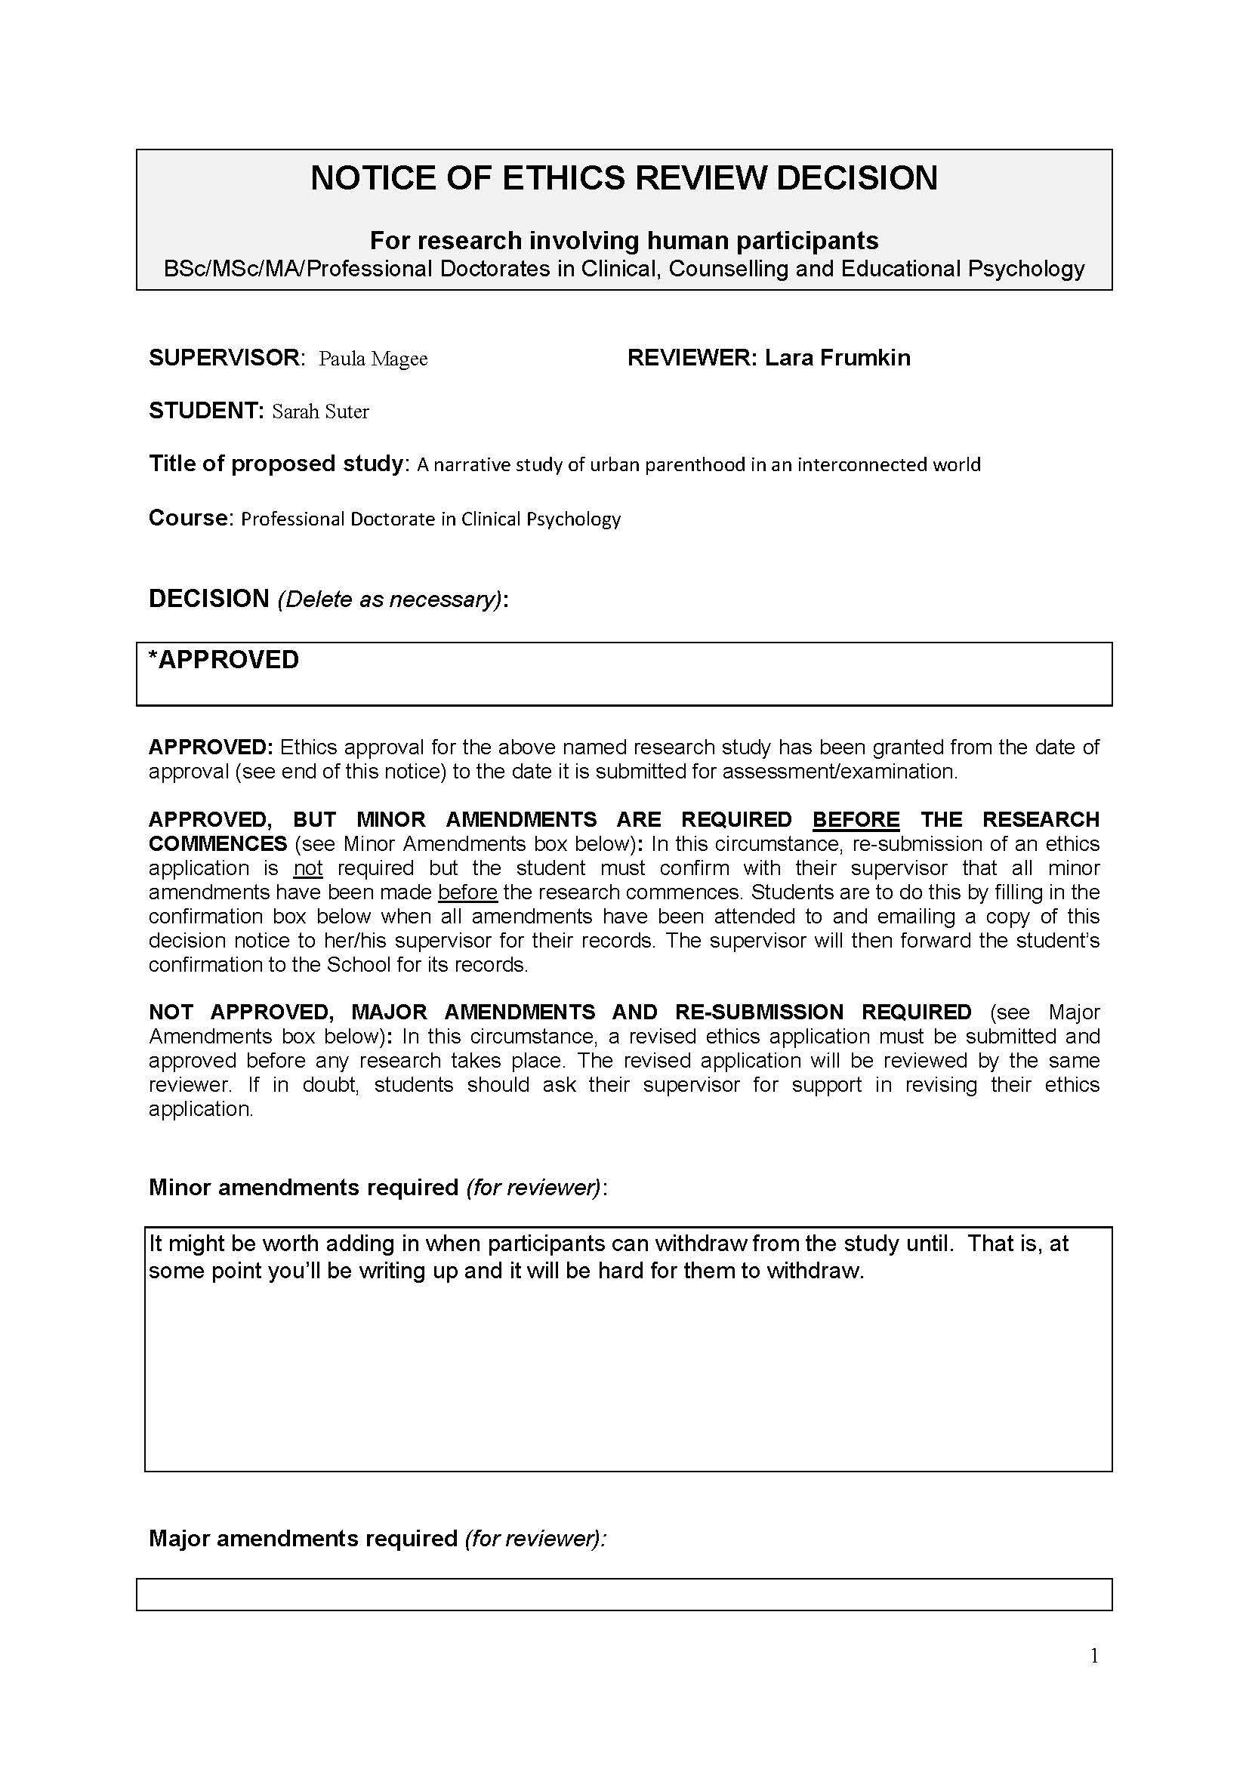

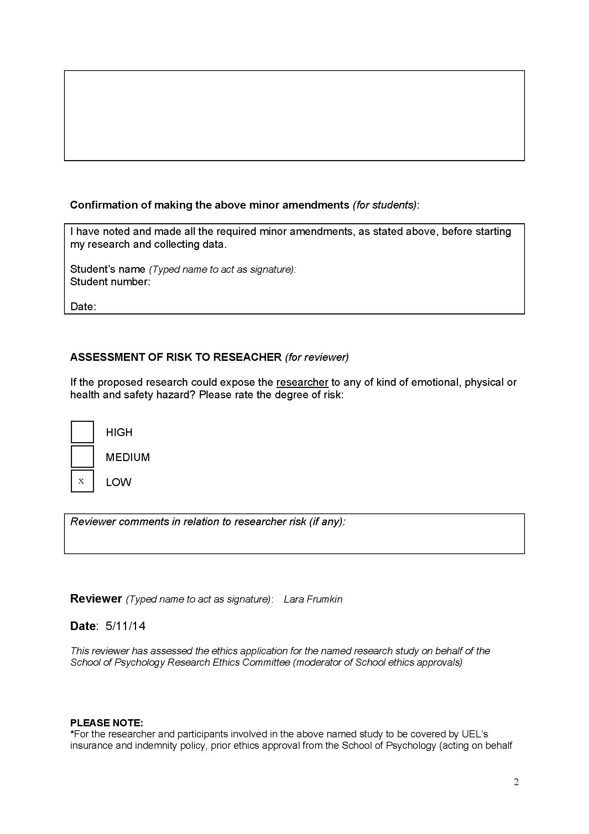

APPENDIX B – INVITATION TO PARTICIPATE

Participation Information Sheet: Page 1 of 3
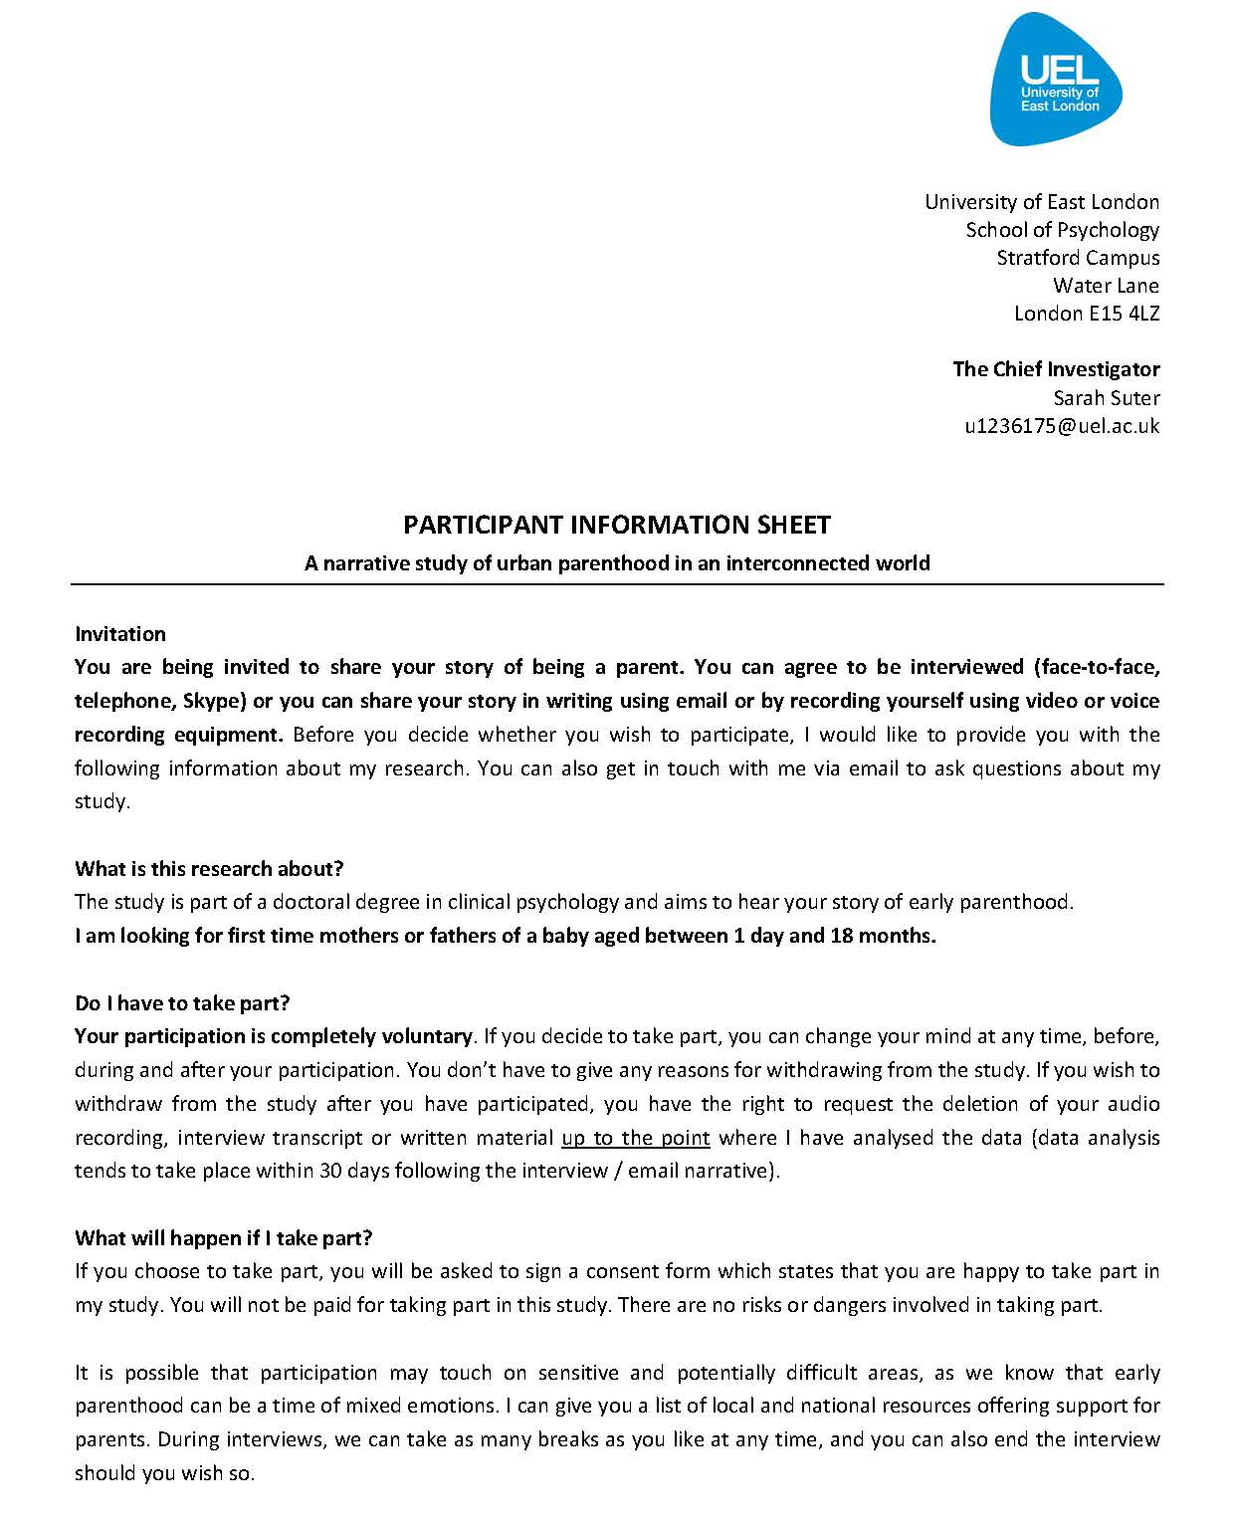

Participation Information Sheet: Page 1 of 3
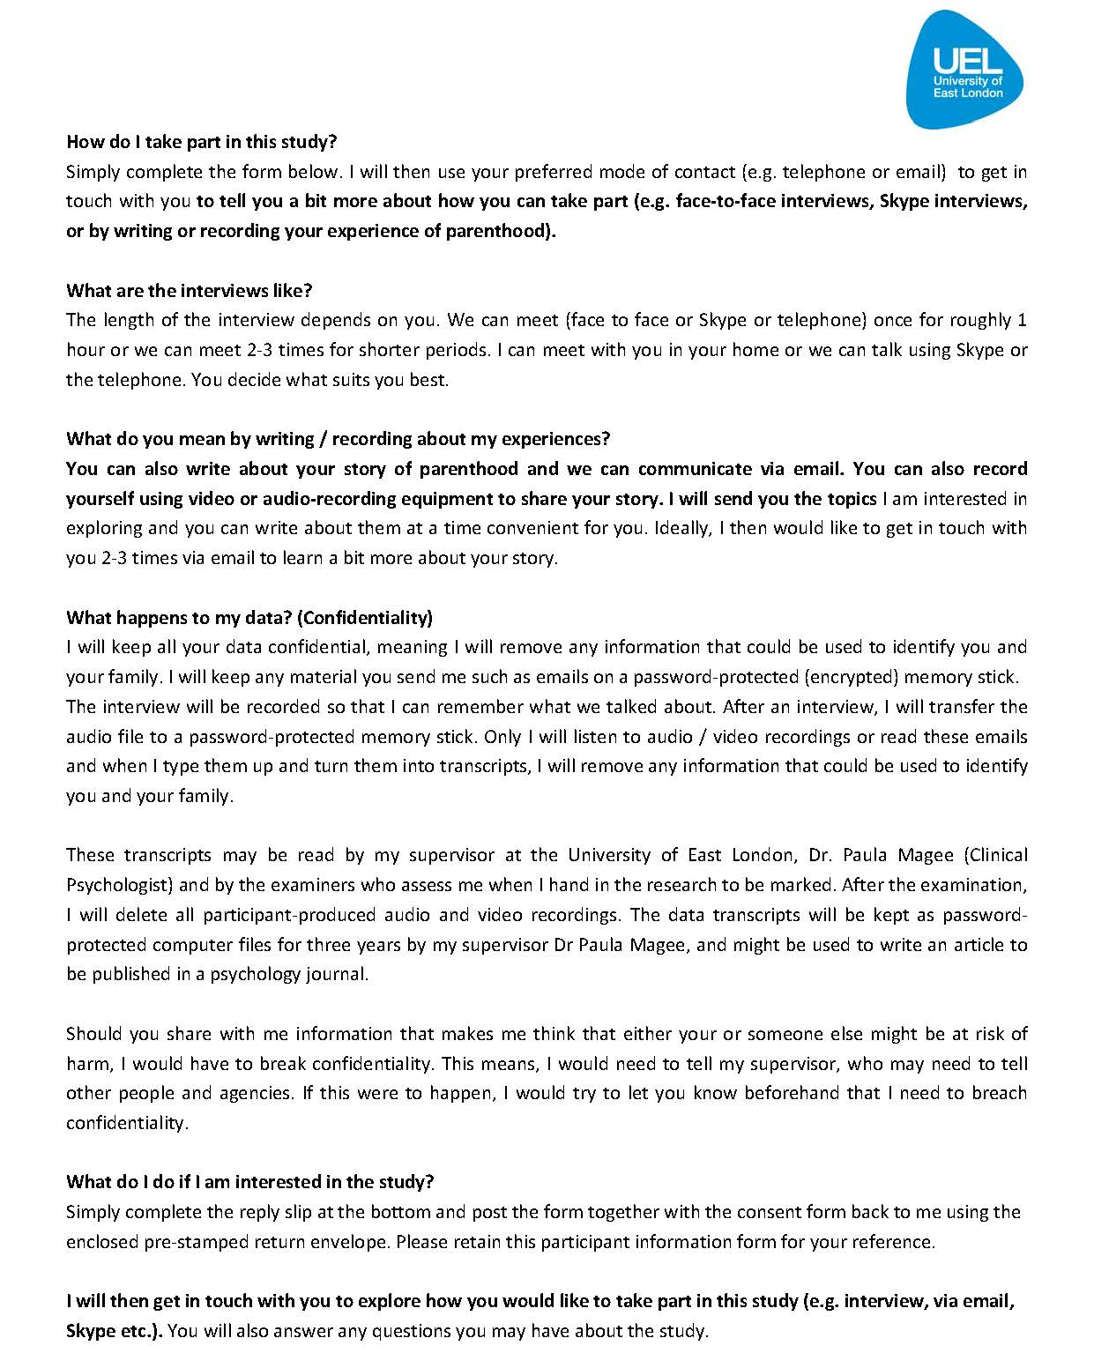

Participation Information Sheet: Page 1 of 3

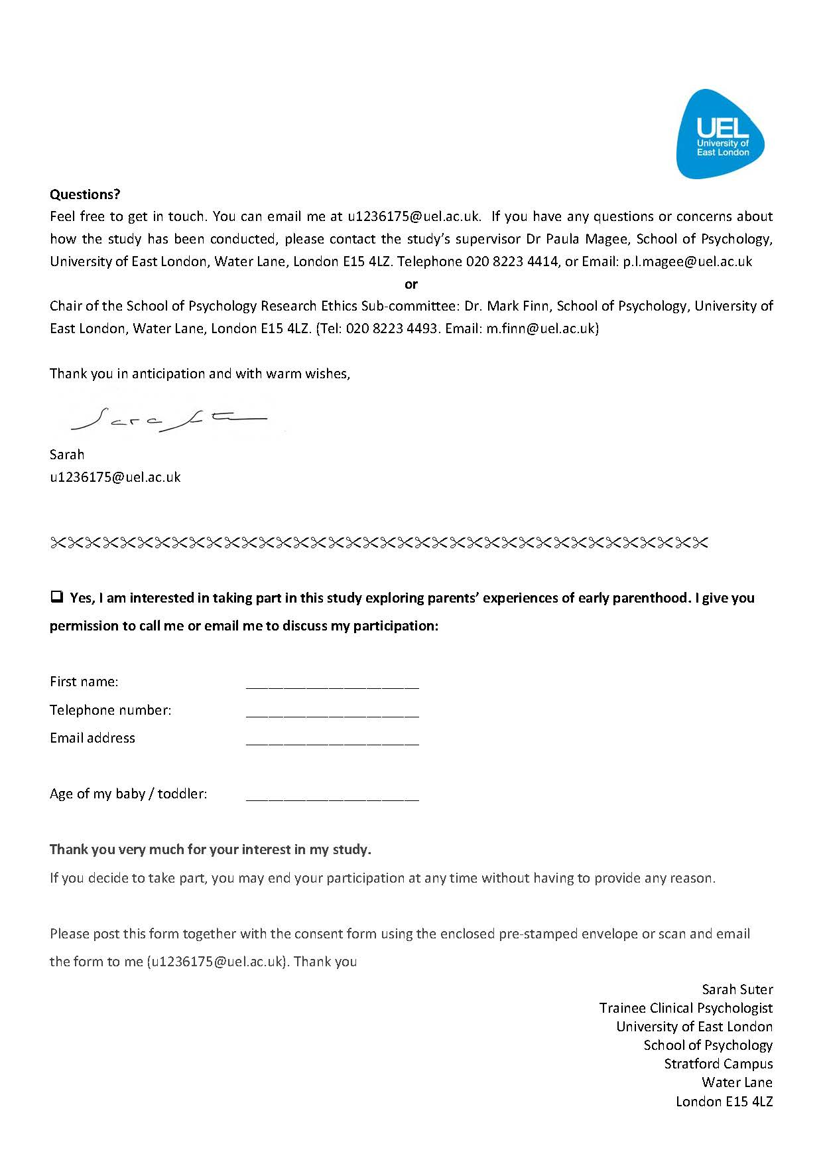

APPENDIX C – CONSENT FORM
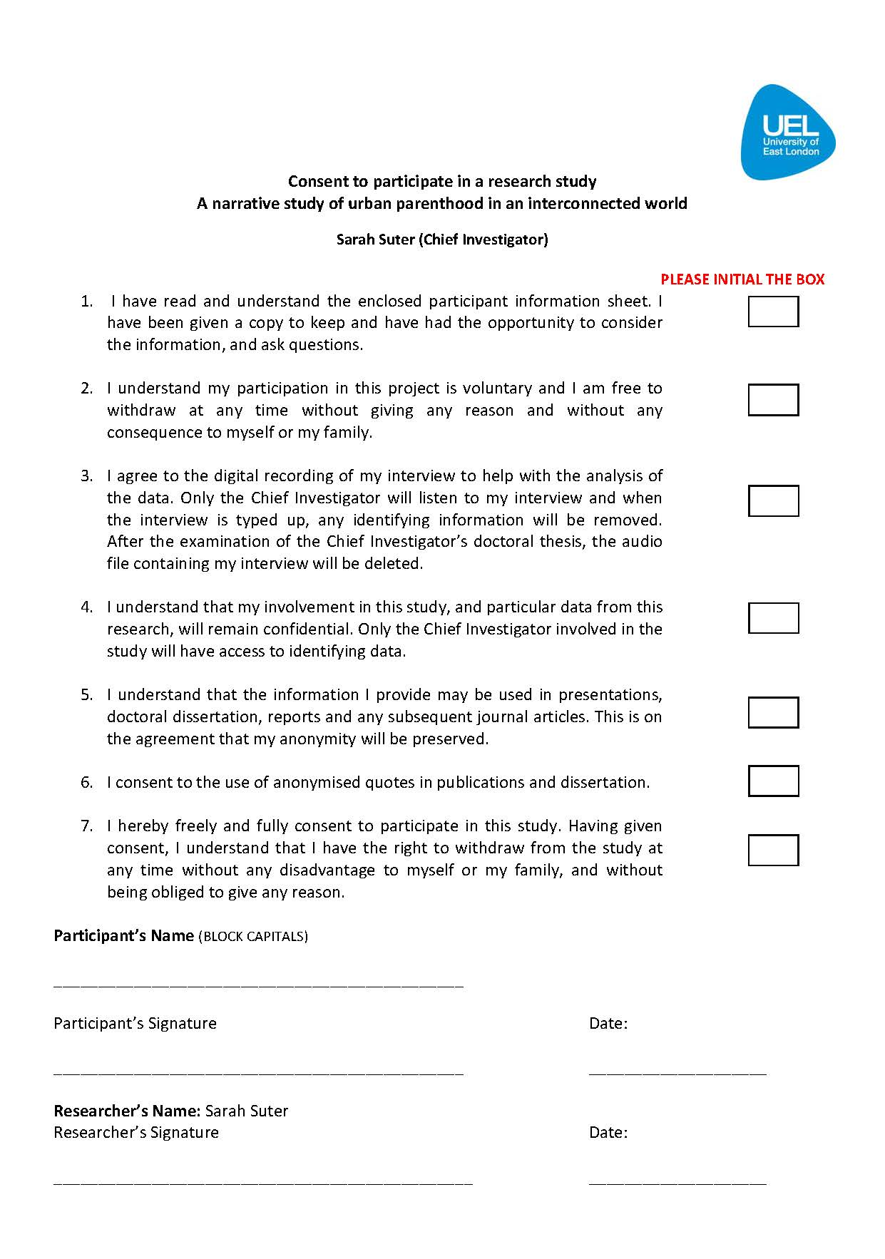

APPENDIX D – INTERVIEW SCHEDULE

“I would like to hear about your story of being a parent. You can tell me your story in any way that feels comfortable to you. There are no right or wrong answers and I am not going to ask you lots of questions because narrative research is not like that.

I guess what I am interested in is your own story of parenthood and your ideas about being a parent. I have a couple of broad questions and you are welcome to bring in your own ideas that I haven’t suggested and that are relevant to your story about parenthood.”
“What has influenced your understanding of parenting and your relationship to being a parent?

“Can you share with me how information has shaped how you feel and think about being a mother or father?”

If following the first two questions there are indications that they use the internet: “What is it like to use the internet to seek advice or google for information about life with a baby?”

If following the first three questions there are indications that they use social media: Can you tell me about how XZ insert name of social media has impacted on how you think and feel about yourself and about looking after your baby?”

Set of self prompts
Significant other people: “How did you learn about that?” “Who did you ask for support?” “Was anyone aware of how you have been feeling?” “Who were you with?”
“How long have you been feeling like that?”
“What made you feel like that?”
“Tell me about a time…”
“What kind of sense did you make of that?”
“What was that like?”
“You say ‘it was like….’ Can you say a bit more about that?

APPENDIX E – TRANSCRIPTION KEY

Symbols used:

/X/ Repetition of a word
… Pause of 3 seconds or longer
Word- Self-interruption at point of interruption
[ ] Word e.g. name of region or husband removed for confidentiality reasons
(?) indicates unclear word
<laughter> laughter
mm-hm Agreement
um filled pause
mmm Agreement, stalling for time
oh surprise
yeah informal version of yes

APPENDIX F – TRANSCRIPTION SAMPLE
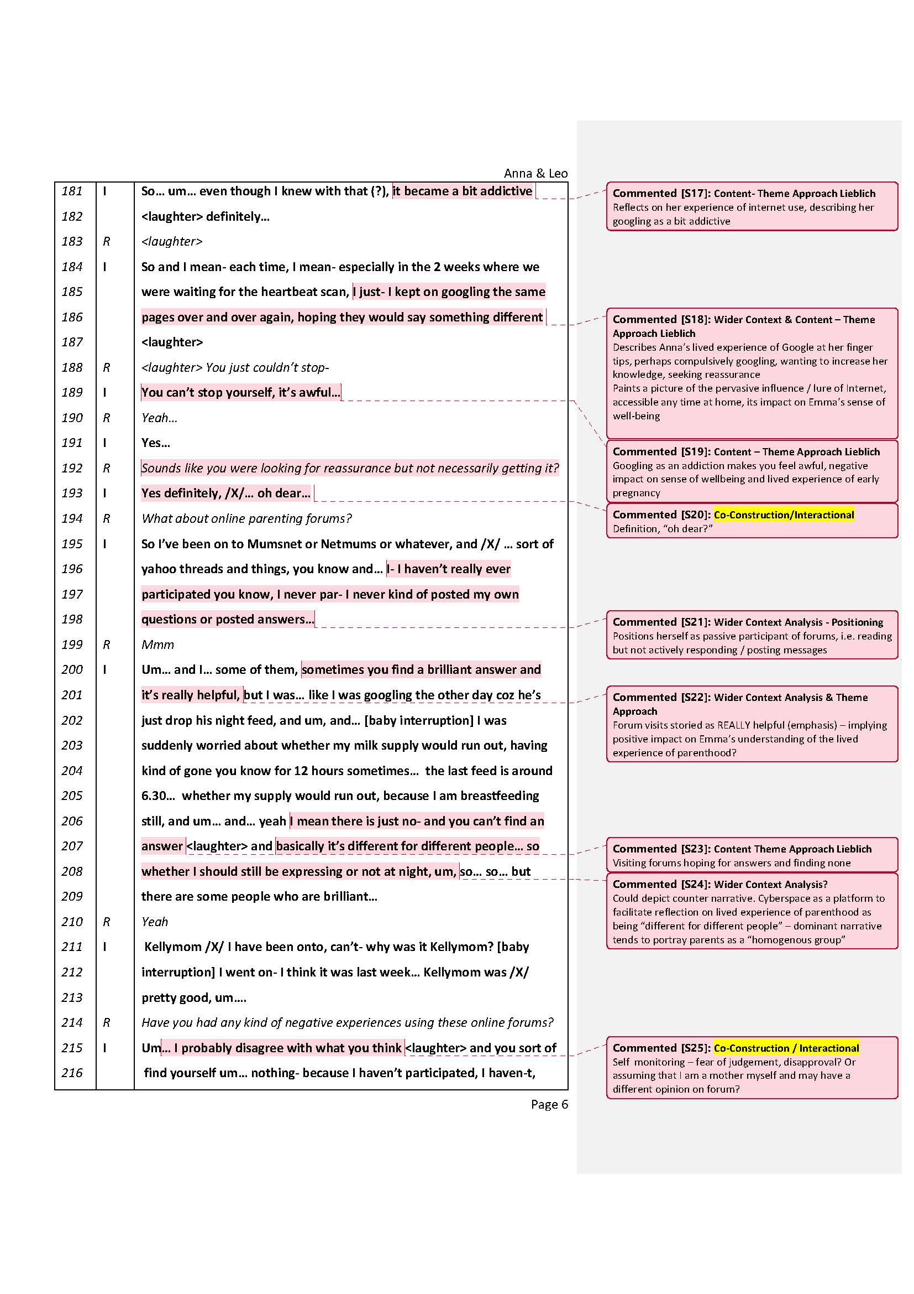

APPENDIX G – INVITATION TO FEEDBACK

Email to participant

INVITIATION TO FEEDBACK ON ANALYSIS

Dear [name],

I hope you and baby [name] are well.

Thank you for having taken part in my research study exploring your story of first-time parenthood.

I know it’s been a while since we met. I struggled getting enough participants which delayed my analysis. I have finally analysed your story and have written up my interpretation of what I think you talked about. Please find attached your copy of my interpretation.

Your feedback on my interpretation would be most welcome!

Of course you don’t have to provide any feedback.

If you like to give feedback and don’t have much time, feel free to just read the first paragraph which is a global impression of your story.

If you choose to give feedback, feel free to agree or disagree with my interpretation and if you could, try to reflect on what you were feeling when you read my interpretation.

I would also be interested in whether my interpretation reflects how you feel about your experience of parenthood and whether you feel I have missed out something really important you wrote about and that I need to add.

As you can see, I have allocated pseudonyms to yourself and baby [name]. You may not like these names. Please feel free to change them.

Whether you choose to feedback or not is entirely up to you. Your thoughts on my interpretation would be greatly valued and I thank you for considering to offer your thoughts.

I am wishing you and your family a wonderful Easter time.

With gratitude
[name of researcher]

Trainee Clinical Psychologist
University of East London

APPENDIX H – EMAIL PARTICIPATION LETTER

A narrative study of urban parenthood in an interconnected world

Dear XZ

Thank you for returning the consent form to me. You indicated that you would prefer to write about your story of parenthood.

Below, you can find a list of the topics I am interested in exploring with you. You can write about your story in any way that feels comfortable to you. You can use the format of a diary to share your story, or the format of an essay, or a blog, whatever feels right to you.

Narrative research is about storytelling. Interviews consists of 2-3 very broad questions, meaning narrative research is very different to other forms of research where often you would get asked quite a rigid set of questions. Therefore, the questions below are broad and few in number and you are welcome to bring in your own ideas and write about other topics that are relevant to your story about parenthood.

Research Questions
“What has influenced your understanding of parenting and your relationship to being a parent?

“Can you share with me how information (e.g. NCT classes, books, magazines, internet etc.) has shaped how you feel and think about becoming and being a mother?”

“What is it like to use the internet to seek advice or google for information about life with a baby?”

Can you tell me about how the internet and/or social media (e.g. facebook, mumsnet etc.) has impacted on how you think and feel about yourself and about looking after your baby?”

If you get stuck please feel free to drop me an email (u1236175@uel.ac.uk).

Once I have received your story, I might be in touch with you to invite you to explore with me some of the strands of your story. We can use email again to do so.

Thank you very much for your time.
Best wishes,

