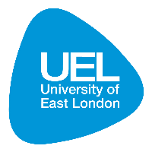
Institute for Health and Human Development
Research Impact | November 2013 | Mala Rao
Strengthening primary health systems in India
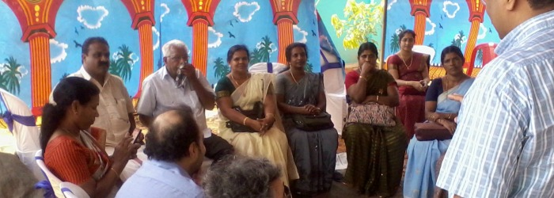
Image: Outpatients in Kerala, India

Research conducted at the University of East London (UEL) is helping to tackle health inequality in some of India’s largest states by changing the way in which health care is financed and implemented.

Studies carried out by researchers from UEL’s Institute for Health and Human Development (IHHD) is influencing the way in which life-saving treatments are funded for those living in poverty and has helped to develop new strategies for the provision of high quality comprehensive primary care across India.
Crippling out of pocket health expenditure and lack of access to health care among the poor are significant challenges to improving health in India. In the highly populated states of Andhra Pradesh (AP) and Madhya Pradesh (MP), which are home to 154 million people, many live in poverty and suffer high rates of disease and mortality.
Leading international health expert Professor Mala Rao has been evaluating health financing schemes in both of these states to assess their effectiveness and efficiency on behalf of organisations such as the UK Department for International Development (DFID), and supported by the Wellcome Trust, IDRC and the Rockefeller Foundation.
Rao’s review of the Government of Madhya Pradesh’s State Illness Assistance Fund (SIAF) revealed that the scheme was underused and inequitable. It also exposed a poor data management system and highlighted that access to treatment was complex and burdensome. The review supported the development of more efficient financial support for care of the seriously ill and led to significant improvements such as the constitution of a State Steering Group which was tasked with overseeing the restructuring of the scheme.
Government orders reflecting Rao’s recommendations have since resulted in a change to the fund management and delivery, re-negotiated costs with healthcare providers, devolved powers to authorize funds at district level, and better verification of SIAF-funded patients. Subsequently, the World Bank has acknowledged ‘substantial progress’ in the management of the scheme, laying the foundations for the eventual development of a single comprehensive health delivery system. For citizens, the number of annual total approvals for treatment has risen more than threefold, and a new feedback system is now being used to support improved monitoring, evaluation and selection of healthcare providers.
A separate assessment of the Government of Andhra Pradesh’s (GoAP) Rajiv Aarogyasri Community Health Insurance scheme indicated a need for hospital-based healthcare schemes to be built on a strong platform of primary (family) care. The assessment also informed the development of a similar scheme in Maharashtra, the 'control' state in the research.
Findings from both assessments supported the promotion of comprehensive primary care as the most effective means to reduce healthcare costs and improve health literacy, helping people to better understand their health care entitlements and navigate complex care pathways.
In recognition of her work, Rao was appointed by the Chair of the Health Workstream of the UK-India CEO Forum as the Public Health academic expert to lead the development of a White Paper exploring the benefits and practicalities of a primary care partnership between India and the UK. The paper reached a very wide global audience of health policy leaders when it was published in the British Medical Journal in May 2012. In India, the paper, and its discussion at a UK-India workshop in 2012, influenced the Government of India to encourage states to plan primary care pilots which would inform the development of comprehensive primary care, as a crucial platform for affordable universal health care.
In Kerala, Rao has helped to develop proposals for piloting a new model of care across three primary health centres. In May 2013, the Government of India approved funding for the Government of Kerala to implement the proposal, which if successful, will be replicated across the country to reduce out-of-pocket expenses for outpatient care, provide better and more comprehensive and systematic community based care for people with a wide range of medical conditions, and reduce the need for secondary care.

About the researcher
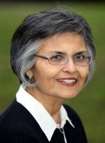
Mala Rao is Professor of International Health at UEL. She was Honorary Public Health Adviser to the Administrative Staff College of India, Hyderabad during 2011-2013 and the lead technical adviser to DFID's team in Madhya Pradesh, India. She was the founding Director of the first Indian Institute of Public Health established by the Public Health Foundation of India. In 2012, Mala was awarded an O.B.E. in the Queen's New Year's Honours List for services to public health in the UK and overseas. Her 30 years work in policy, practice and research work has had major impact in both the UK and India.
http://www.uel.ac.uk/hsb/staff/malarao/

Acknowledgments
The GoAP/SIAF research was funded by the International Development Research Centre, Canada; the Wellcome Trust; UK Department for International Development; and the Rockefeller Trust.
As well as Mala Rao, Gopalakrishnan Netuveli and Adrian Renton from IHHD at UEL, the project involved collaborators from:
- Administrative Staff College of India, Hyderabad;
- ACCESS Health International;
- SughaVazhvu Healthcare, Thanjavur, India;
- Indian School of Business, Hyderabad;
- World Bank, Development Research Group (DECRG)

References

Katyal, A., Singh, P. V., Samarth, A., Bergkvist, S. and Rao, M. (2013) 'Using the Indian National Sample Survey data in public health research', National Medical Journal of India, 26(5), pp. 291-294.

Narasimhan, H., Boddu, V., Singh, P. V., Katyal, A., Bergkvist, S. and Rao, M. (2014) 'The Best Laid Plans: Access to the Rajiv Aarogyasri community health insurance scheme of Andhra Pradesh', Health, Culture and Society, 6(1), pp. 85-97. doi: 10.5195/hcs.2014.163.

Rao, M. and Mant, D. (2012) 'Strengthening primary healthcare in India: white paper on opportunities for partnership', BMJ, 344, p. e3151. doi: 10.1136/bmj.e3151.

Rao, M., Ramachandra, S. S., Bandyopadhyay, S., Chandran, A., Shidhaye, R., Tamisettynarayana, S., . . . Bangdiwala, S. I. (2011) 'Addressing healthcare needs of people living below the poverty line: A rapid assessment of the Andhra Pradesh health insurance scheme', National Medical Journal of India, 24(6), pp. 335-341.

About the Institute for Health and Human Development
The Institute of Health and Human Development (IHHD) was set up in 2006 as a centre for UEL’s research activity on health and wellbeing and their social, economic and cultural determinants, and on innovation in services and interventions for health improvement. Our mission is to provide high quality theoretical and applied research, consultancy, knowledge transfer and service innovation through the development and use of new and creative approaches. We aim to deliver world-leading research and development which informs policy, services and interventions that promote people’s health and wellbeing locally, nationally and internationally.

Please cite this work as Rao, M (2013) Influencing health system strengthening in India. London: University of East London, Institute for Health and Human Development. Available at: XXXXXXXXXXXXX.
This work is licensed under a Creative Commons Attribution-NoDerivatives 4.0 International License

