**SHALLOW WATER HYDRODYNAMIC INVESTIGATION OF LOCAL SCOUR OVER SMOOTH  
AND ROUGH SEDIMENT BEDS**

Mantripathi P.R. Jayaratne1 and Mohammad S. Salim2

**Abstract**: Over the recent years, a number of studies in nearshore sediment transport have been researched but a greater understanding of soil-hydrodynamic interaction has still paramount importance. A series of 2D small-scale physical experiments were performed at the University of East London (UEL) hydraulics laboratory to investigate the influence of flow and sediment properties on soil scour. Measured sediment and flow data were used to develop a simple empirical relationship for scour rate of each crescent zone with the help of dimensional analysis and best-fit technique under smooth bed condition. The proposed paper discusses the extended investigation on soil-hydrodynamic behaviour by increasing the mobile bed roughness to greater values used in earlier experiments by the authors to better understand sediment particle sorting mechanism and their spreading characteristics during scour. Eventually, the proposed experimental work will lead to the comparison, calibration and development of predictive curves of scour rate for different soils of each developing crescent zones.

***Keywords****: soil-hydrodynamic interaction; local scour; physical experiments; crescent zones; empirical relationship; dimensional analysis and best-fit technique.*

## INTRODUCTION

A rise in sea level produces major geophysical impacts in coastal areas such as scour of shorelines (Bijlsma et al., 1996). In 2006, several houses had been lost to the sea and many of those remaining were in a precarious position in Happisburgh, Norfolk, UK. Some of the 1950s sea defences, built to protect the village from further scour, were seen along the Happisburgh beach. The soft sedimentary rock of the cliffs was subjected to the fastest coastal scour in Norfolk ([http://www.happisburgh.org.uk](http://www.happisburgh.org.uk/), 2006).

Studies on sediment transport are currently one of the main issues in the marine coastal environment. Most research studies in scour rate prediction are based on dimensional analysis using small-scale laboratory experiments with non-cohesive and cohesive uniform bed material under steady-flow conditions (Ansari et al., 2002). A number of empirical models were proposed to estimate scour rate from the laboratory experiments such as du Boys (1879), Einstein (1950) and Vanoni (1975). An influential work has been done by van Rijn (1984a,b,c) but in most of the investigations, owing to scale effect, laboratory settings oversimplified or ignored the complexities of natural streams. The majority of researches were conducted with uniform flow, a constant depth and non-cohesive bed materials, thus the scour-rate equations based on laboratory flume data were found to overestimate scour rate measured at bridge piers (Mueller and Wagner, 2005). Garcia and Parker (1991) reviewed and compared previous studies of sediment entrainment and provided improved, field data-based formulations to handle sediment mixtures. Garcia (1999) also presented an overview of non-cohesive sediment transport, both as bed-load and suspended load.

Lecturer in Civil Engineering, School of Architecture, Computing & Engineering, University of East London, Docklands Campus, 4-6 University Way, London E16 2RD, UK, Email: [r.jayaratne@uel.ac.uk](mailto:r.jayaratne@uel.ac.uk)

*2* PhD Student in Coastal Engineering, School of Environmental Systems Engineering, The University of Western Australia, 35 Stirling Highway, Crawley, WA 6009, Australia. Email: [21101508@student.uwa.edu.au](mailto:21101508@student.uwa.edu.au)

Formerly, Lecturer, Legenda Education Group, Linton University College, 71700, Mantin, Negeri, Sembilan, Malaysia

In order to accurately predict the sediment transport it is necessary to measure sediment scour rate both quantitatively and qualitatively. These rates depend not only on hydrodynamic conditions but also on the bulk properties of the sediment. In a sediment bed, these properties can cause changes in the scour rate by several orders of magnitude. The purpose of much of our recent laboratory work is to measure and predict the effects of bulk properties on scour rates. For this reason, laboratory experiments with well-defined sediment properties are essential. A unique apparatus, called ‘Soil Protrusion Apparatus’ (SPA), has been developed at the University of East London hydraulics laboratory which is useful for this type of laboratory experiments, as well as for the determination of scour rates. In the laboratory, SPA has been used to investigate the effects of various bulk properties on scour rates but the emphasis has been on fine-grained, non-cohesive sediments.

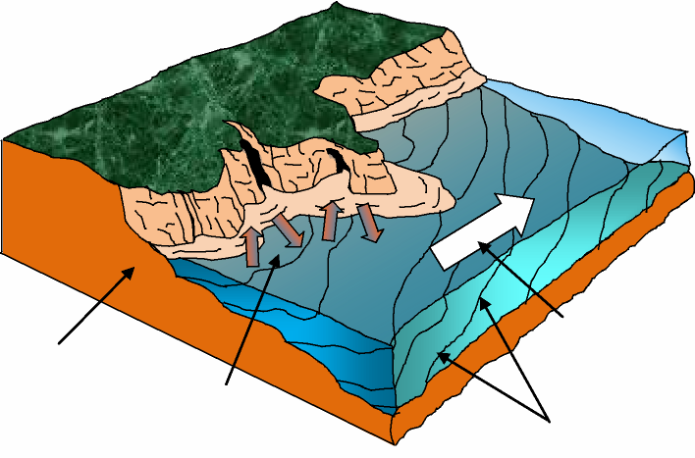

In this context, the physics and relevant formulae for scour of the bottom bed without any obstacles are outlined based on previous research work (Jayaratne et al., 2010; Salim and Jayaratne, 2011) to understand the behaviour of scour in natural streams. It is noteworthy to say that, to analyse and explain various interesting phenomena involved in the active layer of soil, experiments were initially conducted in smooth bed for proper visualisation of the interactive incidences which accordingly conducted into rough sediment bed for simulating the field condition. The relative importance and quantitative overview of the effects of bulk properties on scour rates are also discussed. The ultimate objective is to be able to predict scour rates of each developing crescent zones based on the knowledge of bulk properties. For this purpose, applying digital photographic-based techniques, a physical model which adequately represents the micro-scale morphological characteristics of the sediment scour was employed. Such high-resolution and fully dimensional models of channel topography offer real potential to develop new ways of characterising sediment transport models and understanding hydrodynamic mechanics. Finally, an empirical equation showing a relationship between dimensionless average grain diameter and spreading area with scour rate of each crescent zone per unit width for both smooth and rough bed is presented which could be used with further modification to predict the scour rates in field environment.

Scour  
bank

Longshore  
currents

Direction of

sediment movement Developing crescents

**Fig. 1. Typical features of coastal scour process.**

## METHODOLOGY

A series of laboratory tests to determine scour rates as a function of bulk properties were performed by means of SPA as shown in Fig. 2. The Ahlborn sediment mobile bed tank was purposely re-fabricated in order to install a SPA that takes 100.0mm diameter sediment core samples (Fig. 2). The apparatus was placed at a distance of 1.5m from the upstream end of the tank, and along its centre line. The sample tube was fitted to be pushed at a preset protrusion (z). Tests were carried out for average grain size diameters, d50=0.15, 0.26, 0.30 and 0.75mm samples under wet conditions on rough beds. Experiments were repeated at least 3 times for each test condition to ascertain reproducibility and representability of observations. Longitudinal and lateral scour spreading of the sediment plumes were recorded via a high definition Sony digital video camera (1920×1080, 24 frames per second) and measured using AUTOCAD 2010 software as shown in Fig. 2. The flow rate was adjusted as desired through a control of the voltage input into the pump. Propeller type current meters (0.06- 1.5m/s) were used in the upstream and downstream of the tank to monitor the uniformity of the flow and its measurements. The extended description of the SPA can be found in Salim and Jayaratne (2011).

## EXPERIMENTAL PROCEDURE

During the experiments several steps were followed. First of all, flow discharge was calibrated according to the test conditions ranging from 1.65-3.57l/s and soil samples were placed in the SPA tube. SPA dial was rotated to set the desired soil protrusion maintaining the dial gauge reading according to the test conditions where, 1 complete cycle=1.0mm thickness. The mounted digital video camera was turned on to record each experiment until the sample achieved equilibrium stage and digital stop watch was used to record the time. After that the pump was started and the scouring of soil sample was observed carefully. Velocity measurements were taken in the marked upstream and downstream points on the tank bed and later converted those values using the Nixon scale. Using the digital still camera soil sample spreading patterns was captured. A metre-ruler was used to take the longitudinal and lateral spreading length of the sample. Using a steel blade, scoured sample was separated maintaining a tangent all the time and finally, separated sample were collected in a paper envelop. The all the steps mentioned above were repeated for the next test run. At the end of all experiments recorded video clips were downloaded using SONY Picture Motion Browser software in order to save each experimental clip according to its reference number.

## PREPARATION OF THE FREEZE SEDIMENT BED (ROUGH BED)

In order to physically prevent migration of bed forms and ‘freeze’ the geometry of the loose channel for better comparison of smooth and rough bed conditions, a low cost technique as discussed in Benson et al. (2001) was applied during the experiments. Table 1 shows the quantities of chemicals per coat used for immobilizing the bed. Two separate sprayers was used in applying the chemicals, one for the sodium silicate solution (Na2SiO3) and one for the sodium bicarbonate solution (NaHCO3).

The tank was drained in order to provide natural bed geometry before freezing. After 12-24 hours, while the sediment remained visibly slightly damp, the first coat was applied over the whole area. Sodium silicate and water was mixed in the sprayer itself, but the sodium bicarbonate solution was made separately beforehand in order to prevent un-dissolved lumps entering the sprayer. Care was taken to achieve a fine spray and keep the spray moving across the bed so as not to disturb the loose sand, especially on the first coat. It was essentially monitored that the two mixtures would be applied directly to the sand with separate sprayers to avoid mixing the chemicals until they are actually in the sediment as described in Benson et al. (2001).

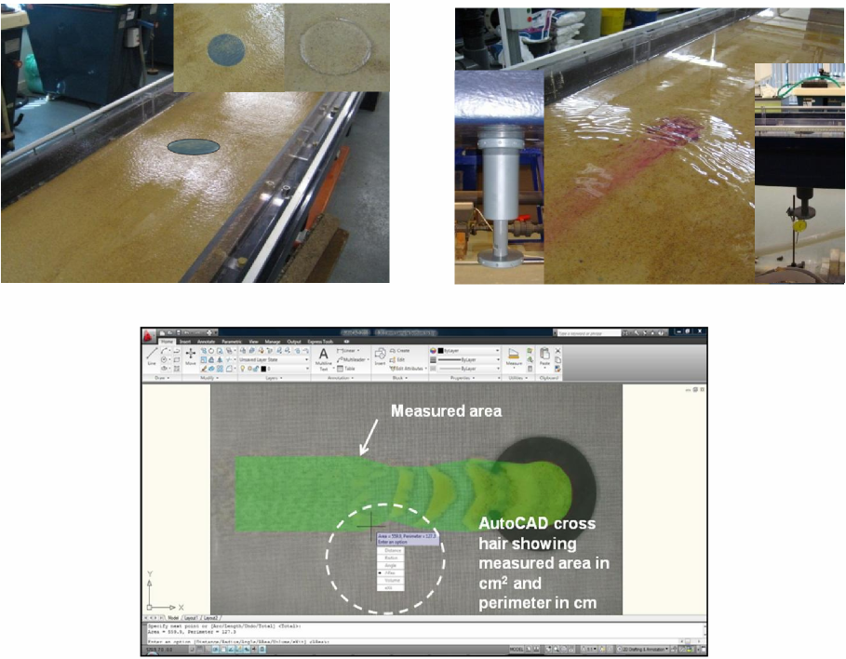

**(d)**

**(g)**

**(f)**

**(e)**

**(c)**

**(b)**

**(a)**

**Fig. 2. (a) Modified Ahlborn sediment bed tank, (b) Ø100.0mm Soil protrusion tube, (c) 5.0mm  
thick protrusion in the soil sample tube, (d,e) Soil Protrusion Apparatus (SPA) with a dial gauge  
(0.25mm precision), (f) Unidirectional flow visualised after sprinkling Potassium Permanganate  
(KMnO4), (g) AUTOCAD measurement of spreading length and area.**

**Table 1. Relative quantities of chemicals used for bed freezing, sufficient to cover 2.4m2 (4.0×0.6)  
with one coating.**

|  |  |  |
| --- | --- | --- |
|  | **Sodium silicate mixture (Na2SiO3)** | **Sodium bicarbonate mixture (NaHCO3)** |
| Volume of chemical (l) | 0.33 | - |
| Mass of chemical (g) | 48.0 | 12.0 |
| Volume of water (l) | 0.27 | 0.21 |
| Approx. total volume (l) | 0.60 | 0.21 |

## PREVIOUS INVESTIGATION

## Physical Model

## In previous laboratory experiments, scour rates for smooth and rough bed conditions were measured with SPA by changing the hydraulic (water flow rate, upstream and downstream velocities, water depth) and sediment parameters (average grain diameters, soil protrusion, specific gravity, uniformity coefficient). Model parameters were calibrated using measured hydrodynamic data (Jayaratne et al., 2010). Sediment was injected into steady flow over an impermeable, smooth plastic bed, at a rate that balanced the flow condition. Transport capacity and hydraulic measurements were obtained with four test materials covering a range of sizes (d50=0.15, 0.26, 0.30 and 0.75mm), density and a range of flow rates (Q=1.65l/s to 3.57l/s) with a constant water depth of 2.2-3.2cm. Hydraulic measurements obtained with flows with Reynolds numbers in the turbulent flow regime indicated that the depth of water was raised into the moving sediment layer, such that it exceeded the predictions of the velocity required to start scouring. The transport component due to flow processes depends on discharge and material properties. Particle size was found to be statistically significant during scour (Salim and Jayaratne, 2011). It was observed that, for the same flow conditions, different soils give different long term equilibrium deposition patterns due to the grain size distribution (Jayaratne et al., 2010).



(a) d50=0.15mm (b) d50=0.26mm (c) d50=0.30mm (d) d50=0.75mm

at t=21.0s at t=23.0s at t=25.0s at t=27.0s

**Fig. 3. Equilibrium stage of 4 different soil samples with soil protrusion, z=5.0mm and water  
discharge, Q=3.57l/s.**

Figure 3 shows that for the same experimental conditions, equilibrium settling patterns of soil samples in the downstream section of the tank form a specific shape named ‘crescent zone’ as described in Jayaratne et al. (2010). According to Fig. 3a, crescents are dense and smaller in size and they are connected to each other. In Fig. 3b, crescents are less dense than those shown in Fig. 3c. In Fig. 3d, the soil samples loose its characteristic behaviour of forming crescents due to increment in particle d50 size (Salim and Jayaratne, 2011). A time dependent analysis is described in Salim and Jayaratne (2011) showed that during the scour process, crescent zones maintain a sequential order (see Fig. 4). The reason for this is related to the small eddies developed by the crescents for each zone. Sediment particles in each crescent zone attempt to settle down as groups of same grain sizes (d50). Extended investigation will be carried out on rough sediment bed for better comparison of the analysis in future.

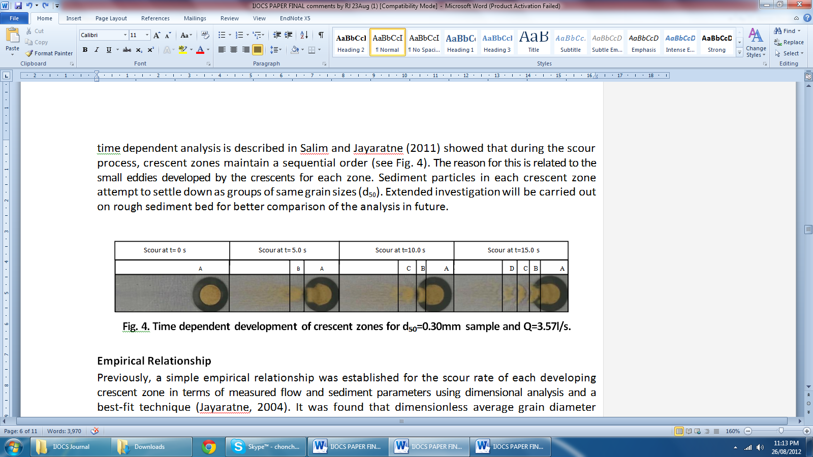

**Fig. 4. Time dependent development of crescent zones for d50=0.30mm sample and Q=3.57l/s.**

**Empirical Relationship**

Previously, a simple empirical relationship was established for the scour rate of each developing crescent zone in terms of measured flow and sediment parameters using dimensional analysis and a best-fit technique (Jayaratne, 2004). It was found that dimensionless average grain diameter decreases incrementally with the Reynolds number. Furthermore, for the smooth bed condition, a dimensionless parameter for the spreading area and scour rate of each developing crescent zones per unit width were found to be directly proportional to the Reynolds number. This is because, under the same flow conditions, the maximum extent of crescent zone varies with the gradation of soil sample. An empirical relationship for volumatric total sediment transport rate was developed using the dimensionless parameters (Eq. 1 & 2).

 [1]

where: *qcs* = Volumetric total sediment transport rate of each crescent zone (m2/s/m)

*d*50*,sample* = Median particle size of soil sample (m)

*d*50,crescent zone = Median particle size of each crescent zone (m)

*Acrescent zone* = Area of each crescent zone (m2)

*Asample*  = Area of soil sample in the SPA tube core (m2)

Using the best-fit technique, a relationship for total scour rate (qts) was obtained as;



[2]

where *k* is a numerical constant (=1.36) with dimensions m2/s/m (Salim and Jayaratne, 2011).

**NEW INVESTIGATIONS**

Coastal morphodynamics is one of sensitive issues to better understand the sediment scour in which scour takes place for the consequence of fluvial hydrodynamic processes. Therefore, prediction of the subsequent stream degradation into its own deposit requires knowledge of the spatial structure of the grain size variation of the deposit (Viparelli et al., 2010). A complete set of experiments for d50=0.15, 0.26 and 0.30mm sediment samples were performed to compare and further investigations of soil-water interaction under rough bed conditions.

**Effect of Spreading Length and Area on Smooth and Rough Bed**

The significance of hydrodynamic interaction in terms of stream morphodynamics requires a sediment transport research with the detailed specification of various influential parameters. This requirement has been emphasised by recent interest in the prediction of spreading length and area sedimentation through process-based physical simulation models which are sensitive to the description of the topographic hydrodynamic interaction during sediment scour. The methodological importance of topographic monitoring extends beyond model parameterisation and topographic surfaces are now also increasingly used to define deterministic and stochastic validation criteria for scour rate prediction models of sediment transport evolution (Hancock and Willgoose, 2001).

(a)

(b)

D50=0.30mm, wet D50=0.26mm, wet

D50=0.15mm, wet

D50=0.30mm, wet D50=0.26mm, wet

D50=0.15mm, wet

Figures 5a and 5b show the longitudinal and lateral spreading length ratio changes due to different discharge conditions where scour spreading length for small particle size 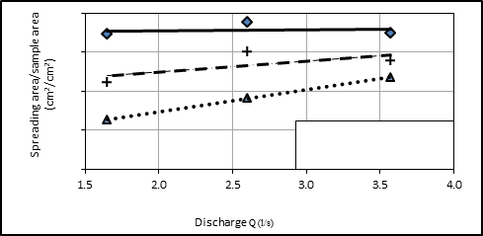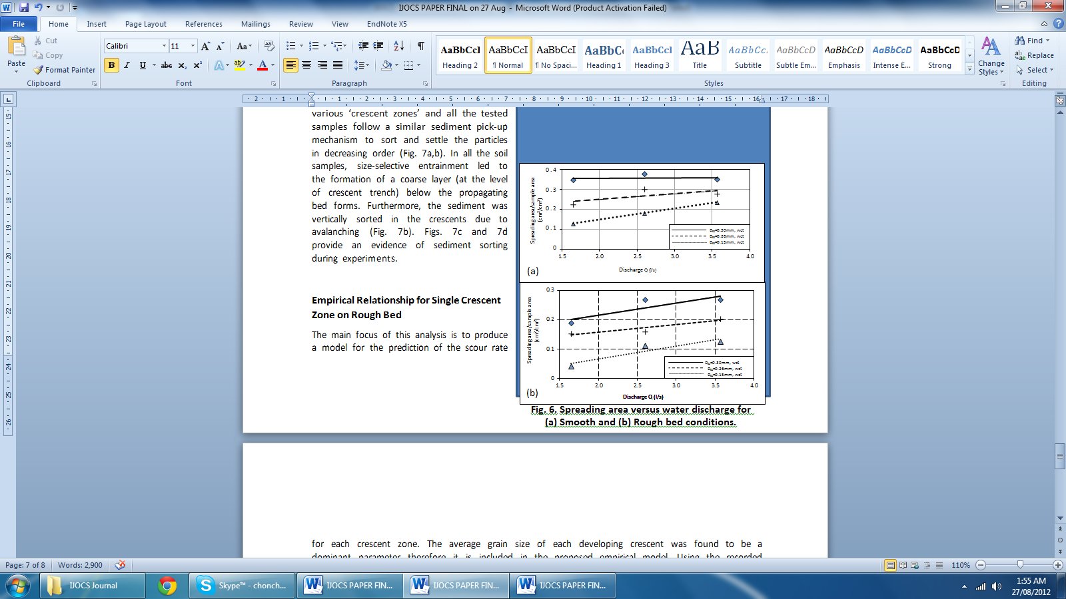increases with discharge for both smooth and rough bed conditions respectively. Based on the understanding of sediment behaviour in hydrodynamic scour in terms of spreading area versus water discharge curves as shown in Fig. 6a and 6b, for different sediment sizes the ratio of spreading area increases with the increment of water discharge. Spreading area 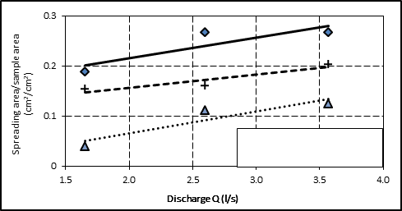also increases with the increment of average grain size. The higher the grain size is the higher the spreading area. Moreover, the spreading area is less in rough bed that of smooth bed condition.

**Fig. 5. Spreading lengths versus water discharge (a) Smooth bed and (b) Rough bed condition**

0.4

0.3

0.2

0.1

0

D50=0.30mm, wet D50=0.26mm, wet

D50=0.15mm, wet

(a)

D50=0.30mm, wet D50=0.26mm, wet

D50=0.15mm, wet

**Physical Modelling of Sediment Sorting**

(b)

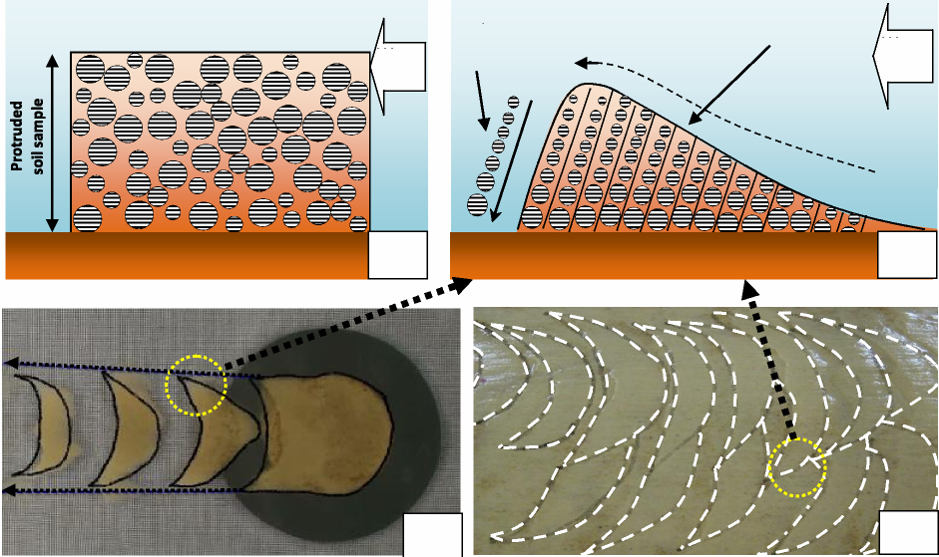In this investigation, the experimental design has been often identified as the primary control of the observed pattern of sediment transport. Ashmore and Church (1998) even described the investigation of morphology as a new paradigm in sediment transport research. However, perhaps the most profound methodological shift in the treatment of topography is the growing recognition that fluvial process scour rates and behaviour may be robustly inferred indirectly, from an examination of the changing pattern of channel morphology over time.

**Fig. 6. Spreading area versus water discharge for (a) Smooth and (b) Rough bed conditions.**

Water  
flow

Water  
flow

(b)

(a)

Sediment  
sorting

Crescent trench

(d)

(c)

**Fig. 7. (a) Schematic diagram of protruded soil sample, (b) Schematic diagram of sediment  
sorting process in a single crescent trench, (c) Particle sorting in smooth bed and (d) Particle  
sorting in rough bed condition**

Based on this concept, sediment particle sorting mechanism and characteristics were investigated to define the particle size as prominent parameter for the development of an empirical relationship. With different water flow rates it forms various ‘crescent zones’ and all the tested samples follow a similar sediment pick-up mechanism to sort and settle the particles in decreasing order (Fig. 7a,b). In all the soil samples, size-selective entrainment led to the formation of a coarse layer (at the level of crescent trench) below the propagating bed forms. Furthermore, the sediment was vertically sorted in the crescents due to avalanching (Fig. 7b). Figs. 7c and 7d provide an evidence of sediment sorting during experiments.

(d)

**Empirical Relationship for Single Crescent Zone on Rough Bed**

The main focus of this analysis is to produce a model for the prediction of the scour rate for each crescent zone. The average grain size of each developing crescent was found to be a dominant parameter therefore it is included in the proposed empirical model. Using the recorded video footage of each experiment, it was also found that spreading area of scoured soil plays a vital role for the development of crescent zones.

Data analysis process for the rough bed condition presented and compared in this paper is similar to the case of smooth bed condition explained in Salim and Jayaratne (2011).

|  |  |
| --- | --- |
| qts | 4 3 2 1 0 |

|  |  |
| --- | --- |
| R2 = 0.9193 | Description: _Pic88 |

Fig. 8 illustrates the relationship between the scour rate of each measured crest zone with average grain diameter and crescent area. It is evident from Fig. 8 that, predictions from the dimensional analysis using best-fit technique for rough bed condition is satisfactory though few records are remarkably exceeding limits and scattering, where an over estimation from the regression model is quite obvious at small scour rates. Performing the similar steps as followed in smooth bed condition, the original equation for total scour rate (*qts*) can be obtained as shown in Eq. 3 which represents improved understanding of predicting scour rates of each developing crescent zones based on the knowledge of bulk properties.

0 1 2 3 4

(d50 sample /d50 crescent zone)×(Acrescent zone/ A sample)

**Fig. 8. Relationship of dimensionless erosion rate  
with dimensionaless average grain diameter and  
spreading area**



[3]

where:

*qts* = Volumetric total sediment transport rate of each crescent zone (m2/s/m)

*d*50,*sample* = Median particle size of soil sample (m)

*d*50,crescent zone = Median particle size of each crescent zone (m)

*A crescent zone* = Area of each crescent zone (m2)

*A sample* = Area of soil sample in the SPA tube core (m2)

*k* = 2.44 m2/s/m

**CONCLUSIONS**

The present work leads to the development of laboratory and empirical procedures for estimating the effects of bulk properties on sediment scour rates. Soil samples that have been tested by the authors can be described by Eqs. [2] and [3], i.e. scour rates are relatively simple and unique function of governing sediment diameter and spreading area parameters. The parameters that appear in the proposed empirical models are generally functions of the mean particle size and spreading area. In this study non-cohesive soil samples were used however, cohesive soil samples are also required to test for further understanding of physical processes. The work reviewed in this paper is an initial step towards the prediction of scour rates from bulk properties. However, despite this, our knowledge at present is sufficient to qualitatively interpret scour rate properties and, more quantitatively, to interpolate scour rates of soil samples where the bulk properties as average grain size and spreading area is known.

**ACKNOWLEDGEMENTS**

The authors wish to thank the financial support provided by the Graduate School of University of East London (UEL) to carry out the laboratory experiments in line with the extensive research project “Mathematical and Physical Modelling of Hydrodynamic Erosion of Soils (HES)” set up under “UEL Promising Researcher Fellowship (2009/10)”. The Secretariat of PIANC-COPEDEC VIII is also greatly acknowledged for the partial financial support given to participate and present the previous version of this paper at the 8th International Conference on Coastal and Port Engineering in Developing Countries, IIT Madras, Chennai, India from 20-24 February 2012.

**REFERENCES**

Ansari, S.A., Kothyari, U.C., Ranga Raju, K.G. (2002) “Influence of cohesion on scour around bridge piers”, Journal of Hydraulic Research*,* 40 (6), pp. 1177–1185.

Ashmore, P.E. and Church, M.J. (1998) “Sediment transport and river morphology: a paradigm for study”, In: Klingeman, P.C., Beschta, R.L., Komar, P.D., Bradley, J.B. (Eds.), Gravel Bed Rivers in the Environment, Water Resources Publications, Oregon, pp. 115– 139.

Available online at http://www.happisburgh.org.uk/ (Last accessed: 15/04/2010).

Benson, I.A, Valentine, E.M, Nalluri, C. and Bathurst, J.C. (2001) “Stabilising the sediment bed in laboratory flumes”, Journal of Hydraulic Research, 39 (3), pp. 279-282.

Bijlsma, L., Ehler, C.N., Klein, R.J.T., Kulshrestha, S.M., McLean, R.F., Mimura, N., Icholls, R.J., Nurse, L.A., Perez Nieto, H., Stakhiv, E.Z., Turner, R.K., and Warrick, R.A. (1996) “Coastal zones and small islands”, In: Watson, R.T., Zinyowera, M.C., and Moss, R.H., Impacts, Adaptations and Mitigation of Climate Change: Scientific Technical Analyses, Cambridge University Press, pp. 289–324.

du Boys, P.D.F. (1879) “Le Rhoˆne et les rivie`res a` lit affouillable”. Annales des Ponts et Chausse´es 18(5), pp. 141–195 [in French].

Einstein, H. A. (1950) “The bed-load function for sediment transportation in open channel flows”, Technical Bulletin 1026, U.S. Dept. of the Army, Soil Conservation Service.

Garcia, M.H. (1999) “Sedimentation and erosion hydraulics”, Hydraulic Design Handbook, Ch. 6, L.W. Mays, ed. McGraw-Hill, New York. pp. 1–112.

Garcia, M.H. and Parker, G. (1991) “Entrainment of bed sediment into suspension in open channel flows”, Technical Bulletin 1026. U.S. Department of Agriculture*,* Journal of Hydraulic Engineering. 117(4), pp. 414–435.

Hancock, G. and Willgoose, G.R. (2001) “The interaction between hydrology and geomorphology in a landscape simulator experiment”, Hydrological Processes 15, pp. 115–133.

Jayaratne, M.P.R. (2004) “Modelling of suspended sediment concentration and cross-shore beach deformation model”, PhD Thesis, Yokohama National University, pp. 133.

Jayaratne, R, Salim, S. and Wijeyesekera, C. (2010) “Sediment transport with a hydrodynamic perspective”, 8th International Conference on Geotechnical and Transportation Engineering (Geotropika ‘10)*,* Kota Kinabalu, Sabah, CD-ROM (Paper No: 117).

Mueller, D.S. and Wagner, C.R. (2005) “Field observations and evaluations of streambed scour at bridges”, Report No. FHWA-RD-03-052, Office of Engineering Research and Development, Federal Highway Administration, pp. 134.

Salim, S. and Jayaratne, R. (2011) ““Studies on hydrodynamic erosion with soil protrusion apparatus””, 34th IAHR Biennial Congress, Brisbane, CD-ROM, pp. 3761-3768.

van Rijn, L.C. (1984a) “Sediment transport I: Bed load transport”.” Journal of Hydraulic Engineering. 110(11), pp. 1431–1456.

van Rijn, L.C. (1984b) “Sediment transport II: Suspended load transport””, Journal of Hydraulic Engineering. 110(11), pp. 1613–1641.

van Rijn, L.C. (1984c) “Sediment transport III: Bed forms and alluvial roughness”, Journal Hydraulic Engineering. 110(12), pp. 1733–1754.

Vanoni, V.A., ed. (1975) “Sedimentation engineering”, ASCE Manuals and Reports on Engineering Practice 54.” ASCE, New York.

Viparelli, E., Haydel, R., Salvaro, M., Wilcock, P.R. and Parker, G. (2010) “River morphodynamics with creation/consumption of grain size stratigraphy 1: laboratory experiments”,” Journal of Hydraulic Research, 48:6, pp. 715-726.