Supplementary Material S1 – BIV validation
The BIV results were validated by Manual Bubble tracking (MBT), which involved frame by frame analysis of the positions of individual bubbles. The co-ordinates of air bubbles were painstakingly recorded in each frame using Adobe Photoshop 6.0 software and then converted into the physical dimensions of the field of view before the distance moved between successive frames and hence bubble velocities were estimated.
MBT analysis was carried out in five distinct regions of the overtopping flow, as shown in Fig. S1-1. The rationale for this approach was that the behaviour of bubbles is different in the five regions i.e. the relative effects of buoyancy and the number of bubbles will be markedly different depending on the proximity to the structure so the level of agreement with the BIV technique may differ between regions. Subjectivity in the precise position of the centre of a non-circular bubble was recorded as a confidence score (1-3), and for the purposes of the validation only those data points with the highest confidence scores were used.
Figure S1-2 compares the velocity estimates V_{BIV} and V_{MBT} from the respective BIV and MBT techniques at the 5 locations, for the steep-fronted wave overtopping the 150 mm freeboard wall. The largest velocities were measured in the upward and downward jet with values around 1.5 ms^{-1/2} shown in Fig. S1-2a and b respectively, together with the best R² values. The largest number of bubbles were tracked in the bubble cloud where a similar level of agreement was found but with the value of R² reduced largely because of both discrepancies in the estimation of the vertical velocity component and increased bunching of the data as shown in Fig. S1-2c. The data presented in Fig. S1-2d were obtained from the movement of a lone bubble, as indicated in Fig. S1-1. It is also the only set of data in which the magnitudes of most of the BIV values exceed the magnitudes of the corresponding MBT values and sometimes have different sign. The discrepancy is mainly associated with the horizontal components but the reason for this is unknown. Finally there is very good agreement for the region of the crest of the wall, shown in Fig. S1-2e, except for the smallest values of the horizontal components (0 to 0.2 ms^{-1/2}).
It is to be expected that there would be slight differences in the velocities predicted by the two techniques; BIV produces average velocities over a sub-window which in this analysis is 64 x 64 pixels whereas the MBT technique attempts to track an individual bubble, assigning a pixel location value which requires subjective judgement. Also, this limited validation has shown only that BIV can fairly accurately predict the velocities of bubbles in the flow, not the velocity of the flow itself. Having said that, in the areas of strong flow where BIV is apparently most accurate, the effects of buoyancy are likely to be minimal, and so the velocity of the bubbles would be very similar, if not the same, as the velocity of the water. Therefore there is a good level of confidence in the velocities used in the overtopping flow determination.
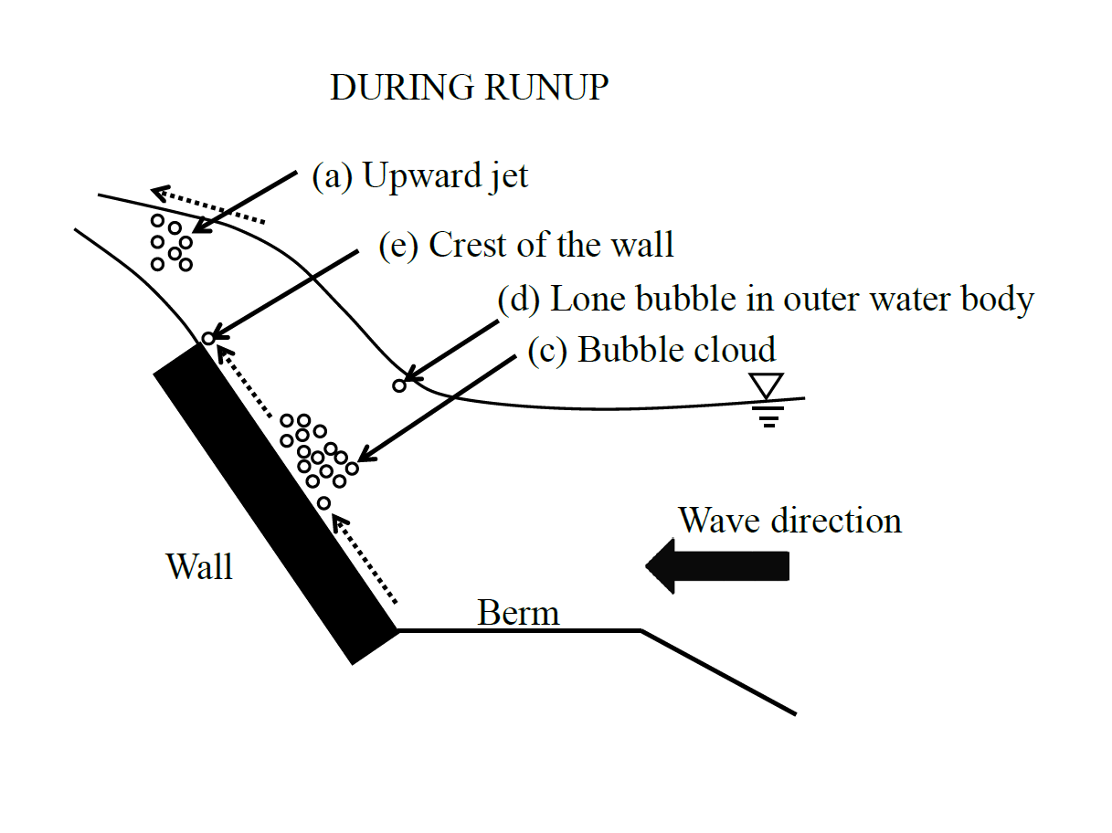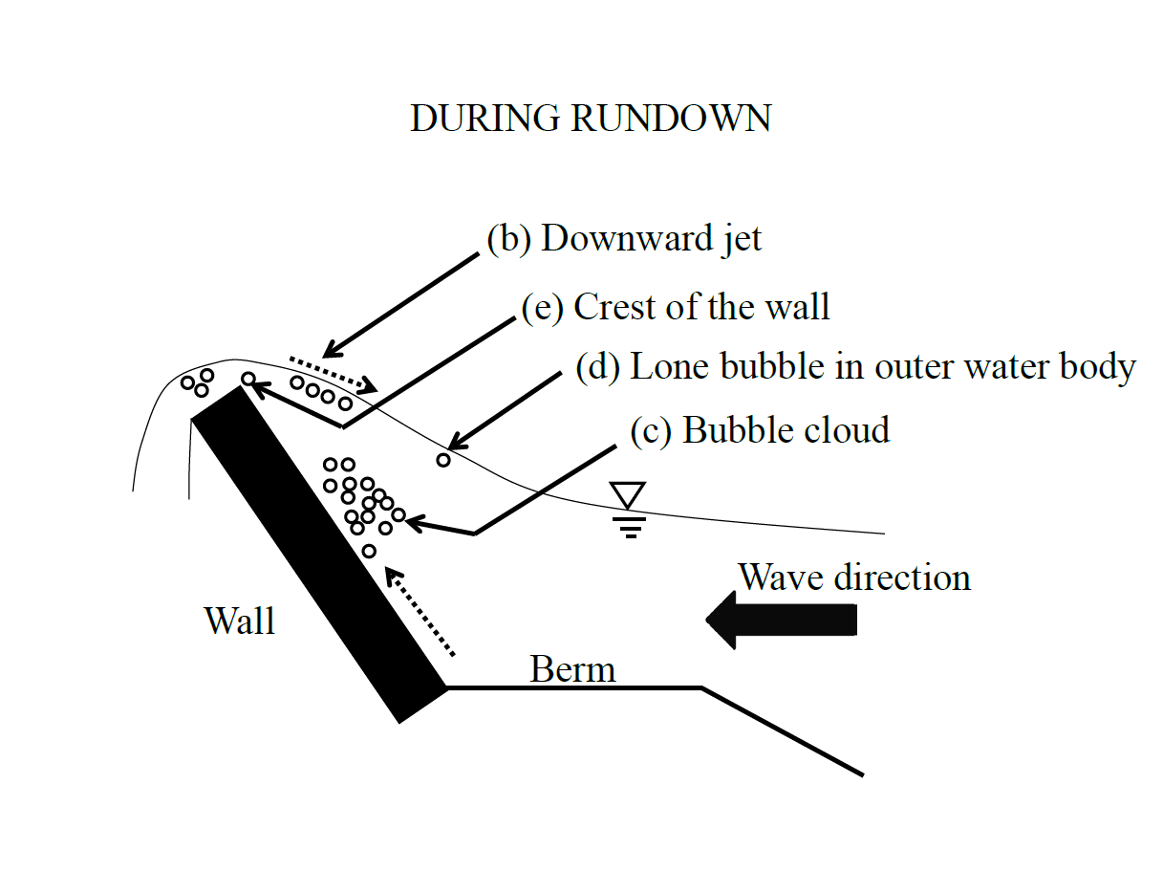
Figure S1-1 Regions of MBT validation during the runup and rundown phases
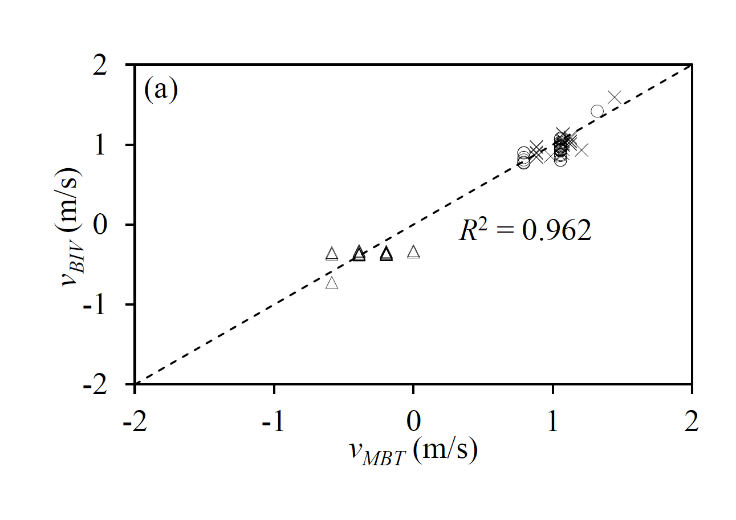 | 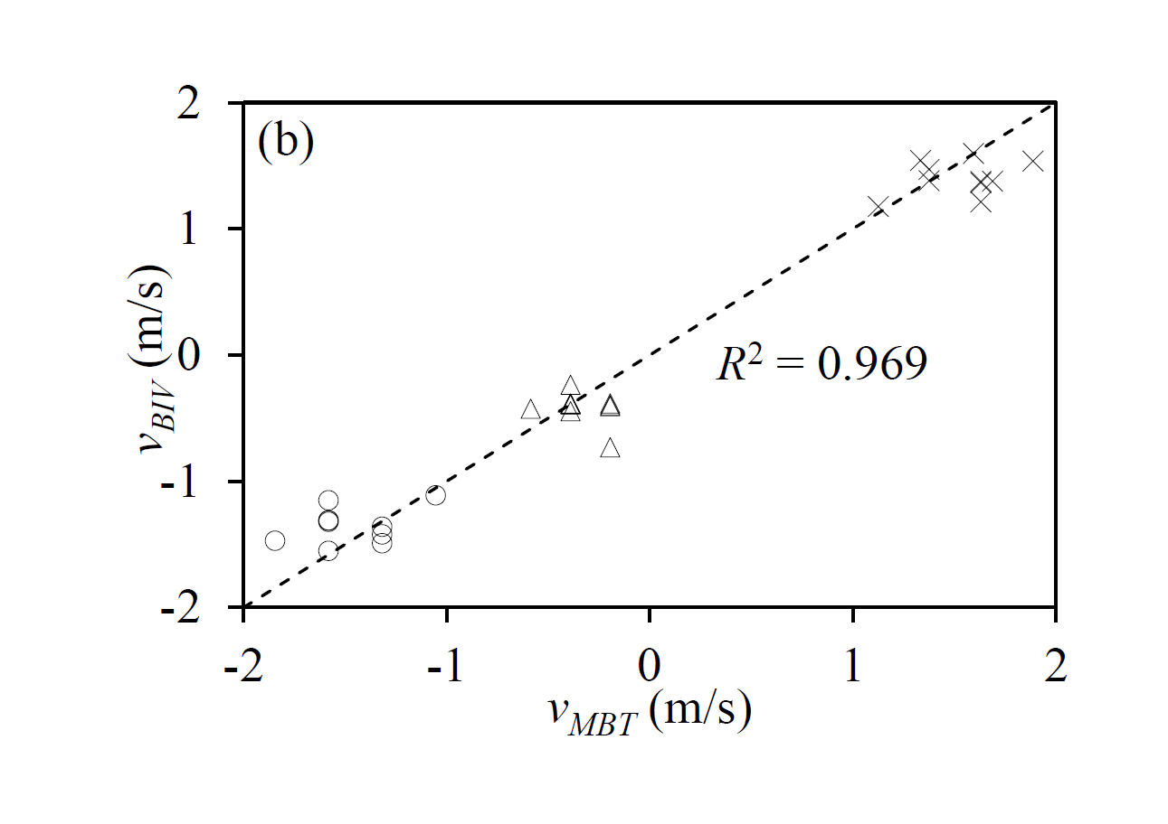
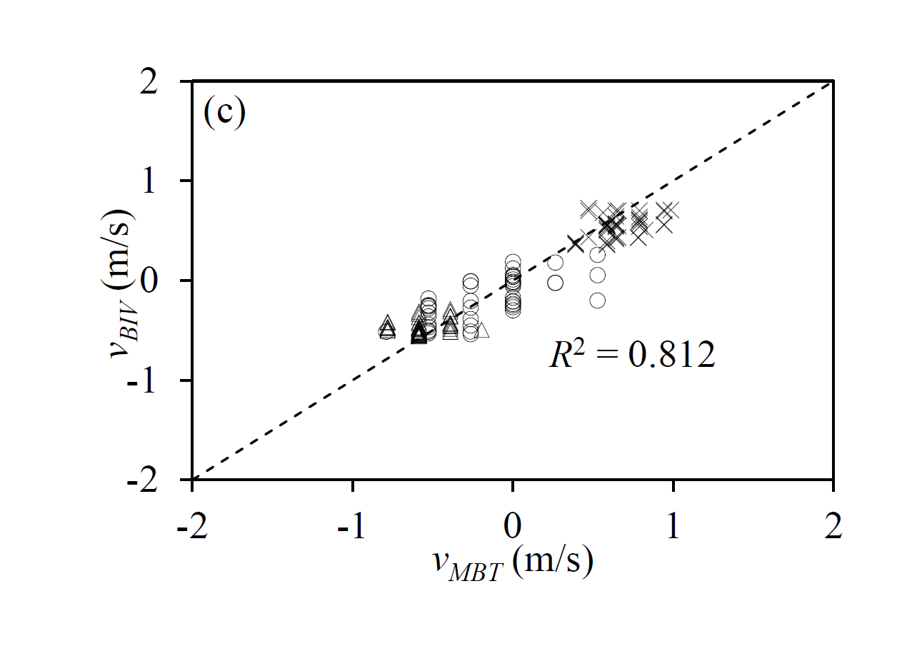 | 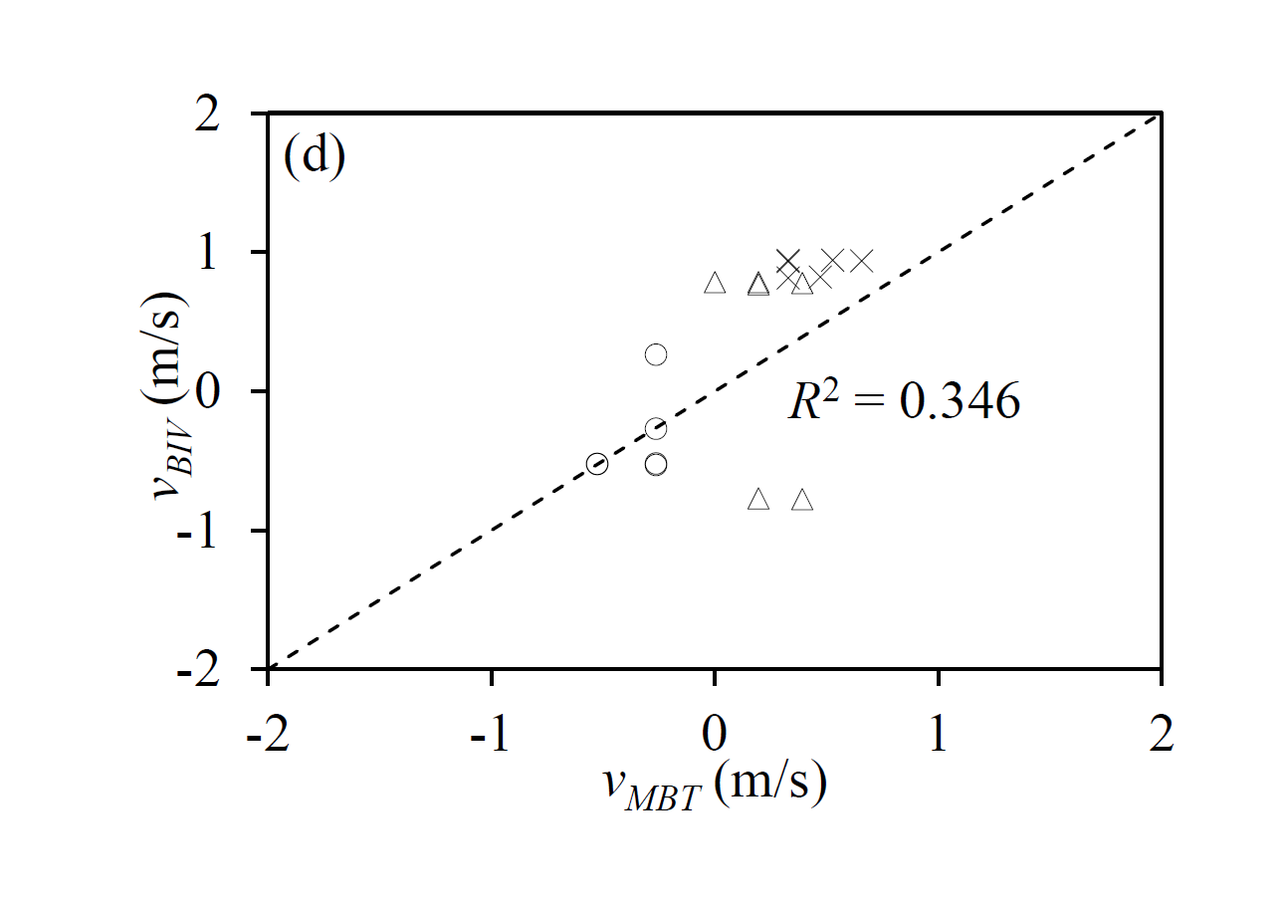
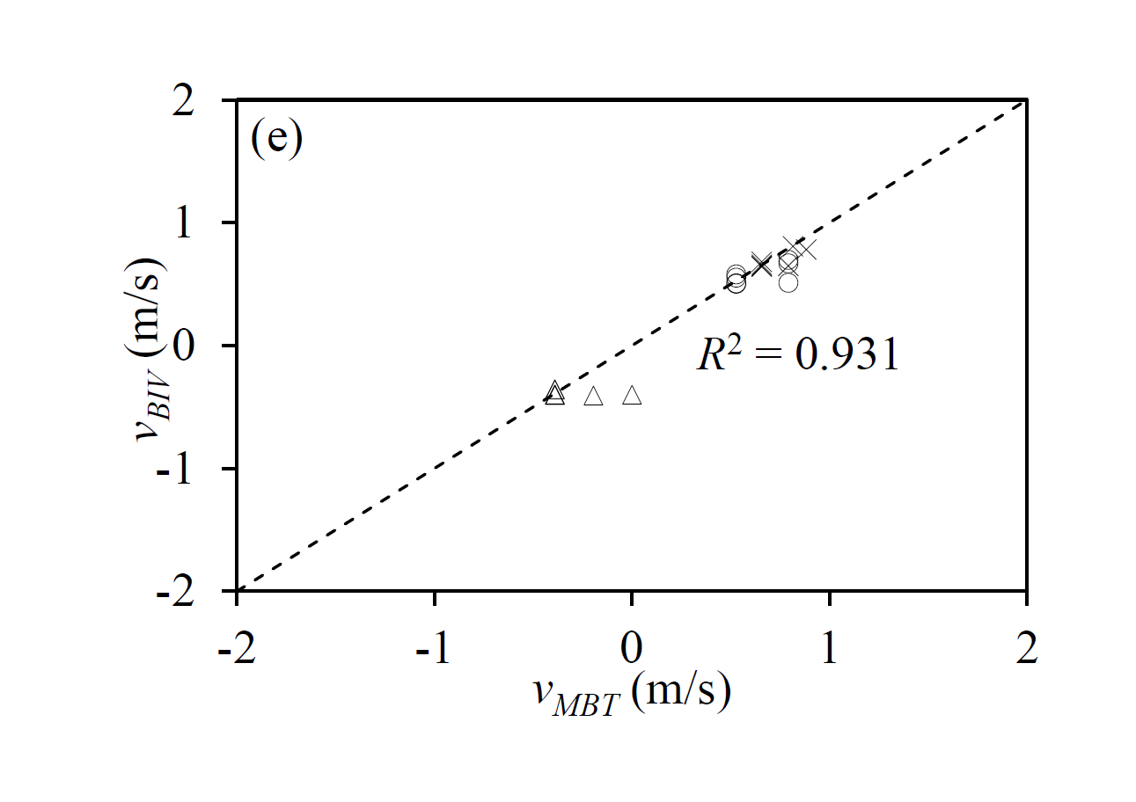
Figure S1-2 Comparison of BIV velocity estimate with MBT method for 5 regions of the overtopping wave (a) in the upward jet, (b) in the downward jet, (c) in the bubble cloud, (d) for a lone bubble in the outer body of water and (e) over the crest of the wall: Δ, horizontal component of velocity; ○, vertical component of velocity; ×, velocity vector; - - - , 1:1 agreement

