Supplementary Materials
S4. Additional graphs
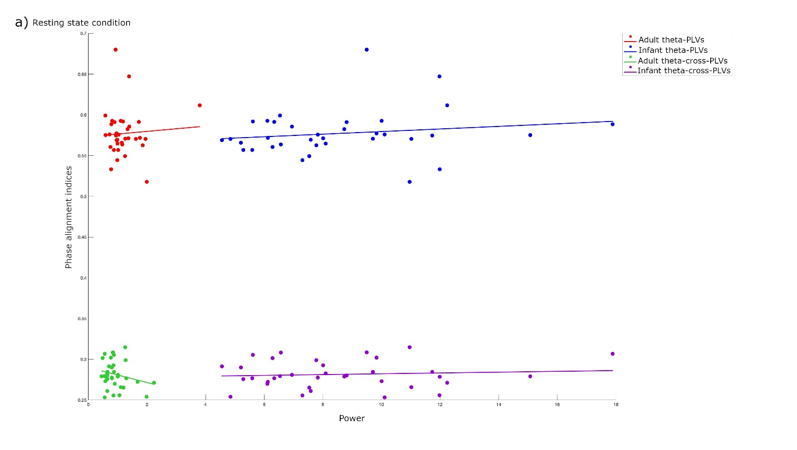
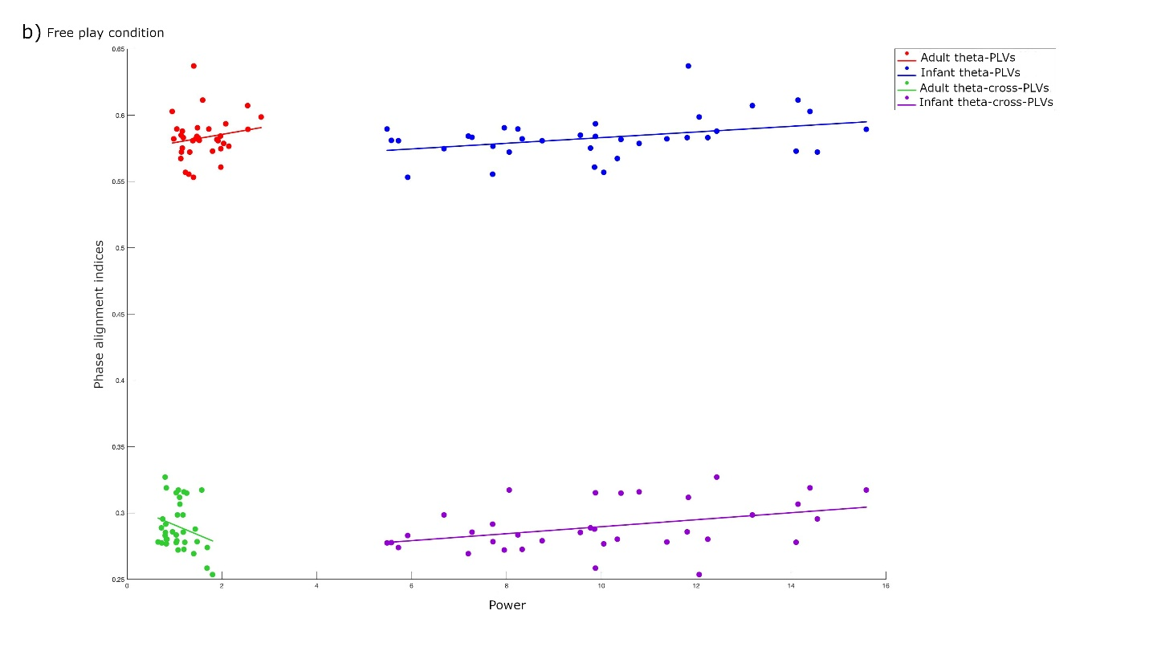
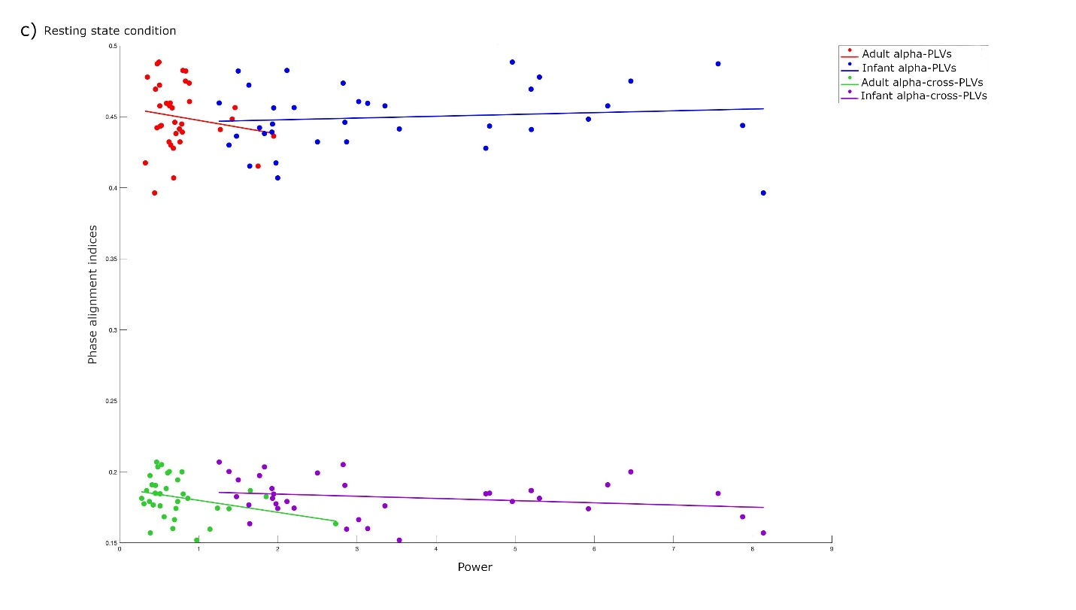
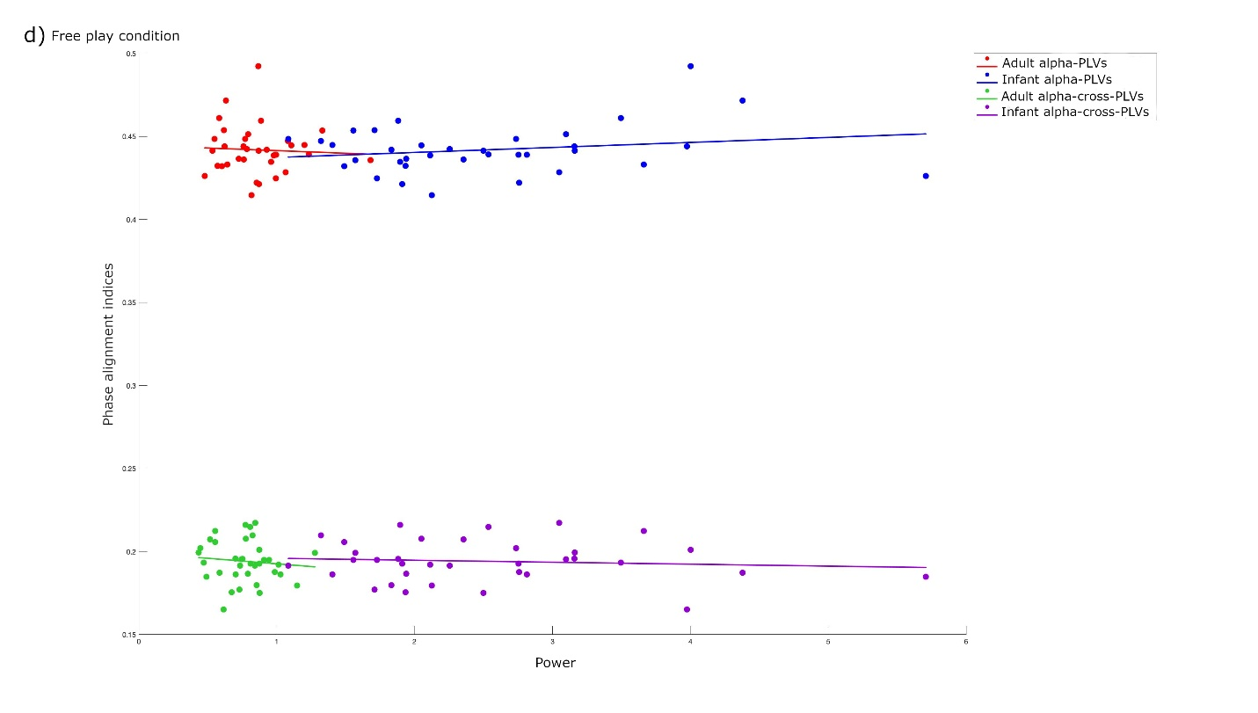
Figure 1: Scatterplots illustrating Spearman’s correlation results. a) associations between infant-adult theta cross-PLVs, infant-adult theta PLVs and infant and adult theta power in the resting state condition. b) associations between infant-adult theta cross-PLVs, infant-adult theta PLVs and infant and adult theta power in the free play condition. c) associations between infant-adult alpha cross-PLVs, infant-adult alpha PLVs and infant and adult alpha power in the resting state condition. d) associations between infant-adult alpha cross-PLVs, infant-adult alpha PLVs and infant and adult alpha power in the free play condition.
S5. Data used in the final analyses
We will make data publicly available upon publication.

