Detecting the onset of accelerated long-term forgetting: evidence from temporal lobe epilepsy.

Terence McGibbon & Ashok S. Jansari

School of Psychology, University of East London, Water Lane, London E15 4LZ, UK

Short Title: Onset of Accelerated Long-term Forgetting and Epilepsy
Running Head: Accelerated Long-term Forgetting

Address for correspondence:
Terence McGibbon
School of Psychology
University of East London
Water Lane
London
E15 4LZ
UK
Tel: +44 (0)7990 787075
Fax: +44 (0)20 8223 4937
Email: t.mcgibbon@uel.ac.uk

Abstract
Accelerated Long-term Forgetting (ALF) refers to a slowly developing anterograde amnesia in which material is retained normally over short delays but then forgotten at an abnormally fast rate over days to weeks. Such long-term memory impairment is not detected by standard clinical tests. This study analysed ALF in a temporal lobe epileptic, RY. Key issues addressed were: (i) the timeframe of ALF onset; (ii) whether disruption of memory consolidation during sleep is a necessary requirement for precipitating ALF; (iii) the effectiveness of repeated recall in limiting the impact of ALF. RY’s memory for novel word-pairings was compared with that of matched controls using cued-recall and forced choice recognition (FCR) tests at multiple delays (5, 30, 55, 240 min). To investigate the impact of repeated recall some pairings were recalled at all intervals, and all material (repeatedly and non-repeatedly recalled) was tested again after a 24 hour delay. RY’s initial learning and performance at 30 min were normal, but by 55 min both his cued-recall performance and the subjective quality of his recognition memory were significantly impaired. This suggests disruption of secondary consolidation processes occurring relatively soon after learning. It also raises the possibility of developing a standard test to diagnose ALF within a single clinical session rather than requiring multiple visits. Since RY remained awake it appears that disruption of memory consolidation during sleep is not a necessary condition for him to experience ALF. Repeated recall at multiple time-points within the first 4 hours sustained normal recall performance to 24 hours, indicating repeated recall could form the basis for a protective strategy.

Keywords: Accelerated long-term forgetting (ALF), Long-term amnesia (LTA), Temporal lobe epilepsy, Medial temporal lobe, Recollection, Long-term memory

1. Introduction
The traditional view of memory consolidation as a single stage process that converts short term memories into a form in which they can be retained for long periods (Weingartner & Parker, 1984) has come under attack in recent decades. There is mounting evidence that such a single stage model may be inadequate. One such line of evidence comes from the study of patients displaying a form of amnesia referred to as “long-term amnesia” (LTA; Kapur et al., 1997), or “accelerated long-term forgetting” (ALF; Butler & Zeman, 2008). In contrast to the classical amnesic syndrome, in which memory is impaired within minutes, patients suffering from ALF show relatively normal acquisition and initial retention of new information and perform within the normal range for standard neuropsychological tests at delays of up to 30minutes. However, they then display accelerated forgetting of the same information over periods of hours to weeks (Ahern et al., 1994; Blake, Wroe, Breen, & McCarthy, 2000; Butler et al., 2007, 2009; Jansari, Davis, McGibbon, Firminger, & Kapur, 2010; Kapur et al., 1996, 1997; Mameniskiene, Jatuzis, Kaubrys, & Budrys, 2006; Mayes et al., 2003; Muhlert et al., 2011; Muhlert, Milton, Butler, Kapur, & Zeman, 2010; O’Connor, Sieggreen, Ahern, Schomer, & Mesulam, 1997). This pattern of forgetting suggests the existence of secondary consolidation processes, occurring at time frames beyond the 30 minute interval of standard clinical tests, which are necessary to convert memories into a form suited to long term retention. A failure of these processes could explain the distinctive forgetting pattern found in ALF.
In a review of ALF cases known at the time, Mayes et al. (2003) highlighted the fact that although cases had arisen from multiple aetiologies (including anoxia, encephalitis and head injuries) either epilepsy or temporal cortex damage, or both, were present in most cases, while medial temporal lobe (MTL) damage was rare. This is significant as there is evidence that some forms of memory are dependent on the MTL initially but become less reliant on this structure over time through secondary consolidation processes (e.g. temporal gradients in retrograde amnesia in cases of MTL damage; Zolan-Morgan, Squire, & Amaral, 1986). Mayes et al. (2003) speculate that, in the case of ALF, an intact MTL enables the initial consolidation of information, while disruption of either the transfer to long term neocortical storage sites, or the maintenance of information within these sites, results in forgetting. They discuss structural damage and disruption of consolidation processes by epileptiform activity as possible causes.
Further evidence of a link between epilepsy and ALF comes from symptoms reported by patients suffering from temporal lobe epilepsy (TLE). Such patents often complain of severe memory problems, yet perform well in standard neuropsychological tests that measure anterograde memory retention over delays of up to 30 minutes (Blake et al., 2000; Corcoran & Thompson, 1992; Mameniskiene et al., 2006; Martin, Loring, Meador & Gregory, 1988). One possible explanation is that standard tests may be insufficiently sensitive to detect mild deficits in early processing (Butler & Zeman, 2008). An alternative possibility is that the standardised test delay of 30 minutes is too short to detect a long-term recall impairment which these patients suffer from, and that this ALF is ultimately as detrimental to everyday living as the impairments of immediate and delayed recall measured by the standard tests. The presence of ALF in this patient group has been confirmed by group studies (Blake et al., 2000; Mameniskiene et al., 2006; Muhlert et al., 2011; Wilkinson et al., 2012). In the largest study, Mameniskiene et al. (2006) compared 70 TLE patients with matched controls, using recall at 30 minutes and 4 weeks to provide a measure of long-term retention. They found that the number of seizures during the study and the age of the patient were significant predictors of accelerated forgetting. A further notable predictor was the presence of sub-clinical epileptic activity as measured by EEG. Wilkinson et al. (2012) also found evidence that long-term forgetting was associated with frequency of seizures, but in addition found that hippocampal pathology in patients with TLE can cause deficits in acquiring new memories and retaining these over short delays. Muhlert et al. (2011) found evidence of ALF in TLE cases but not in cases of idiopathic generalised epilepsy, indicating that only epilepsy with temporal lobe involvement contributes to ALF.
A final line of evidence linking epilepsy and ALF comes from patients with Transient Epileptic Amnesia (TEA), a condition which is often accompanied by ALF. In a review of ALF in cases of TEA, Butler and Zeman (2008) highlight both sub-clinical epileptiform activity and structural damage as likely causal factors. Clinically apparent seizures are not a necessary condition for ALF as the patients in several reported TEA studies were seizure free (e.g. Butler et al., 2007).
In the vast majority of cases where epilepsy was present, patients were taking anti-epileptic drugs (AEDs) at the time of testing. This suggests medication as a further possible causal factor due to the amnestic effects that have been associated with these drugs.(Jokeit, Kramer & Ebner, 2005) However Jansari et al., (2010) report a case of temporal lobe epilepsy (TLE) where ALF was clearly detected both before and after medication, and TEA patients subjectively report ALF symptoms prior to onset of medication and often report improvements after treatment (Butler et al., 2007).
In addition to its cause, several other aspects of ALF remain undetermined. Firstly, the timeframe of onset is unclear. Previous studies which have found intact memory performance at short delays have typically tested memory at 30 minutes, finding no impairment, and then again after a single extended delay of between 24 hours (e.g. Martin et al., 1991) and 8 weeks (Blake et al., 2000). Even where testing has been performed at multiple time points, to try to identify the timescale of ALF occurrence, the shortest extended delay has been 24 hours (Jansari et al., 2010; Muhlert, Milton, Butler, Kapur, & Zeman, 2010). Wilkinson et al. (2012) found evidence of accelerated forgetting at 1 hour. However, as their patients displayed impaired initial learning and were not tested using standardized measures at 30 minutes it is not clear that their forgetting at the 1 hour interval meets the normal criteria for ALF. Overall, it is clear that further detailed study of ALF during the first 24 hours will be necessary to pinpoint the timing of onset and profile its development.
Secondly, the role of sleep in ALF requires further study. Sleep has been found to improve performance of newly learnt perceptual, motor and virtual navigation tasks (Walker, Brakefield, Morgan, Hobson & Stickgold, 2002; Peigneux et al., 2004), and to improve recognition memory for newly learnt spoken language material (Fenn, Nusbaum & Margollash, 2003) and recall of word-pair associations (Ellenbogen, Hulbert, Stickgold, Dinges & Thompson-Schill, 2006). Given that ALF has been detected at 24 hours, it is possible that disruption of consolidation processes that occur during the first night’s sleep after initial learning may contribute to the accelerated forgetting. This is particularly relevant in cases of TEA where there is a strong association between amnesic episodes and waking from sleep. This has led Butler et al. (2007) to suggest that nocturnal seizure activity may interfere with consolidation. However, although there is some evidence of a link between sleep and ALF, additional detailed analysis of memory performance during the same waking day as learning will be required to confirm whether the proposed disruption of memory consolidation processes that occur during sleep is a necessary requirement for ALF, or merely a contributory factor.
Thirdly, the use of repeated recall and rehearsal as protection against ALF requires further evaluation. Mayes et al. note that for their patient JL, who suffered from ALF, “greatly over-rehearsed semantic memories were invulnerable to the effects of LTA” (p.595, 2003). This suggests that rehearsal could form the basis of a memory compensation strategy for ALF patients. In the first known direct test of repeated recall as a protective strategy in a case of ALF, Jansari et al., (2010) found that memory for repeatedly recalled short stories was maintained at normal levels to 4 weeks, for both recognition and free-recall, while free-recall of non-repeatedly recalled stories was significantly impaired within24 hours and reached floor after 2 weeks. This result highlights the importance of further research into the benefits for ALF patients of different forms of repeated recall or rehearsal on retention of different types of material.
The current study addressed these three unresolved aspects of ALF by extending an on-going case study of a patient RY, displaying sub-clinical TLE and ALF, who has been studied by Jansari and colleagues since 2003 (e.g. Jansari et al., 2010). RY complains of poor sleep patterns, waking early and often sleeping for only a few hours. When neurologically examined in 2003 his EEG data showed greater epileptic activity during sleep than while awake. Ellenbogen et al., (2006) showed that sleep protected declarative memories by increasing immunity to associative interference. It was speculated that due to sub-clinical epileptic activity RY might not benefit from this memory consolidation during sleep in the way that normal controls do. This hypothesis was supported by initial work with RY which tested at an extended delay of 24 hours, and then at further time points up to 4 weeks (Jansari et al., 2010), and which found that the most significant loss occurred during the first 24 hours. However a pilot study using a modified and extended version of Ellenbogen et al.’s cued-recall of word-pair associations procedure found evidence of ALF after 12 hour of wakefulness (McGibbon, Jansari & Gaskell, 2008). This suggested that the onset of RY’s ALF occurs during the same waking day as learning, and therefore, even if disruption of memory consolidation processes that occur during sleep contributes to his ALF, it cannot be the sole cause.
In the current study the profile of RY’s forgetting during the first few hours after learning was examined more closely. A novel test procedure was developed to test for cued-recall and forced choice recognition (FCR) of word-pair associations at time points of 5 minutes, 30 minutes, 55 minutes and 4 hours. The impact of repeated recall at all time points was also investigated, to build on previous evidence (Jansari et al., 2010) that repeated recall of short stories can limit the effects of ALF, by extending the method to memory for word-pair associations.

2. Case History
RY, a right handed man born in 1939, presented in 2001 complaining of memory problems which had started about one year earlier. He reported difficulty recalling the details of events that had occurred more than about 4-6 weeks previously. He gave the example of a holiday to Hawaii completed a few months earlier. When his wife asked about the trip he claimed that he had never been there. Looking at photographs from the holiday failed to trigger any recollection. Similarly, many social events attended with his wife were often totally forgotten after 6 months. RY currently runs a small software company, and reported difficulty referring back to work he had done one year previously. RY also reported problems navigating by car to places he had been many times in the past. While he was still able to use map-reading skills for successful navigation, he could no longer visualize the route from memory.
Current cognitive function, as measured by standard neuropsychological testing, was normal with the exception of autobiographical memory (Table 1). RY’s performance on the AMI (Autobiographical Memory Interview; Kopelman, Wilson, & Baddeley, 1990) was in the ‘probably abnormal’ or ‘definitely abnormal’ range for all time periods, and for both episodic and personal semantic memory.
RY’s medical history was unremarkable with the exception of cardiac surgery in 2005 (Zeman, Boniface, and Hodges (1998) report that a history of cardiac disease was common in their series of TEA patients). RY also reported experiencing ‘turns’ during which his awareness changes and he feels a sense of déjà vu. This lasts for about 20 seconds, followed by a dreamlike episode which can include experiencing forgotten memories from the past. These memories can usually be recalled after the ‘turn’, but then fade rapidly. These ‘turns’ had been experienced from childhood. However they had become more frequent approximately a year before presentation, by which time they were occurring in clusters of four or five about twice a month, often in the morning after a lack of sleep. No olfactory, gustatory or epigastric sensations were reported.
A sleep-deprived EEG subsequently identified right temporal spike activity, with epileptiform discharges occurring more often during sleep than while awake. A diagnosis of temporal lobe epilepsy was followed by prescription of anticonvulsant medication (Lamotrigine, 50mg, twice daily).
A neuropsychiatric evaluation conducted at first diagnosis failed to identify any psychosocial causal factors. MRI investigations at multiple time points since 2001 have found no evidence of focal or generalised pathology. Figure 1 shows three coronal slices through the length of RY’s hippocampi, taken in 2007. Two independent experts have judged these images to be structurally normal.

Test | Sub-test | RY’s performance
NART (errors = 10) |  | Pre-morbid IQ 118
WAIS-R | Performance IQ | 124
 | Verbal IQ | 123
WMS-R | Stories Immediate Recall | 28 (80th percentile)
 | Stories Delayed Recall | 25 (82nd percentile)
 | Designs Immediate Recall | 36 (95th percentile)
 | Designs Delayed Recall | 34 (94th percentile)
WMS-III | Faces Immediate Retention | 41 (scaled score 14)
 | Faces Delayed Retention | 44 (scaled score 18)
Rey-Osterieth Figure | Delayed visual recall | 70th Percentile
WRMT | Faces | 67.5th Percentile
 | Words | 86.7th Percentile
AMI | Childhood semantics | 10.5/21 (Definitely abnormal)
 | Childhood autobiographical | 4/9 (Probably abnormal)
 | Early Adulthood semantics | 11.5/21 (Definitely abnormal)
 | Early Adulthood autobiographical | 4/9 (Probably abnormal)
 | Recent semantics | 15/21 (Definitely abnormal)
 | Recent autobiographical | 4/9 (Definitely abnormal)
WSCT |  | 6 Categories (Normal)
Graded Naming Test |  | 24/30 (Normal)
WAIS-R= Wechsler Adult Intelligence Scale Revised; WMS-R= Wechsler Memory Scale Revised; WMS-III= Wechsler Memory Scale III; WRMT= Warrington Recognition Memory Test; AMI= Autobiographical Memory Interview; WSCT= Wisconsin Card Sorting Test

Table 1: Neuropsychological assessment of RY

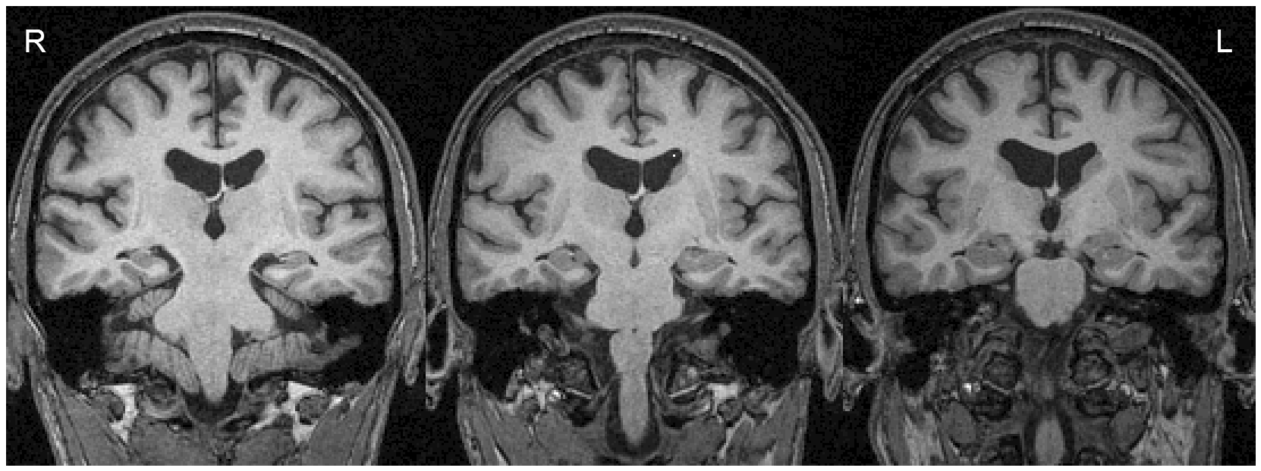
Fig. 1. T2 weighted 3D coronal images of patient RY showing normal hippocampi bilaterally.

3. Material and Methods
A customised paradigm was developed to profile RY’s ALF during the first 4 hours after learning, and to investigate the impact of repeated recall on retention measured at 24 hours. Memory for word-pairs was tested using cued-recall and forced choice recognition at four time intervals during the same day (5 min, 30 min, 55 min, 4 hours), and after a night’s sleep. A repeated measures design was used. All participants took part in all conditions in the same order (no counter-balancing).

3.1 Normal Controls
RY’s performance was compared to 5 age- and IQ-matched control subjects who were free of neurological or psychiatric disorders. RY: age at time of testing (in 2007) = 68, Wechsler Test of Adult Reading (WTAR) IQ=116. Control group: N=5; 2 males, 3 females, mean age 66.3, SD 4.9 years, mean WTAR IQ=117.88, SD 6.29. All participants gave informed written consent to take part in the study, which was approved by the local ethical committee.

3.2 Stimuli & Procedure
Pilot study data indicated that to avoid stressing or fatiguing participants, a maximum of 12 word pairs could be learnt in any one single learning period, each lasting approximately 10 minutes. To ensure that the total procedure (except the 24 hour test) from start to finish could be completed within a single visit it was necessary to restrict the number of learning periods to 3. With 3 learning periods of 12 word-pairs each the total number of word-pairs to be learnt was 36. A total of 4 word-pair lists were required; one to be recalled at 5 minutes and at all other time intervals (repeatedly recalled list), and one each to be recalled after 30 min, 55 min and 4 hours. As 4 lists were required, and 36 word-pairs were available, the length of each list was therefore set at 9 word-pairs.
Additional words were required as alternate answers (foils) for two 4-choice FCR tests. For each FCR test the first word of a pair was presented, followed by the correct paired associate (target) and three foils. Different foils were used for each test; 6 foils were therefore required for each word pair. With 6 such foils per word-pair, and 36 word-pairs, the total number of words (word-pairs and foils) required was 288.
All words were 1 syllable, 4 to 6 letters, and were nouns with no pronunciation variants. The 288 words were assigned to 8 lists of length 36 such that the parameters word length, familiarity, concreteness, imageability and frequency were matched in the various lists. The first two lists were then combined to produce 36 word-pairs. Any word pairs with obvious semantic relationships were re-paired randomly. Word-pairs were then assigned randomly to produce the required the 4 word-pair lists, each of 9 word-pairs length (e.g. TROOP-SHAWL). The words from the remaining six lists were randomly assigned to provide the 6 FCR foils per word-pair.
The word-pairs from the four lists were interleaved equally across the three learning periods. The stimuli for each learning period therefore consisted of 3 pairs from each list. The pairs from each list were also interleaved within each stimulus set to provide the order for first presentation. This interleaving of material from the 4 lists both across and within learning periods minimised the impact of task learning effects, pro-active interference, fatigue, and any sub-clinical epileptiform activity.
The word pair lists were learnt using a two-phase process. In the first study-only phase word pairs were presented on a computer screen in a fixed sequential order, displayed in black capitals on a white background. Each pair was displayed for 7 seconds. Phase two, using an anticipation-plus-study procedure, followed immediately. The pairs were processed in a random order to avoid order effects. The first word in each pair was presented and the participants were required to type the second word. Immediate feedback was then provided (“Correct. The correct pairing is:” or “Incorrect. The correct pairing is:”) which included display of the correct pairing for two seconds. After displaying all pairs, the process repeated, using a new random order. Once any individual pair had been answered correctly three times it was removed from the stimulus set. Once all pairs had been removed from the set (100% learning criterion) the learning session was complete.
Each learning period was followed by a 5 minute rest, and then a test period. During the rest period participants performed a distraction task (pencil and paper maze completion), to prevent rehearsal. Once all material had been learnt the gap between tests increased throughout the procedure. During these longer gaps participants were engaged in general conversation. During the final gap, before the 4 hour test period, participants were accompanied to lunch by the researcher. Each test period consisted of cued-recall followed by FCR testing. Word-pairs were allocated to each test interval such that each item was tested at the correct delay (refer to Figure 2 for full detail).

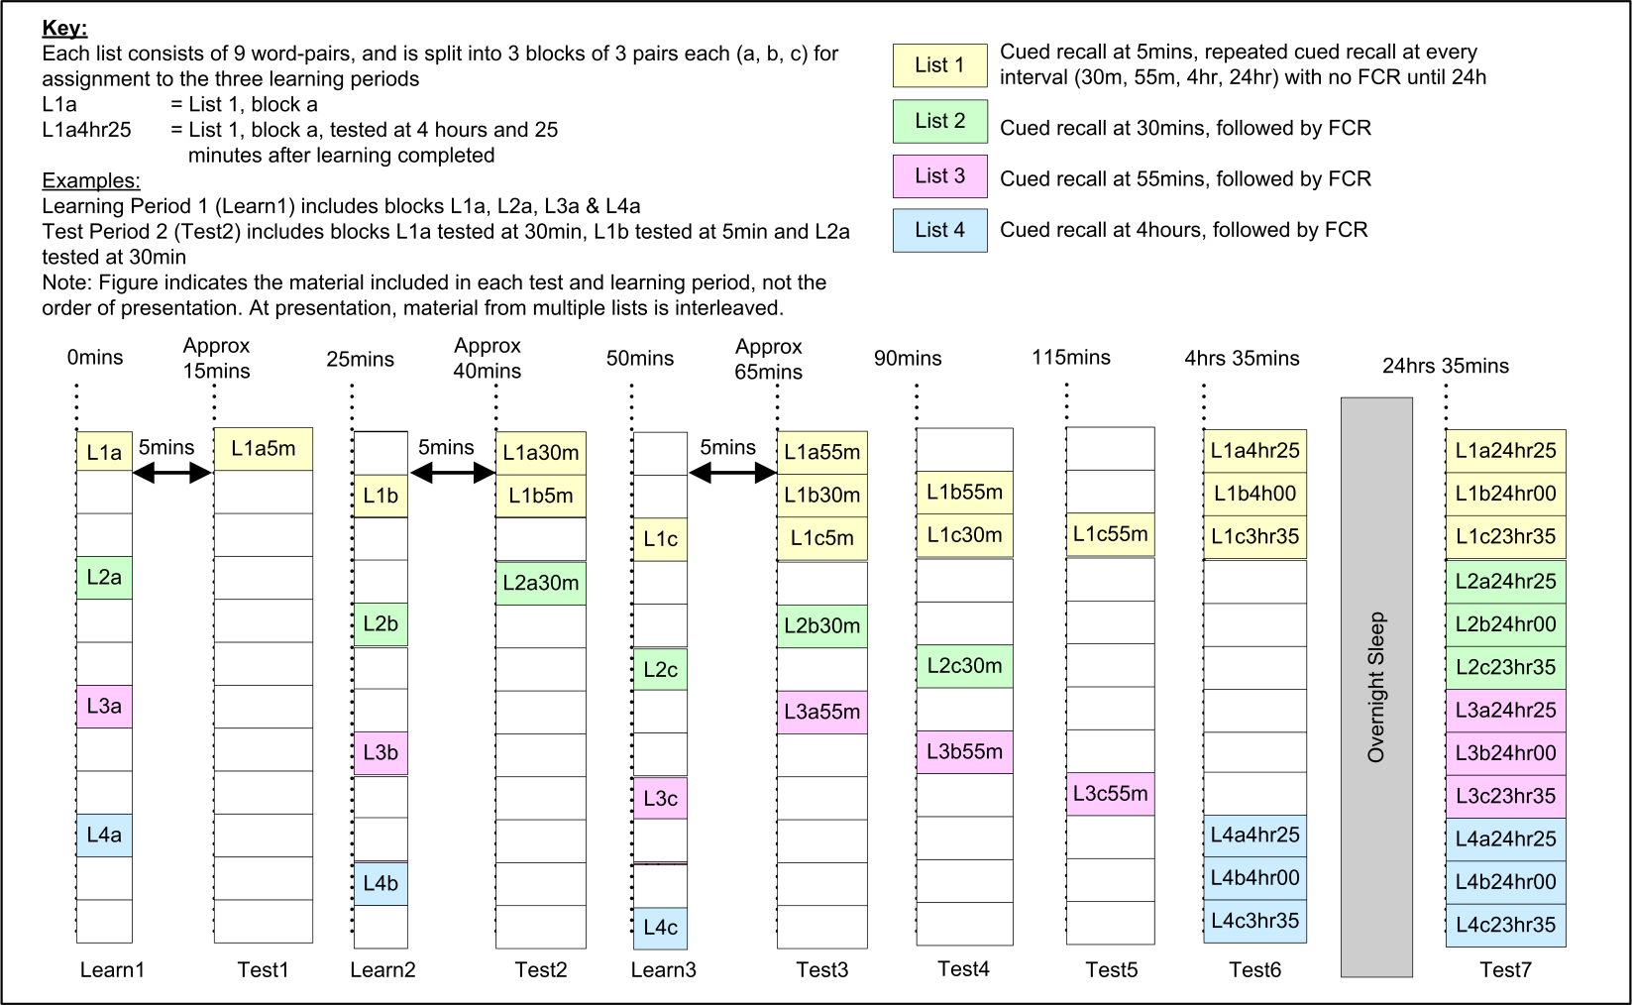
Fig. 2. Timings for learning and test intervals.

List 1 was cued-recalled tested at each test interval (5mins, 30 mins, 55mins, 4hrs). The remaining lists (Lists 2, 3 and 4) were tested at one test interval only; List 2 was tested at 30mins, List 3 at 55mins and List 4 at 4 hrs. These three tests, combined with the 5 minute interval result from List 1, were intended to profile the onset of RY’s ALF.
The purpose of List 1 was to check whether it was possible to limit the impact of ALF by repeatedly recalling material, without any re-presentation. This maps to real-world scenarios where repeated presentation is impossible but repeated recall is possible. For this reason FCR testing was omitted for List 1 until the final test at 24 hours delay, thus eliminating any possibility that re-presentation of the correct answer during such an FCR test might contaminate the measurement of the benefits of repeated recall. Lists 2, 3 and 4, which were not repeatedly-recalled, were tested with both cued-recall followed immediately by FCR.
The 5 minute test interval was included as a check of initial encoding, to protect against the possibility that short-term memory may have been used for any of the three recalls used as criterion for initial learning. This also simulated the first recall within a possible repeated recall strategy for protection against the impact of ALF, in which it was expected that the patient would be advised to perform the first recall a few minutes after learning.
As well as the testing detailed above, all 4 complete lists were also cued-recall and FCR tested at 24 hours, after one night’s sleep (refer to Figure 3 for a summary of test regime). The initial learning period started at 10:00am, with the 24 hour test period starting at 10:00am the next morning after a night’s sleep.

List | Test Delay
 | 5 mins | 30 mins | 55 mins | 4 hours | 24 hours
List 1 | Cued-recall | Cued-recall | Cued-recall | Cued-recall | Cued-Recall & 4FCR
List 2 |  | Cued-Recall & 4FCR |  |  | Cued-Recall & 4FCR
List 3 |  |  | Cued-Recall & 4FCR |  | Cued-Recall & 4FCR
List 4 |  |  |  | Cued-Recall & 4FCR | Cued-Recall & 4FCR

Fig. 3. Summary of test regime.

While initial learning to criterion was performed using a computer, recall testing was pen and paper based. Participants were given a sheet with the first word from a number of pairs from the relevant lists presented in random order in one column, followed by one blank column. Participants were asked to recall any matching second words, and to place these in the empty column. For example, for the pairing TROOP-SHAWL the cue provided was TROOP, and the accurate response was SHAWL. Morphological errors (eg., “troops” instead of “troop”) were scored as correct. Only words matched to the correct associate were counted as accurate responses. No feedback was given to the participants regarding their performance, and correct answers were not presented. An upper time limit for each test was set, calculated to allow 15 seconds per word-pair. However, in practice every participant finished well within the allotted time without any prompting.
FCR testing was also pen and paper based. Participants were given a sheet with a number of first words from word-pairs from the relevant lists presented in random order. Four options for the second word in the pair were presented beside each first word. Participants placed a tick beside their choice. For example, for the pairing TROOP-SHAWL the cue provided was TROOP and the four options were FLOAT, BROOM, FROST, SHAWL. Participants were instructed to answer all questions, and to guess if they could not recall the correct matching word. They also placed a tick in either a Remember, Know or Guess box, to indicate whether they remembered the pairing, did not remember the pairing but did know the correct answer (e.g. one foil seemed more familiar, or they knew by a process of elimination), or whether the answer was a pure guess (RCA paradigm; Gardiner & Java, 1993). As with the cued-recall testing, no feedback was given to the participants regarding their performance, and correct answers were not presented. An upper time limit for each test was set, calculated to allow 15 seconds per word-pair. Every participant finished well within the allotted time without any prompting.
To minimise fatigue and task-learning effects the items were randomly interleaved within each test interval and the order was changed for the 24 hour test.
Initial briefing included a familiarisation trial using the software to learn a list of three word pairs, not present in any of the other lists. This was followed by trial cued-recall and FCR tests for this list. At all stages, participants were instructed not to rehearse the word-pairs between sessions. A post sleep self-report questionnaire was used before the 24 hour test, to monitor the number of hours slept and any disturbance of sleep.

Results
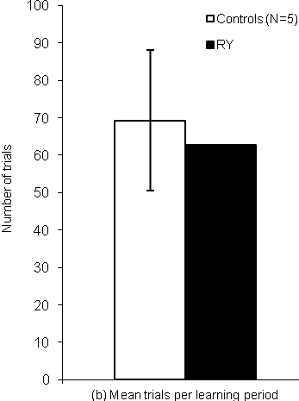
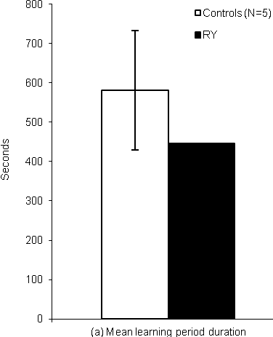
All participants, including RY, reported a minimum of 7 hours sleep overnight. To provide an indication of initial learning the mean duration and number of trials to reach criterion for each learning session, for RY and normal controls, were compared (Fig 4). RY performed similarly to controls on both criteria (mean duration, t(4) = .81, p = .23; number of trials, t(4) = .30, p = .39) indicating intact acquisition of new material.

Fig. 4. Average trials and duration per learning period (error bars represent 1 SD).

Cued-recall scores were compared using Crawford and Garthwaite’s (2002) method for comparing a single case with a group of control subjects. For cued-recall of non-repeatedly recalled word-pairs RY’s performance was within 1 SD of the control mean at 5 minutes (RY score = 7; NCs: Mean = 8, Range = 7-9; t(4) = .91, p = .21) and 30 minutes (RY score = 5; NCs: Mean = 6.6, Range = 5-9; t(4) = .80, p = .23), but beyond that point indicated accelerated forgetting, falling significantly below controls at 55 minutes (RY score = 2; NCs: Mean = 5.6, Range = 4-7; t(4) = 2.88, p = .02) and 4 hours (RY score = 2; NCs: Mean = 5.6, Range = 5-8; t(4) = 3.52, p = .01). This pattern was confirmed by analysis of forgetting rates using the following formulae: 5 minutes to 30 minutes forgetting = (5mins recall – 30mins recall)/(5mins recall); 30 minute to 55 minutes recall = (55mins recall – 30mins recall)/(30mins recall). This relative rate of forgetting analysis minimises the impact of any differences between RY and controls’ absolute performance. RY’s forgetting rate was normal between 5 and 30 minutes (t(4) = .79, p = .24), but became significantly greater between 30 and 55 minutes (t(4) = 3.30, p = .01).
In contrast, for cued-recall performance of repeatedly recalled material, RY’s performance remained close to the control mean for all time periods. To allow direct comparison of the results for repeatedly and non-repeatedly recalled material, both sets of data are displayed together in Figure 5. This clearly highlights both RY’s accelerated forgetting for non-repeatedly recalled material and a reinforcement or consolidation effect for repeated cued-recall.

Fig. 5. Cued-recall performance for non-repeatedly and repeatedly recalled material (error bars represent 1 SD).

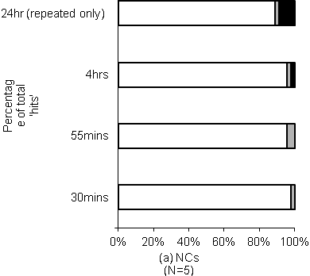
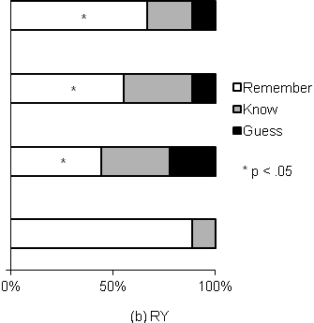
For recognition of both repeatedly and non-repeatedly recalled word-pairs RY as well as normal controls performed at ceiling at all time points. Figure 6 presents the breakdown of FCR responses between “Remember”, “Know” and “Guess” categories for non-repeatedly recalled word-pairs at each test delay, and for repeatedly recalled word-pairs tested at 24 hours (repeatedly-recalled pairs were only FCR tested after 24 hours; refer to section 3.2). Normal controls maintain a high level of Remember responses across all time points. In contrast, while the proportion of RY’s responses which are Remember is in the normal range at 30 minutes, it is then impaired at all other time points (30mins test, t(4) = 1.62, p = .09; 55mins test, t(4) = 7.63, p < .01; 4hrs test, t(4) = 3.69, p = .01; repeatedly recalled material tested at 24hrs, t(4) = 3.15, p = .02), indicating a rapid deterioration in the recollective aspect of familiarity between 30 minutes and 55 minutes. The fact that RY’s remember responses at 24 hours even for repeated recalled material are significantly less frequent than those of normal controls indicates that repeated recall failed to maintain the subjective quality of RY’s recognition at normal levels.

Fig 6. Comparison of percentage of correct FCR responses marked as Remember, Know or Guess.

To investigate the time limits of the memory protection provided by a single recall and FCR, and to allow any such benefit to be compared with that provided by repeated recall at multiple intervals, material which was not repeatedly recalled was cued-recall tested a second time after 24 hours.
Figure 7 summarises this data, plotting performance at the 24hr point as a function of the original learning regime. RY’s 24 hour cued-recall performance for the repeatedly recalled material was within normal limits (just over 1SD below control mean, t(4) = 1.28, p = .14), while performance for all other lists was significantly impaired (30mins test, t(4) = 2.45, p = .04; 55mins test, t(4) = 2.31, p = .04; 4hrs test, t(4) = 6.49, p < .01). Repeated cued-recall was the only reinforcement schedule that maintained RY’s recall performance at normal levels.

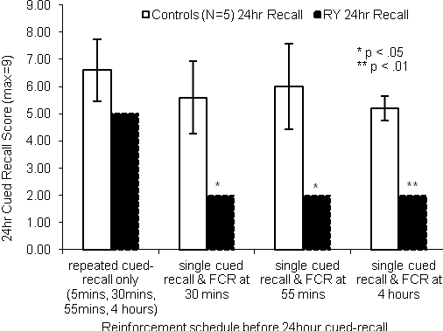

Fig. 7. 24 hour cued-recall performance as function of previous cued-recall and FCR schedule (error bars represent 1 SD).

5. Discussion
The current study extended an on-going case study of a patient displaying sub-clinical TLE and ALF. Three unresolved aspects of ALF were addressed: the timeframe of onset, the role of sleep, and the use of repeated recall as a protection against the impact of ALF. Using a word-pair association paradigm it was found that RY’s initial learning and performance at 30 minutes were normal, but by 55 minutes both his cued-recall performance and the subjective quality of his recognition memory were significantly impaired compared to matched controls. Since the patient remained awake and seizure free throughout the test period it appears that neither disruption of consolidation processes during sleep nor clinically observable seizures are necessary conditions for RY to experience ALF. For word-pairs recalled at multiple time-points within the first 4 hours performance remained within the normal range to at least 24 hours, showing that such repeated recall had a protective effective. In contrast a single recall within the first 4 hours was insufficient to generate such protection.
The current study directly addressed the timeframe of ALF onset by measuring memory performance during the first few hours after learning. For cued-recall of non-repeatedly recalled word-pairs, RY performed in the normal range at delays of up to 30 minutes, but displayed accelerated forgetting from that time on, with his scores becoming significantly impaired by 55 minutes. This suggests the onset of RY’s ALF occurs somewhere between 30 and 55 minutes. Such a forgetting rate is consistent with the data from a pilot study which demonstrated significantly degraded cued-recall of word-pair associations after a 12 hour delay (McGibbon, Jansari & Gaskell, 2008). However, it indicates a more rapid memory loss than detected in previous recall tests (Jansari et al., 2010), which have shown RY performing well above floor at 24 hours and taking around one week to reach floor. However, these previous tests have involved short stories and visual figures; RY’s recall of word lists or word pairs over extended periods has not been tested before. A short story consists of multiple items of information combined together in an integrated fashion, each item linking (and thus providing recall cues) to multiple other items in the story. For the story to make sense it will also link to existing general knowledge and schemas, and this semantic context provides yet more recall cues. In this way, short story recall is a close approximation to real-world episodic memory. In contrast the items in this study’s word-pair lists were deliberately chosen to avoid any possible semantic links between pairs and between items in each pair. This minimises the risk of participants’ prior associations impacting the results, a general approach dating back to Ebbinghaus (1885). Many studies have shown that recalling meaningless “pure” information is harder than recalling meaningful material (e.g. Bower, 1969). It may be that a word-pair recall test highlights forgetting of associations in a way that a short story test does not, and therefore provides a more immediate diagnosis and measure of RY’s ALF, and a “cleaner window” into the ALF itself. An alternative explanation for the different ALF timescales detected with different material is that ALF over short and long delays reflect two different processes, as proposed by Wilkinson et al. (2012), with forgetting over short period linked to hippocampal pathology while forgetting over longer periods is associated with ongoing epileptiform activity. However, it is currently not clear why different material should be differentially susceptible to two processes in this way.
A final explanation for the relatively rapid degradation in RY’s cued-recall performance in the current study could be poor initial encoding; however there is evidence against this. Firstly, the duration of RY’s learning sessions and number of presentations required to learn to criterion were both within the normal range. Secondly, all participants learnt to the same criterion. And finally, RY’s intact performance at 5 minutes and 30 minutes indicate that his initial encoding is adequate. It is therefore unlikely that his poor performance at 55 minutes is due to inadequate encoding.
With respect to the role of sleep in ALF, the current study provides clear evidence of ALF occurring during the same day as learning, before sleep had occurred. With one exception (Wilkinson et al., 2012), previous studies have only detected ALF after at least one night's sleep. Since for normal controls sleep provides a protective effect for newly learnt material (e.g. Ellenbogen, Hulbert, Stickgold, Dinges & Thompson-Schill, 2006) it is possible that in ALF patients disturbed sleep may result in a failure to obtain this benefit. If this were the only cause of ALF then normal controls would have no advantage over ALF patients during a waking study. The fact that RY showed ALF within 55 minutes argues against this as a sole cause in his case. This is interesting considering the apparent link between ALF and sleep in TEA (Butler et al., 2007). It may be that ALF in TEA and non-TEA patients have separate causes, or alternatively the nocturnal seizure activity Butler et al. suggest as a cause of disrupted consolidation may also be present in RY at a sub-clinical level during the waking state. Further testing incorporating EEG monitoring would help isolate the cause of ALF in cases like RY.
Evidence for the impact of repeated recall on memory consolidation and its use in countering the effects of ALF comes from the results for cued-recall of repeatedly recalled word-pairs. In contrast to the accelerated forgetting seen for non-repeatedly recalled material, these results show intact retention across the whole 24-hour period. As the gap between successive test intervals increases significantly over the course of the 24 hours, this result indicates a genuine reinforcement or consolidation effect for repeated cued-recall, rather than merely a refresh at each recall followed by the same rate of forgetting. For example, multiple repeated recalls within the first 4 hours provided protection against ALF for at least the next 20 hours (the gap between the 4 hour test point and the next test point at 24 hours).
This consolidation for repeatedly recalled material is consistent with previous results for RY’s recall of short stories (Jansari et al., 2010) and with evidence that memories of ALF patients remain intact for information frequently recalled or rehearsed over many years (Mayes et al., 2003), suggesting that frequent recall can provide protection against the impact of ALF. As far as we are aware this series of studies with RY is the first to investigate the benefits of repeated recall in ALF, not only at different timeframes but also for different materials. These findings raise the possibility that a repeated recall strategy could be employed by patients to counteract the effects of ALF, much as a spaced retrieval technique can be used to teach new information to patients with dementia (Brush & Camp, 1998). For short stories a single recall at 30 minutes was sufficient for RY to extend retention to 24 hours (Jansari et al., 2010). However for word-pair associations multiple cued-recalls were required during the first 4 hours to achieve the same retention. This indicates that the timing and frequency of the recalls in any such strategy needs to be nuanced and would be partly determined by the type of information to be retained.
In contrast to cued-recall, RY’s recognition performance (FCR) was at ceiling at all time points for both repeatedly and non-repeatedly recalled material. At first viewing, RY’s intact FCR scores suggest his recognition does not degrade over the timeframes of this study. However, a closer inspection through use of the RCA paradigm (Gardiner & Java, 1993) showed that the subjective quality of RY’s recognition does degrade, with a shift from “Remember” to “Know” and “Guess” responses occurring more rapidly than for normal controls. This deterioration becomes significant over the same time period (between 30 and 55 minutes) as the deterioration of cued-recall. This deterioration in the subjective quality of RY’s recognition memory despite intact performance on basic FCR testing concurs with his performance for recognition of unfamiliar faces (Jansari, Davis, Firminger, Ward & Kapur, 2005).
Anecdotally it appeared that in many cases RY’s FCR scores were sustained primarily by familiarity with the individual items (target versus foils) rather than for the actual word pairings per se. For example, on multiple occasions he reported knowing that he had not seen any of the foils before which, combined with some familiarity for the target, helped him to identify the correct response even though he had no recollection of the target’s pairing with the cue word. This suggests that memory of the association or relation between a pair of words is being lost before memory for the individual items.
The possible dissociation between RY’s recall and recognition memory (shown by falling cued-recall scores while FCR scores remain at ceiling) and between memory for relational information and item familiarity (suggested by the shift from Remember to Know responses in FCR) may help in theorising the location of any structural damage or focus of sub-clinical epileptiform activity causing his ALF. Dissociations between recollection and recognition have frequently been found, with both lesion studies (Holdstock et al., 2002) and neuroimaging of healthy participants during encoding (Ranganath et al., 2003; Davachi, Mitchell & Wagner, 2003) as well as for retrieval (Eldridge, Knowlton, Furmanski, Bookheimer & Engel, 2000). These studies have indicated that the hippocampus is selectively involved in recollection, while the rhinal cortex, and possibly other areas within the parahippocampal gyrus, support familiarity-based recognition. Similarly, previous studies have indicated that the hippocampus supports relational processing while the entorhinal and parahippocampal cortices support item based processing (Davachi & Wagner, 2002). Taken together this evidence suggests the process or damage causing RY’s memory problems may impact both the hippocampus and parahippocampal gyrus (since both recollection and recognition are impaired relative to controls), but affects the hippocampus more severely (since recollection and relations between items are impacted first). However, the fact that no structural abnormalities have yet been found suggests that if the cause is structural then it is either very subtle or undetectable by current neuro-imaging techniques.
Existing consolidation theories suggest that both semantic and episodic memory are intially reliant on the MTL, with traces in this structure providing an index that link the components of a memory together into a coherent whole. Alvarez and Squire postulate that during secondary consolidation indexing of both semantic and episodic memory shifts to the neocortex, such that both memory types become independent of the MTL (Standard Consolidation Theory; Alvarez & Squire, 1994). In contrast Nadel and Moscovitch argue that while the indexing of semantic memory may relocate to the neocortex, episodic memory indexing remains reliant on the MTL indefinitely, and that episodic memories are consolidated through setting up of multiple traces (Multiple Trace Theory; Nadel & Moscovitch, 1997). RY's intact memory for word-pair associations at 5 minutes and 30 minutes suggest that memory encoding and the initial storage of index information in the MTL are happening normally. However evidence of accelerated forgetting by 55 minutes suggests degradation of MTL-based traces before secondary consolidation processes can transfer this information to other locations (Standard Consolidation Theory) or before multiple traces can be setup in the MTL (Multiple Trace Theory). This could be due to a failure of a process than maintains memory traces, or to active disruption due to epilepsy. The fact that RY’s memory did not improve after medication with anti-epileptic drugs (Jansari et al., 2010) counts against epilepsy as the primary cause. However it remains possible that drug treatment has not eliminated sub-clinical activity that is causing his ALF. Indeed, even where interictal EEG abnormalities are not present, this does not rule out the possibility of ongoing epileptiform activity as this may be occurring in deep temporal structures such that it does not show on routine EEG analysis (Bilo et al., 2009). Alternatively, it is possible that a lifetime of sub-clinical epilepsy may have caused subtle structural or functional damage which has so far remained undetected. Further analysis (EEG, MRI, MEG) will be required to investigate these possibilities.
If RY’s memory problems are caused by disruption of MTL based traces before secondary consolidation can occur, then possible strategies to minimise the impact of his ALF should focus on refreshing traces through repeated recall or rehearsal until secondary consolidation has taken place. This suggestion is supported by evidence of consolidation through repeated recall in the current and previous studies (Jansari et al., 2010).
In conclusion, the current study provides the first evidence that onset of ALF can occur in the first few hours following normal initial learning and retention over the period covered by standard clinical tests. This suggests that, at least for RY, ALF reflects disruption of secondary consolidation processes that occur relatively soon after learning. In RY’s case it was possible to detect the effects of ALF at 55 minutes using word-pair associations. This suggests that it may be possible to develop a standard test that can detect ALF within a single clinical visit. For example, to capture the ALF within one hour, then the above procedure could be adapted to simply one learning session lasting approximately 10 minutes followed by a 50 minute gap during which other non-verbal clinical tests could be performed before recall testing was completed. Evidence of ALF occurring on the same day as initial learning indicated that even if disruption of memory consolidation processes that occur during sleep contributes to RY’s rapid forgetting, it cannot be the sole cause. Evidence was found that repeated recall can be effective in counteracting the impact of ALF, suggesting this could form the basis of a rehabilitation strategy for ALF patients. Future work is required to validate effectiveness of this technique with other data types, for example memory of real life events (episodic memories). Further work is also required to assess whether these results generalise to ALF patients as a group.

Acknowledgements
We would like to thank RY and his wife for generously donating their time. We would also like to thank Dr Gareth Gaskell at the University of York for assistance with generation of stimuli, and Dr Peter Nestor, Consultant Neurologist at Addenbrooke’s Hospital, Cambridge for his advice on RY’s brain scans.

References
Ahern, G., O’Connor, M., Dalmau, J., Coleman, A., Posner, J. B., Schomer, D. L. et al. (1994). Paraneoplastic temporal lobe epilepsy with testicular neoplasm and atypical amnesia. Neurology, 44, 1270-1274.

Alvarez, P. & Squire, L. R. (1994). Memory consolidation and the medial temporal lobe: A simple network model. Proceedings of the National Academy of Sciences USA, 91, 7041-7045.

Bilo, L., Meo, R., Ruosi, P., Fulvia de Leva, M. & Striano, S. (2009). Transient epileptic amnesia: An emerging late-onset epileptic syndrome. Epilpesia, 50(5), 58-61.

Blake, R. V., Wroe, S. J., Breen, E. K & McCarthy, R. A. (2000). Accelerated forgetting in patients with epilepsy. Evidence for an impairment in memory consolidation. Brain, 123 (3), 472-483.

Bower, G. H., Clark, M. C., Lesgold, A. M. & Winzenz, D. (1969). Hierarchical retrieval schemes in recall of categorized word lists. Journal of Verbal Learning and verbal Behaviour, 8, 323-343.

Brush, J. A. & Camp, C. J. (1998). Using spaced retrieval as an intervention during speech-language therapy. Clinical Gerontologist, 19 (1), 51-64.

Butler, C.R., Bhaduri, A., Acosta-Cabronero, J., Nestor, P.J., Kapur, N., Graham, K.S., Hodges, J.R. & Zeman, A.Z. (2009). Transient epileptic amnesia: regional brain atrophy and its relationship to memory deficits. Brain, 132, 357-368.

Butler, C.R., Graham, K.S., Hodges, Kapur, N., Wardlaw, J.M. & Zeman, A.Z. (2007). The Syndrome of Transient Epileptic Amnesia. Annals of Neurology, 61 (6) , 587-598.

Butler, C.R. & Zeman, A.Z. (2008). Recent insights into the impairment of memory in epilepsy: transient epileptic amnesia, accelerated forgetting and remote memory impairment. Brain, 131, 2243-2263.

Corcoran, R. & Thompson, P. (1992). Memory failure in epilepsy: retrospective reports and prospective recordings. Seizure, 1, 37-42.

Crawford, J.R. & Garthwaite, P.H. (2002). Investigation of the single case in neuropsychology: Confidence limits on the abnormality of test scores and test score differences. Neuropsychologia, 40, 1196-1208.

Davachi, L., Mitchell, J. P. & Wagner, A. D. (2003). Multiple routes to memory: Distinct medial temporal lobe processes build item and source memories. Proceedings of the National Academy of Sciences of the USA, 100(4), 2157-2162.

Davachi, L & Wagner, A. D. (2002). Hippocampal contributions to episodic encoding: Insights from relational and item-based learning. Journal of Neuropsychology, 88(2), 982-990.

Ebbinghaus, H. (1885). Memory: a Contribution to Experimental Psychology. Republished 1964. New York: Dover.

Eldridge, L. L., Knowlton, B. J., Furmanski, C. S., Bookheimer, S. Y. & Engel, S. A. (2000). Remembering episodes: A selective role for the hippocampus during retrieval. Nature Neuroscience, 3(11), 1149-1152.

Ellenbogen, J. M., Hulbert, J. C., Stickgold, R., Dinges, D. F. & Thompson-Schill, S. L. (2006). Interfering with theories of sleep and memory: Sleep, declarative memory, and associative interference. Current Biology, 16, 1290-1294.

Fenn, K. M., Nusbaum, H. C. & Margollash, D. (2003). Consolidation during sleep of perceptual learning of spoken language. Nature, 425, 614-616.

Gardiner, J. M. & Java, R. I. (1993). Recognising and remembering. In A. Collins, S. Gathercole, M. Conway & P. Morris (Eds), Theories of memory (pp. 163-188). Hillsdale, NJ: Erlbaum.

Holdstock, J. S., Mayes, A. R., Roberts, N., Cezayirli, E., Isaac, C. L. & O’Reilly, R. C. (2002). Under what conditions is recognition spared relative to recall after selective hippocampal damage in humans. Hippocampus, 12(3), 341-351.
Jansari, A.S., Davis, K., Firminger, S., Ward, T. & Kapur, N. (2005). Evaluating subjective memory using the RCA paradigm in a patient with Long-Term Amnesia. Journal of International Neuropsychological Society, Vol 4 (10), 26.

Jansari, A.S., Davis, K., McGibbon, T., Firminger, S. & Kapur, N. (2010). When “long-term memory” no longer means “forever”: Analysis of accelerated long-term forgetting in a patient with temporal lobe epilepsy. Neuropsychologia, 48, 1707-1715.

Jokeit, H., Krämer, G. & Ebner, A. (2005). Do antiepileptic drugs accelerate forgetting? Epilepsy & Behavior, 6, 430-432.

Kapur, N., Millar, J., Colbourn, C., Abbott, P, Kennedy, P. & Docherty, T. (1997). Very long-term amnesia with temporal lobe epilepsy: Evidence for multiple-stage consolidation processes. Brain and Cognition, 35, 58-70.

Kapur, N., Scholey, K., Moore, E., Barker, S., Brice, J., Thompson, S. et al. (1996). Long-term retention deficits in two cases of disproportionate retrograde amnesia. Journal of Cognitive Neuroscience, 8, 416-434.

Kopelman, M.D., Wilson, B.A. & Baddeley, A.D. (1990). The Autobiographical Memory Interview. Bury St Edmunds: Thames Valley Test Company.

Mameniskiene, R., Jatuzis, D., Kaubrys, G. & Budrys, V. (2006). The decay of memory between delayed and long-term recall in patients with temporal lobe epilepsy. Epilepsy & Behavior, 8, 278-288.

Martin, R. C., Loring, D. W., Meador, K. J & Gregory, L. P. (1988). Differential forgetting in patients with temporal lobe dysfunction. Archives of Clinical Neuropsychology, 3(4), 351-358.

Martin, R. C., Loring, D. W., Meador, K. J., Lee, G. P., Thrash, N & Arena, J. G. (1991). Impaired long-term retention despite normal verbal learning in patients with temporal lobe dysfunction. Neuropsychology, 1, 3-12.

Mayes, A. R., Issac, C. L., Holdstock, J. S., Cariga, P., Gummer, A & Roberts, N. (2003). Long-term amnesia: A review and detailed illustrative case study. Cortex, 39, 567-603.

McGibbon, T.I., Jansari, A.S. & Gaskell, G. (2008). Say it Again? The
Importance of Repeated Recall for Ensuring Consolidation in 'Longterm
Amnesia' (LTA). Journal of the International Neuropsychological Society,
14 (2), 70-71.

Muhlert, N., Grünewald, R.A., Hunkin, N.M., Reuber, M., Howell, S., Reynders, H. & Isaac, C.L. (2011). Accelerated long-term forgetting in temporal lobe but not idiopathic generalised epilepsy. Neuropsychologia, 49, 2417-2426.

Muhlert, N., Milton, F., Butler, C.R., Kapur, N. & Zeman, A.Z. (2010). Accelerated forgetting of real-life events in Transient Epileptic Amnesia. Neuropsychologia, 48, 3235-3244.

Nadel, L. & Moscovitch, M. (1997). Memory consolidation, retrograde amnesia and the hippocampal complex. Current Opinion in Neurobiology, 7, 217-227.

O’Connor, M., Sieggreen, M. A., Ahern, G., Schomer, D & Mesulam, M. (1997). Accelerated forgetting in association with temporal lobe epilepsy and paraneoplastic encephalitis. Brain and Cognition, 35, 71-84.

Peigneux, P., Laureys, S., Fuchs, S., Collette, F., Perrin, F., Reggers, J., Phillips, C., Degueldre, C., Del Fiore, G., Aerts, J., Luxen, A. & Maquet, P. (2004). Are spatial memories strengthened in the human hippocampus during slow wave sleep? Neuron, 44, 535-545.

Ranganath,C., Yonelinas, A. P., Cohen, M. X., Dy, C. J., Tom, S. M. & D’Espositio, M. (2003). Dissociable correlates of recollection and familiarity within the medial temporal lobes. Neurospychologia, 42, 2-13.

Walker, M., Brakefield, T., Morgan, A., Hobson, J. A. & Stickgold, R. (2002). Practice with sleep makes perfect: Sleep dependent motor skill learning. Neuron, 35, 205-211.

Wilkinson, H., Holdstock, J.S., Baker, G., Herbert, A., Clague, F & Downes, J.J. (2012). Long-term accelerating forgetting of verbal and non-verbal information in temporal lobe epilepsy. Cortex,48, 317-332.

Weingartner, H. & Parker, E. S. (1984). Memory Consolidation. Hillsdale: Erlbaum.

Zeman, A.Z.J. Boniface, S.J. & Hodges, J. R. (1998). Transient epileptic amnesia: a description of the clinical and neuropsychological features in 10 cases and a review of the literature. Journal of Neurology, Neurosurgery & Psychiatry, 64, 435-43.

Zola-Morgan, S., Squire, L. R. & Amaral, D. G. (1986). Human amnesia and the medial temporal region: enduring memory impairment following a bilateral lesion limited to field CA1 of the hippocampus. Journal of Neuroscience, 6, 2950-2967.

Comparison of the scores for male and female normal controls found negligible differences; it is therefore concluded that the inclusion of three females in the control group did not contribute significantly to the difference found between RY and the controls.

