Unlocking Thesis Data:

University of the Arts London case study

Sara Gould
http://orcid.org/0000-0003-2763-9755

Stephen Grace
http://orcid.org/0000-0001-8874-2761

June 2015

DOI: 10.15123/PUB.4306

© The authors 2015. Licenced under Creative Commons Attribution 3.0 Unported License.
Contents
Overview of the University of the Arts 3
Workflows at UAL 5
Data and supplementary files 7
Use of identifiers 8
Recommendations 9
Appendix: Workflow overlaid with suggested PID creation 10

Overview of the University of the Arts
1: Interviews
The following people were interviewed as part of the case study:
- Stephanie Meece, Scholarly Communications Manager
- Hope Freeman, Research Administrator.

2: Summary data

Summary Table
Institution | University of the Arts London
Higher Degrees Awarded in 2012/13 | 15 []
Thesis submission | Hard copy and electronic
Publications repository | EPrints (UAL Research Online)
Publication repository IDs | Repository URL
Data repository | Small internal repository not currently open online nor linked to the publications repository.
Data repository IDs | N/A
Theses held in… | Hard copy and electronic

3: Summary profile
The University of the Arts London (UAL) is made up of constituent colleges, e.g. Central St Martins, London College of Fashion, London College of Communications and CCW. Research Management and Administration (RMA) is managed by UAL central services although some processes vary slightly between the colleges. This case study describes the workflows of the Research Student Administrator who acts as the student liaison for LCF and also manages the process all UAL theses.
To some extent, UAL is still developing and refining its thesis submission and management processes, having offered PhD research degrees only since 1998.

Workflows at UAL

Deposit into the Library
The PhD writing up time starts when the supervisory team has approved a full first draft of the thesis. When ready to submit, the student submits softbound copies to the college RMA who then organises the viva voce (no copy for the library at this stage).
After the viva voce takes place, any required amendments are made and resubmitted, and the student is notified they have successfully passed, the student must submit one hard bound copy and one electronic copy of the final thesis to the RMA. Students must also complete a Deposit Form which combines agreement to deposit the print copy in the library's reference collection, agreement to allow an e-copy to be added to UAL Research Online which is UAL's institutional repository, and permission for the British Library to hold a copy in EThOS. The electronic copy can be handed in on CD, memory stick, or sent via web transfer such as WeTransfer. The student is considered to have "submitted" when the hard copy, e-copy and signed Deposit Form have all been received by the RMA.
RMA now checks the theses received, including checking that the e-version is identical to the print version. Once checks are completed, the hard copy is forwarded to the library of the individual college where it is catalogued by the college library team and added to the college library collection.
At this point the Deposit Form is scanned and archived, and the paper form is destroyed.

UAL Research Online
Since 2013, the electronic copies are passed to a separate team which looks after UAL Research Online, UAL's institutional repository. RMA uploads the thesis and a copy of the permissions form to a shared folder or dropbox from which UAL Research Online downloads it and adds it to UAL Research Online. The repository team is notified by an email from RMA that new items are ready for retrieval.
Before being added to Research Online, the thesis is checked to ensure all 3rd party copyright has had re-use permission given. Because of the creative nature of the doctoral research undertaken at UAL and the extensive use of multimedia material, it is quite common that full theses cannot be added to Research Online. As part of the checking process, the repository team evaluates the risk: those considered low risk are added to UAL Research Online while high risk theses are added but with an indefinite restriction on access. Researchers may still make a direct request to access the restricted theses and if permission is given, the item is emailed direct to the requester with strict conditions of use described in the email [].
Metadata is copied from the title page of the thesis to create the Research Online record. The name of the UAL college where the research was carried out is always included, as are abstracts and a subject classification selected from a list. Supervisor name and funder information is not currently added; although the team considers this important information, the data is not always available and funding and non-financial support can be complex for creative PhDs. For example, a student’s exhibition may have been funded or supported by a gallery, funding received from an Arts Council organisation or from AHRC, and many different strands of funding may have been received during the course of the research.
UAL Research Online is an excellent example of a repository adapted for optimum storage and access to non-text items. In a single record, text and multimedia files are displayed in separate, tabbed views, with the multimedia files being the default view wetting. This means the user gains immediate access to the more creative elements of the research outputs, while the text based thesis is another click away. The repository makes use of the Recollect metadata schema and an EPrints plug-in for Arts content.
Theses added to UAL Research Online are published under a CC BY NC ND licence unless the student specifies an alternative licence. The student is not informed when the thesis is made available in the repository but most check back in due course to confirm its availability.
A project is underway to digitise all older print theses. Author permission is being sought where existing deposit agreements are not sufficient, then the theses are being digitised and added to UAL Research Online. The intention is to return the print theses to the authors where contact addresses are know, but this decision is still to be confirmed.

Data and supplementary files
Because of the nature of the doctoral research at UAL, its theses frequently have supplementary files that are submitted alongside both the print and e-thesis. A disk of images, sound clips, or video files are relatively common, such as in this example:
- “Using Real-Time Data Flux In Art – The Mediation Of A Situation As It Unfolds: RoadMusic – An Experimental Case Study”, Peter Francis Sinclair, 2013. The thesis consists of 16 sound files and a text PDF. http://ualresearchonline.arts.ac.uk/6571/
Supplementary files are supplied equally as part of the print submission - held on disks at the back of the bound thesis; and as part of the electronic deposit. Student guidelines for thesis submission for examination require that a record of any live performance or exhibition must be included as part of the submitted document for examination, and is therefore also included in the items submitted to the library. Best efforts are made to ensure the full body of works making up the thesis are gathered and recorded.
All supplementary material received in RMA as part of a student’s deposit are reviewed by the team. Content supplied on handheld media – CD, memory sticks – are copied and supplied to the UAL Research Online team using the same workflows as Word and PDF files.
The deposit of non-text files is such a regular occurrence that deposit and ingest workflows can manage both text files and ‘non-standard’ files virtually seamlessly and do not cause particular challenges. However, UAL Research Online does occasionally struggle to provide seamless access to the files for external users due to streaming limitations and the vagaries of the internet. The issue is normally dealt with by producing lower resolution versions of the files, for example by reducing the aspect ratio.

Thinking about the wider question of research data management beyond theses, UAL currently has a data repository which was developed in-house and is not openly accessible but is used to hold data research outputs mainly where the research is funded by AHRC and data is required to be deposited. The data repository is managed by the Research Data Management team and is not connected to the publications repository UAL Research Online either technically or in workflow management. Students are welcome to deposit data into the data repository but its use is not actively promoted.

Use of identifiers
1: ORCiD
ORCiD identifiers have not yet been considered by the University of the Arts London. The Scholarly Communications Manager considers the ORCiD system to be less relevant for arts research than for the more structured science or social science disciplines whose research outputs are published as part of the formal journal article publication process. While the Library will certainly support ORCiD implementation if the institution proposes its adoption, for now the Library team is focusing its attention in other areas. While there are no plans to join the Jisc ORCiD consortium, single ORCiDs can be added manually to UAL Research Online records whenever required.

2: DOI
UAL does not currently assign DOIs for any research outputs or data. However, the Library is now planning to start exploring how DataCite DOIs might be used and is following the progress of Unlocking Thesis Data closely.
The intention is to use PhD theses as the first content for which DOIs would be used. Regardless of the nature of the creative research and the type of final outputs (e.g. written thesis PDF, exhibition, live performance), there is always a written thesis document and a metadata record of the output. Therefore a DOI can always be assigned to the record.
The team has not yet thought about how DOIs might be assigned to theses consisting of a number of multimedia works, and granularity will be one area that will need considerable analysis. On the one hand, the student – and the Library - will most likely see the outputs of their doctoral research as a single entity regardless of how many individual files it consists of. On the other, there may be situations where researchers may wish to access a single file to be used in its own right for their research – in which case individual DOIs taking the user directly to the cited item may be more desirable.
Recommendations
- UAL is following closely the progress of Unlocking Thesis Data and the progress of individual institutions in initiating workflows for DOI assignment. There is already a plan to look at DataCite adoption in the near future as a first step to UAL DOI creation.
- Guidance for students currently relates entirely to processes for creating, submitting and clearing copyright permissions for the central thesis, in either print or e-format. It would be good now to start to advise students on managing their supplementary files and related research data, and describe how these will be managed and made accessible via UAL Research Online.
- Consider the continuing value of requiring both print and electronic versions of the same thesis, and the costs incurred by students and the university as a result.
- When considering the question of granularity of outputs to which DOIs might be assigned, UTD should look to UAL for a range of multimedia, multi-file PhDs which will make excellent example scenarios.

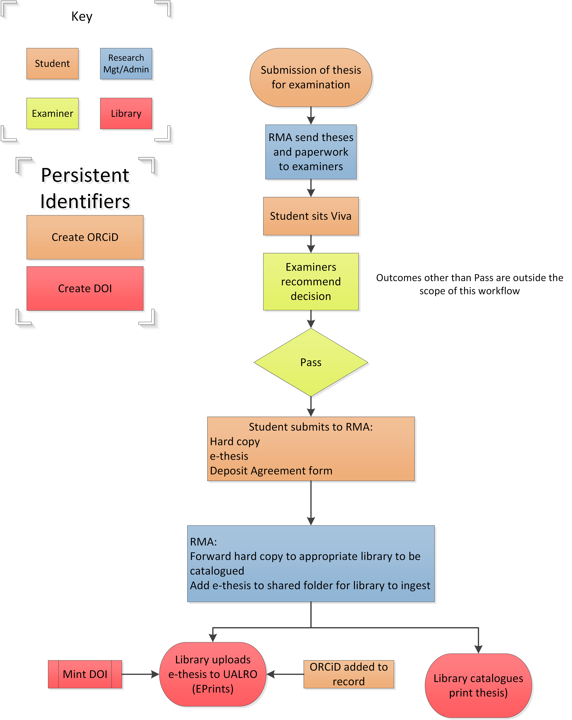
Appendix: Workflow overlaid with suggested PID creation

HESA Table 18a, Higher Degree (Research) Qualifiers by Institution and Subject of Study
For an example of a restricted thesis whose record displays information about requesting a copy, see http://ualresearchonline.arts.ac.uk/7843/

