Supplementary Material S2 – Overtopping kinematics
Velocity vectors from the numerical model and the BIV technique are compared for the steep-fronted, plunging and broken waves overtopping the lowest wall, in Figs. S2-1, S2-2 and S2-3 respectively. BIV data are limited to areas where there are changes in texture associated with bubbles and splash, but the underside of the water surface also provides data, though affected by parallax errors.
For the steep-fronted breaker in Fig. S2-1 the numerical model shows a fast-moving jet, whose velocity is greatest at the impact time t' = 0 s, in the early jet formation. The BIV picks out a relatively thin region of small air bubbles, moving up the wall. At t' = 0.20 s, during the transition region between the jet and quasi-steady flow, the numerical model predicts that the speed of the flow has slowed considerably. Agreement between the two techniques is qualitatively sensible, showing an ordered main flow in the jet direction over the wall. The downwards pointing arrows at the far left of the BIV frame arise due to the overtopping flow hitting the back wall at that time.
Kinematics of the plunging breaker shown in Fig. S2-2 show some similarities to the steep-fronted breaker but at t' = 0.1s the vector coverage in the BIV frame is not as uniform and show higher velocities. Also a larger region of bubbles is tracked. The numerical model clearly shows larger velocities for this wave. At t' = 0.1 s the velocity starts to decrease for the separated splashes which are now in free fall. The extended region of higher velocities is still evident at t' = 0.20 s suggesting more sustained high velocities at the transition from jet to weir-type overflow. A curious feature of the BIV at t' = 0.2 s and t' = 0.35 s is the presence of a number of downward-pointing BIV velocity vectors in the region between the main cloud of bubbles and the curved water surface; their cause is unknown.
The broken wave kinematics in Fig. S2-3 show much stronger effects of air-water mixing and disturbed flow. Although clear differences are visible between the physical flow and the less disturbed numerical flow, similarities are still visible at t' = 0.1 s in terms of regions with trapped air close to the wall and large velocities around the air pockets which are advected with the main uprushing flow. Also both flows show eddies, although of different nature and magnitudes.
Whilst the flow field was qualitatively similar for the numerical model and the BIV, the BIV velocity vectors were consistently of lower magnitude. For the steep-fronted wave there was a difference of about 30% which increased to about 40% for the plunging wave; agreement was much better (within 10%) for the broken wave. The reason for these discrepancies is not known. However, since the BIV method tracks bubbles and not the flow itself, it is not surprising that the technique works best for the highly aerated wave overtopping.

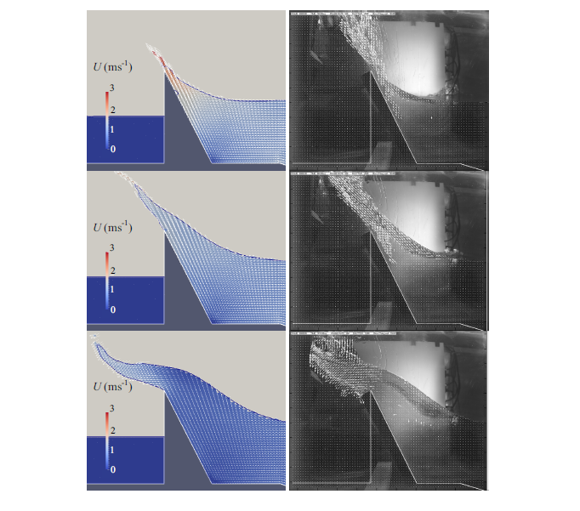
Figure S2-1 Numerical (left) and BIV calculations (right) of steep fronted wave overtopping with 150 mm freeboard. The plots show the velocity field and particle speed, U, at t' = 0.10 s, 0.20 s and 0.35 s from top to bottom

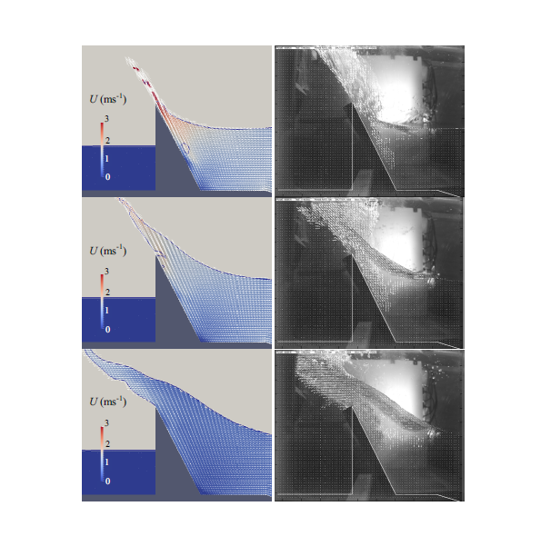
Figure S2-2 Numerical (left) and BIV calculations (right) of plunging wave overtopping with 150 mm freeboard. The plots show the velocity field and particle speed, U, at t' = 0.10 s, 0.20 s and 0.35 s from top to bottom

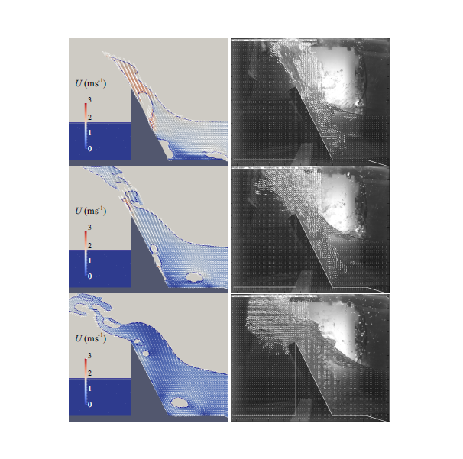
Figure S2-3 Numerical (left) and BIV calculations (right) of broken wave overtopping with 150 mm freeboard. The plots show the velocity field and particle speed, U, at t' = 0.10 s, 0.20 s and 0.35 s from top to bottom

