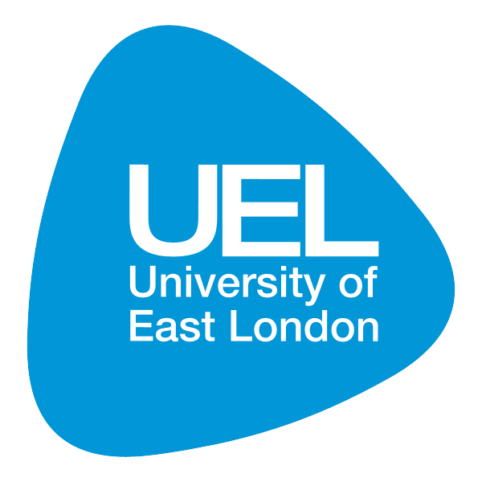

UEL Research & Knowledge Exchange Conference 2012
Call for Abstracts
Name & Title of Presenter: | Dr Nena Foster
School: | HSB
Co investigators: | Emily Freeman, Prof Angela Harden, Dr Patrick Tobi and Dr Ade Fakoya
Title of Abstract: | Getting older and living longer with HIV: Findings from a pilot study conducted in Newham
Key Theme/ Key words: | Ageing, HIV, service user experiences, age-related illness

Abstract (No more than 400 words):
Despite a growing population of people living with HIV (PLWH) aged 50+ and people becoming infected with HIV later in life, we currently know very little about getting older with HIV. There is some research on the experiences of older MSM living with HIV; however, less is known about those who have become infected with HIV via heterosexual transmission, particularly those from ethnic minority groups living in ethnically diverse areas.
This paper will present the findings from an exploratory, mixed-methods study designed to explore the needs and experiences of older adults with HIV in the East London borough of Newham, an ethically diverse and socially disadvantaged urban area. The surveyed 48 adults living with HIV living and/or accessing health or social services in and around Newham. Additionally, interviews were conducted with 11 health and social care professionals and 3 focus groups were conducted with PLWH aged 50+. Study findings on the demographics, HIV health and non-HIV of the study population will be presented, as well as findings on their experiences of financial difficulty, stigma and isolating, experiences of navigating multiple health providers and theory generated about the attribution of non-HIV related, age-related illness. Likewise, health professionals’ views about the future for HIV specialty care for people living longer and getting older with HIV.

