4.3. Evaluation of Bioclimatic Design Principles in Prototype Base-Case Vernacular Buildings
As was previously explained, some retrofitting strategies can be applied to modern residential building envelopes in order to diminish indoor air ambient temperatures in the summer, the direct effect of which is a modification of the micro-climate and changes in the conditions of the immediate surroundings [1, 2]; moreover, several of the studies that will be analysed in the following subsections prove that combining strategies on a larger scale can affect the climate of an entire area. In this study, exemplar vernacular buildings were modelled with the IES software suite in order to analyse the significance of spatial floor-plan layout designs, window openings, shading elements and topographical features of the study areas. The aim of the present empirical analysis was to determine what can be learned from existing vernacular house typologies and how modern concrete-made residential buildings can adopt these bioclimatic design principles in the course of holistic retrofitting schemes without distorting the envelopes of those buildings during the construction process.

4.3.1. Bioclimatic Design Strategy 1: Solarium
Research has shown on the investigation of bioclimatic architectural design principles that the solarium is an indispensable solar feature of the Cypriot houses and a unique Cypriot vernacular architectural element. Solariums serve as a focal space around which various activities of all other spaces are synthesised, whether the house is located in the inland, mountainous, semi-mountainous or coastal regions. According to the experimental analysis of the revival applicability of vernacular houses, whose study discussed the evolution of semi-open spaces and their counter interactions within other indoor occupied spaces and transitional spaces between the courtyard and each occupied space, vernacular Cypriot buildings have many different semi-open space typologies because of climate differentiations. In this study, the base-case representative vernacular buildings demonstrated that using arcaded openings throughout the private and semi-private spaces resulted in effective shading and appropriate occupant privacy (see Dataset E); this is why the solarium acts as a transit space and unites the outer with the inner building layout, as shown in Figures 4.1 (a) and (b).

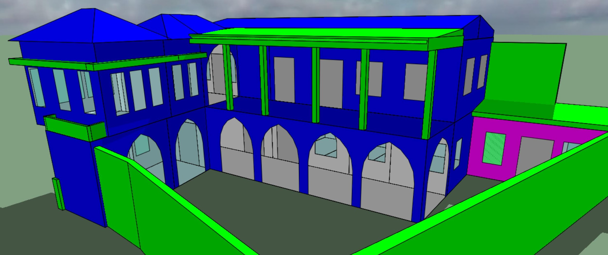
(a)
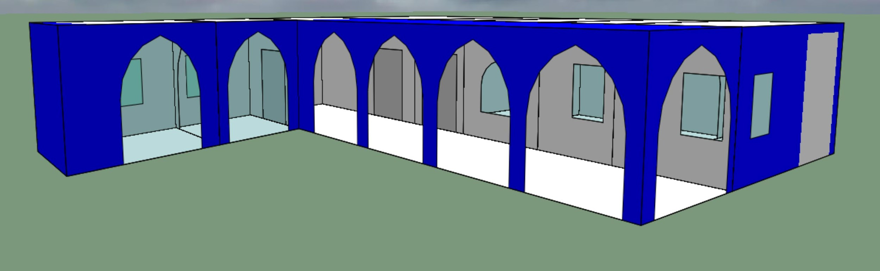
(b)
Fig. 4.1. (a) Arcaded semi-open spaces were devised on the ground-floor level, and the veranda was designed on the first-floor level and was oriented toward the main courtyard in densely urban historic settlement in Cyprus; (b) arcaded semi-open spaces provide continuous integration between the courtyard and indoor occupied spaces and protects residents from direct solar radiation.

As can be seen in Figure 4.1 (a), the solarium is a significant architectural feature and an early instinctive approach to passive solar design. It is simultaneously an outward extension of the house and an inward extension of the courtyard. As was shown in Table 1, an internal space with an open south side accommodates the functions of the ‘double room’ (i.e., Type B) to the arcaded semi-open space in the summer and on sunny winter days. Moreover, the courtyard activities are shifted to the solarium when the weather does not permit occupants to be out in the open. In a study on testing energy effectiveness of passive cooling design strategies, the authors noted that the solar role of the vernacular bioclimatic elements was predominant, whether acting as a portico, a corridor, a central axis, or even when it has evolved into a self-contained space, as shown in Figure 4.1 (b). This confirms that this architectural feature provides a focal space for the house, even in periods of prosperity when the construction of bigger multi-roomed houses was financially and technically possible indicated by this pilot study. In this way, there is a need to bring different approaches together into a standardised framework that utilises the existing construction knowledge that was developed by previous builders; such a combination would have an impact on sustainability and building performance at the time that existing residential buildings are being upgraded [3].

4.3.2. Bioclimatic Design Strategy 2: Courtyard
Several studies have highlighted the need to improve the quality and increase the quantity of the existing housing stock in Cyprus [4, 5]. Previously published research has shown, however, that those involved in the decision-making processes of retrofitting interventions have forgotten to take into account the bioclimatic design principles of vernacular houses built in past centuries [6]; for this reason, this section will delineate an evaluation of the impact of courtyard design on the thermal comfort of occupants (see Dataset F and G). The findings of research support the notion that the courtyard is another building element in Cypriot houses that acts as a climate modifier. It is an arrangement that has naturally evolved because of the climatic conditions, which vary between urban and suburban regions, as shown in Figures 4.2 (a) and (b). This can be seen in the evolution of courtyard typologies, which have led to different design features within the floor-plan layout design of transitional spaces in vernacular buildings.

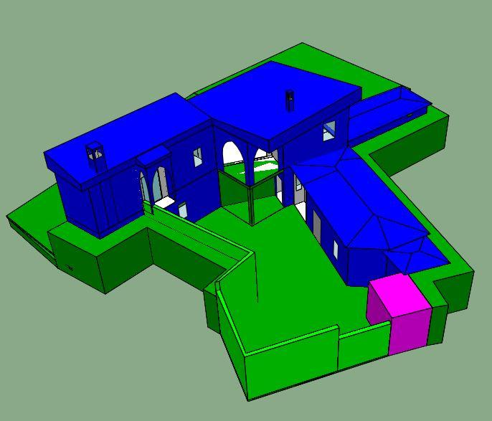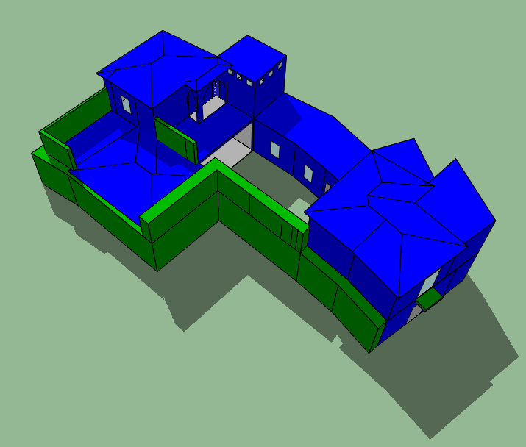
(a) (b)
Fig. 4.2. (a) The main indoor occupied spaces and outbuildings for service purposes are surrounded with the courtyard in rural regions; (b) two different vernacular buildings are entailed within the courtyard in rural regions.

In Cyprus, courtyard spaces are the focal point of the social activities of households and the place where occupants spend most of their time each day. This is because courtyard areas provide privacy to inhabitants, as these spaces are designed to separate family life from activity on the street in urban regions. Furthermore, the courtyard also provides a wide range of activities and environmental benefits in suburban regions; for example, the courtyard has become the most frequently used open space due to the provision of acclimatisation of the indoor air environment in warm-weather summer conditions [7]. Notably, traditional vernacular buildings in the study area respond to the previously described thermal conditions, although it should be noted that traditional lifestyles were centred around agricultural activities, and significant physical effort was required for the daily activities of occupants, partly due to the thermal conductivity level of building materials, and also because of the higher metabolic heat production of the occupants.
As can be seen in Figure 4.2 (a), the main building and other outbuildings have evolved to surround the courtyard, which is in-line with changes to occupant lifestyles and of the family structure in rural regions over the past several decades. Figure 4.2 (a) illustrates that whether the courtyard opens onto the road, thereby allowing social contact, or is positioned at the rear of the house and protected with high adobe walls or the house volume itself for privacy, a microclimate that moderates the climate surrounding the building is always created. It is also important to note that the courtyard and the surrounding areas were typically planted with deciduous vegetation (i.e., grapevines, pomegranates and fig trees), which offered shade in the summer and allowed sun in the winter [8]. It also created windy sides, which were quite valuable when occupants were seeking a breeze in the summer or calm corners in the winter. Arches, trees and arcades around the perimeter are indispensable shields against the overhead midday sun in the summer [9].
Figure 4.2 (b) demonstrates that two main vernacular buildings and the outbuildings have evolved to surround the courtyard according to changing kinship relationships of the occupants. In the illustration, it can be seen that the courtyard appeared at the time when auxiliary buildings were being constructed in the harsh topographical geography of a rural region. The most obvious conclusion to emerge from the present analysis was that courtyards have the potential to influence the quality of the indoor air environment within neighbourhood buildings. To ease the hot, humid climate conditions experienced in the summer, courtyard spaces are the centre of the socio-cultural needs and activities of the house; the spaces allow daylight, shade and cross ventilation and work as a thermal regulator by enhancing breezes regardless of the wind direction.
In addition to the solar-protection feature that comes with courtyard spaces and buildings that have evolved to form the typological features of vernacular houses, it is also important to consider the impact of wind frequency and the direction of prevailing winds; when wind passes over the structure, areas of low pressure are created in the buildings and in the courtyard that help to lessen the risk of overheating and exposure to high solar radiation [10]. Moreover, the courtyard design collects cool air during the night to provide thermally comfortable sleeping conditions; for this reason, incorporating bioclimatic design elements of vernacular houses should be considered whenever possible [11].

4.3.3. Bioclimatic Design Strategy 3: Overhanging Roofs and Other Shading Elements
Figure 74.3(a) illustrates a traditional vernacular house that is located in densely built urban regions and has window-opening features. The main building is built in solid stonewalls and has a wooden roof structure, with ceilings that are constructed out of flat boards made of palm wood that create adequate thermal insulation; the only area not covered in this way is the living space on the ground-floor level, where the timber frame structure is exposed [12]. The house is oriented toward the street, and there are no obstructions from the south, east or west; surrounding outbuildings positioned in the courtyard space provide solar protection from the north. As can be seen in Figure 4.3 (a), solar control through overhanging balcony projections, roofs and shading elements devised on the top of window openings, obstruct the shortwave solar radiation, which thereby limits solar gains and diminishes radiant heat load; this results in less direct short-wave and long-wave radiation being emitted from the surfaces. Solar control strategies should therefore take space configuration, geometry and orientation into account (see Dataset H). It is also important to remember that space configuration affects the relationships of the sky-view area and the surface; subsequently, the heat from long-wave radiation dissipates through several horizontal and vertical surfaces. In Cyprus, solar protection is achieved by overhanging roofs and horizontal–rectilinear shading elements implemented throughout the building envelope, as shown in Figures 4.3 (b) and (c).

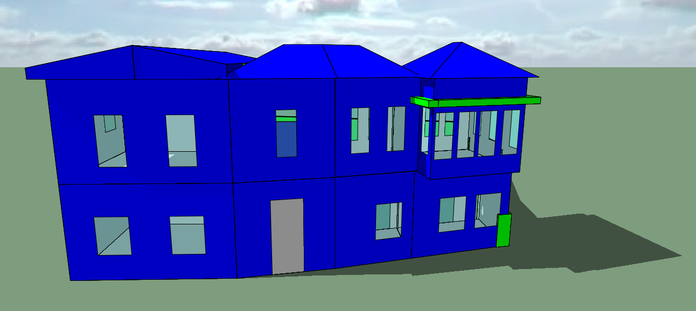
(a)
Fig. 4.3. (a) The overhanging balcony projection allows to avoid high solar radiation into indoor occupied spaces. Additionally, it also provides effective shading to the pedestrians throughout the main street in densely built urban regions in Cyprus.

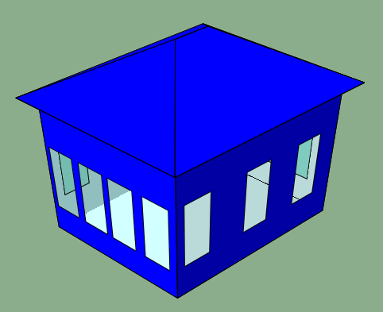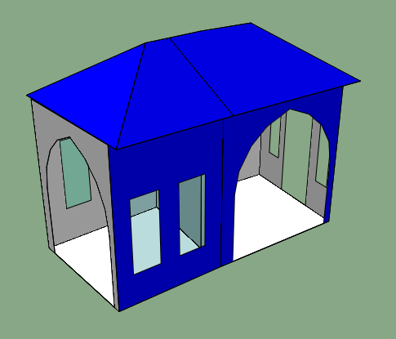
(b) (c)
Fig. 4.3. (b) The overhanging roof was implemented on the balcony space projections to provide an additional solar protection; (c) The arcaded opening was implemented through transitional spaces in order to harness natural ventilation effectively.

One additional point related to thermal mass that is worth considering is that, while most courtyard houses in Cyprus have timber-beamed ceilings and clay-tile roofs, the roofs of some courtyard houses located in the north of the island are covered with a layer of soil with vegetation that serves as insulation [13, 14]. In the Famagusta region, therefore, there as a different, more commonly used typology: the brick or stone vault. This element is used in most of the spaces in the house, and the brick is left exposed to reveal different intricate building designs. Due to latitude of Cyprus, horizontal radiation is severe and intense, and the roofs are the most exposed surfaces of the envelope; it should also be noted that arched and pitched roofs, which are common in courtyards, help to moderate solar exposure and heat gains. At the same time, it is important to realise that the implementation of shading elements has been shown to have a wider range of applications because of the location of buildings, the climate and environmental parameters, among other factors. It should be emphasised that overhanging balcony projections are the most dominant shading elements in Cyprus because they facilitate a thermally comfortable indoor air environment in the summer by harnessing effective natural ventilation.

4.3.4. Bioclimatic Design Strategy 4: Materials
When considering the internal environment in a building, it is necessary to understand the interrelationship between several different thermal characteristics of the building; it is also important to take the energy efficiency of locally available materials in this particular study context into account. This means that materials constitute the ‘skin’ layer of a vernacular building’s envelope, which makes them an essential component of the heat-transfer processes that takes place in climatic urban environments [15]. The most frequently used materials for building envelopes in Cypriot vernacular architecture were limestone, masonry and clay, as is shown in Figures 4.4 (a), (b) and (c). This is because these construction materials were provided by locally available resources; additionally, the different thicknesses of these materials help to maintain a cool indoor air environment in the summer and to contain warmth in the winter [16].

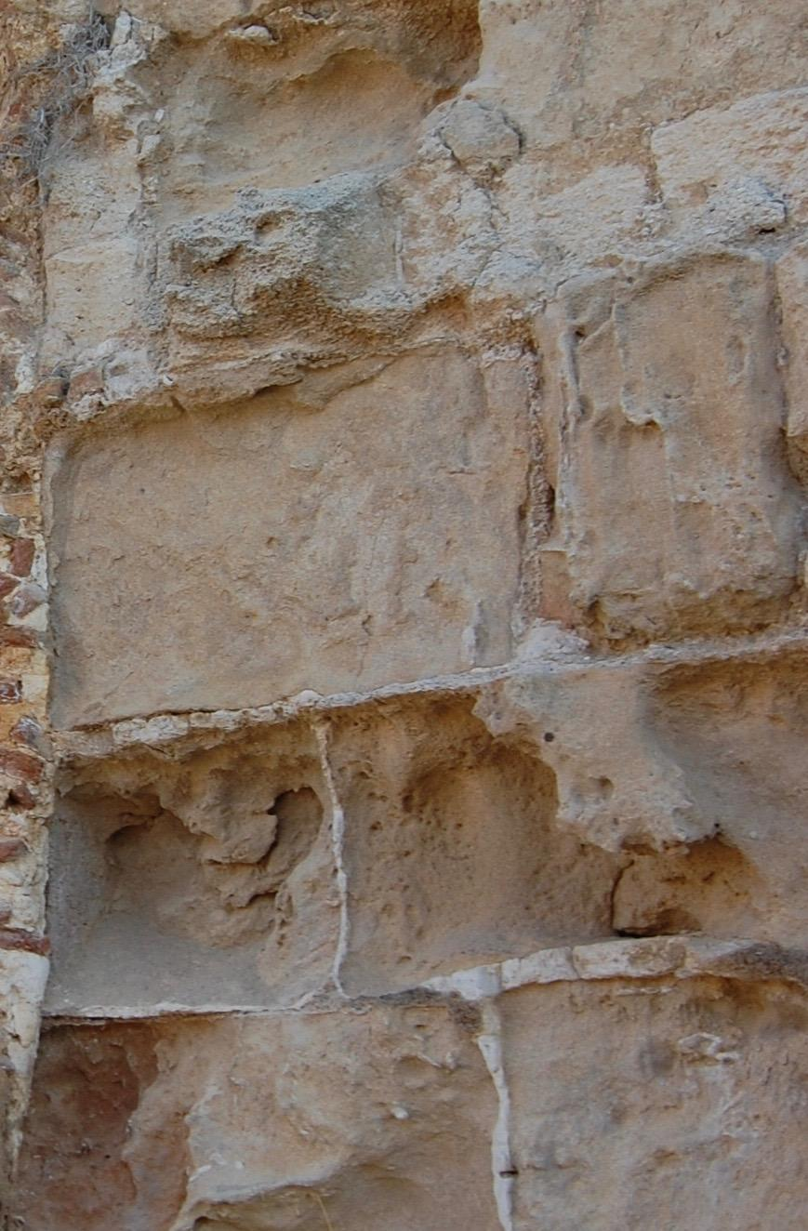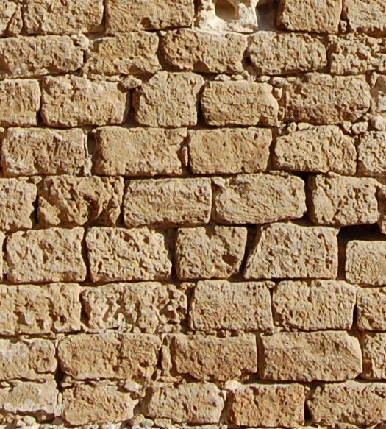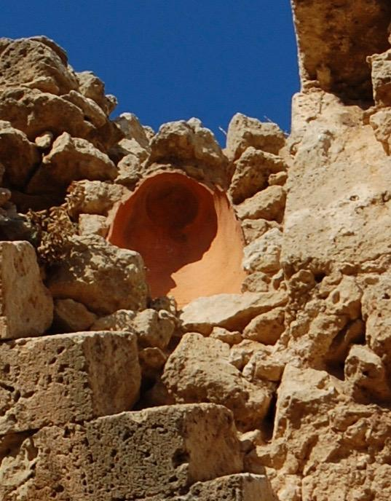
(a) (b) (c)
Fig. 4.4. (a) Limestone; (b) masonry; and (c) clay

However, it is mentioned that there is a need to evaluate the thermal properties of locally available building materials that could be integrated into building-energy simulations to concurrently undertake dynamic thermal simulations with material changes. It also means that construction elements combined with local materials have been acknowledged as being impotent bioclimatic design principles that exacerbate the heat and the island effect in cities [17]. Furthermore, due to their surface properties, the choice of materials affects overall occupant perceptions in terms of thermal, visual and acoustic comfort [18].
Many scholarly studies explained that high-albedo materials can help to reduce the cooling loads of a building [19]; as a consequence, the amount of solar radiation reflected into the sky is maximised, and the quantity of absorbed radiation is diminished, which results in less energy being stored in the building fabric [20]. Converting the vertical elements of a building into highly reflective surfaces increases outdoor discomfort by adding to the occupants’ radiant load [21]. It is important to note that implementing clay-tile roof on the horizontal surfaces of the building has a significant impact on cooling air temperatures, as the material absorbs a greater amount of solar radiation and reflects it back up into the sky [22].
In this research context, it has been deduced that energy use depends on the thermal transmittance of building envelopes. This is why the vernacular houses of Cyprus resemble those in the rest of Mediterranean islands: solid volumes, thick masonry walls with small openings, a whitewashed plaster skin that covers almost everything with an integrative power and the creation of a composition through continuous repetition of traditional building layouts. All these elements produce organic building forms, which have evolved to the climatic conditions through a long response using locally available resources. In a study of vernacular buildings in Cyprus, it is clear that nature takes a decisive role in that particular architectural idiom and brings about climate-responsive design principles from the local builders—and in most cases, from the inhabitants themselves.
Notably, climate, scarcity of materials and topography delineate the primary design parameters and were respected with admirable integrity to the built environment [23]. Furthermore, the primary building materials are hard limestone rock and sandstone, which is referred to as ‘yellow stone’ in the Cypriot dialect; these are used with or without mortar and are covered with plaster to protect the joints from decay caused by wind and rain [24]. As was previously mentioned, a more elaborate and permanent form of vernacular architecture that can be found in four different regions is the arcaded rectangular house; this is the simplest type of overhanging-roofed dwelling typology across the island. The windows of the rectangular house are defined by masonry walls that are 50-80cm thick, include carved niches and storage areas and are limited in number and size according to the climatic characteristics of the specific region. To contend with the hot and humid climate, lintels are made of local yellow-stone blocks or wooden elements.

4.3.5. Bioclimatic Design Strategy 5: Thermal Mass
To gain the full benefit of structural thermal mass, it is essential that internal heat gains have access to the thermal inertia of buildings [24]. Additionally, the rapidly increasing demands and the effects of either internal or external factors on indoor air temperature fluctuations in relation to physiological human-based factors are significantly correlated with the thermal properties of a building. As such, there is a need to consider more in-depth scientific evidence and literature reviews to fill this knowledge gap.
‘Thermal mass’ was defined by Cadima [25] as the capacity of a building to store and release heat at different times of the day; this means that thermal inertia works as a climate moderator by minimising temperature fluctuations inside living spaces, as shown in Figures 4.5 (a) and (b). The denser the material that is used, the more heat it can store, and is thus able to moderate thermal conductivity and increase the time lag between outdoor and indoor temperatures. Because of these properties, the entire thermal mass of a building does not need to be exposed to direct sunlight, but a large portion should be [26]; this results in heat energy that is absorbed and will slowly spread throughout the material, and heat is then released during the evening and night. The cooling-down process cannot take place by heat loss through the building envelope alone; this dissipation is by night ventilation [27].

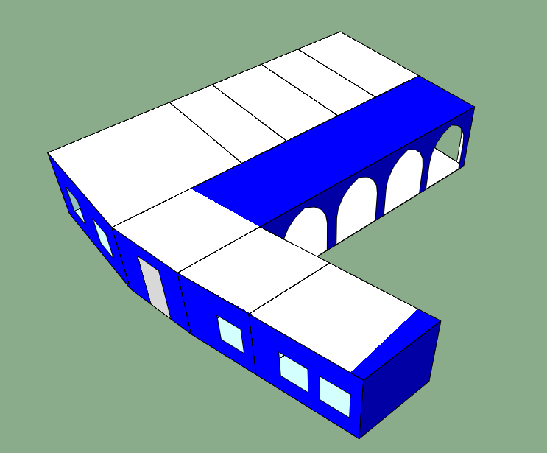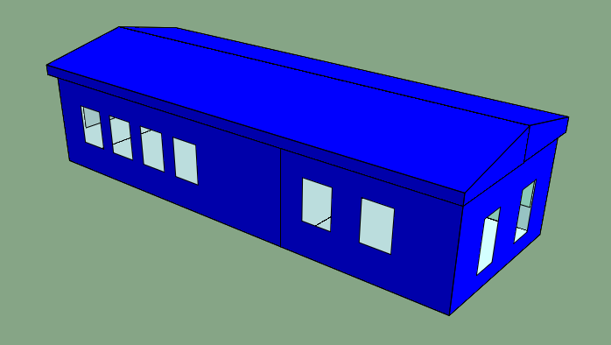
- (b)
Fig. 4.5. (a) Typical ground-floor layout of vernacular house in urban region; (b) typical first-floor layout of vernacular house.

As can be seen in Figures 4.5 (a) and (b), both the indoor occupied spaces and the semi-open spaces lead to a direct circulation of the arcaded transitional spaces on the ground-floor level. These spaces are aligned with each other in order to control indoor air temperatures in the winter. One of the primary concerns is that maintaining the efficacy of the thermal mass relies on the walls and optimised indoor air temperature throughout the year. The thick walls also help to ease indoor air temperatures in summer. Additionally, the arcaded solarium space was devised to be purpose-built in an attempt to avoid excessive solar radiation in this particular Mediterranean climate, especially in the afternoon. Similarly, the indoor occupied spaces are also allocated to each other in close proximity on the ground-floor level, which is oriented toward the main courtyard space. This design feature permits more daylight and captures the prevailing wind in the afternoon; as this is the case, the thermal mass of vernacular buildings significantly contributes to the enhancement of indoor air quality throughout the year.
Notably, in the Cypriot vernacular architecture, walls do not only work as structural elements; they also protect the liveable spaces from light, wind, heat, dust and rain. Because the walls are meant to be thick and heavy, they are built with common clay brick or adobe masonry. In some cases, the brick is left exposed, and it is also common to cover the surfaces with a thin plaster that is painted light colours [28]. It has been emphasised that heavyweight buildings have advantages in hot climates and during heat waves, since their time constant of several days or weeks will delay heat build-up. However, they also carry disadvantages, such as having a very long warm period in winter after periods of inoccupation [29]. These climate change related precipitations demonstrate that thermal mass cannot work as efficiently with intermittent heat gain areas, due to the time it requires to store or release the heat. It is therefore essential that a holistic outlook is taken when considering how to upgrade the energy efficiency of existing residential buildings; hence, the thermal transmittance of buildings strongly correlates with the local climate conditions of the vernacular houses under investigation.

4.3.6. Bioclimatic Design Strategy 6: Windows
Addressing the issue of harnessing natural ventilation to each occupied space in modern residential buildings, it is important to consider the implementation of top-window openings or other climate-responsive environmental features in retrofitting interventions [30]. The features that provide or explain environmentally effective design strategies were delineated. This pilot study investigated several ventilation strategies in self-built residences in Cyprus, which helped to comprehensively illustrate the general situation. This study proposed a meaningful and accessible approach that could be applied by policymakers; while at the same time providing subsequent basis information to formulate a research design layout by means of investigating window typologies in an exemplar vernacular house. As such, in the Cypriot vernacular architecture, most openings in the courtyard houses were kept small to avoid unnecessary heat gains, but were sufficient enough to allow adequate ventilation; they are typically oriented toward an internal courtyard, as shown in Figures 4.6 (a) and (b).

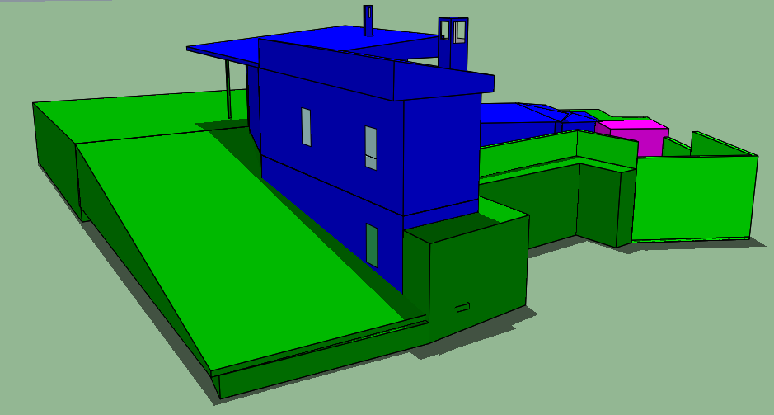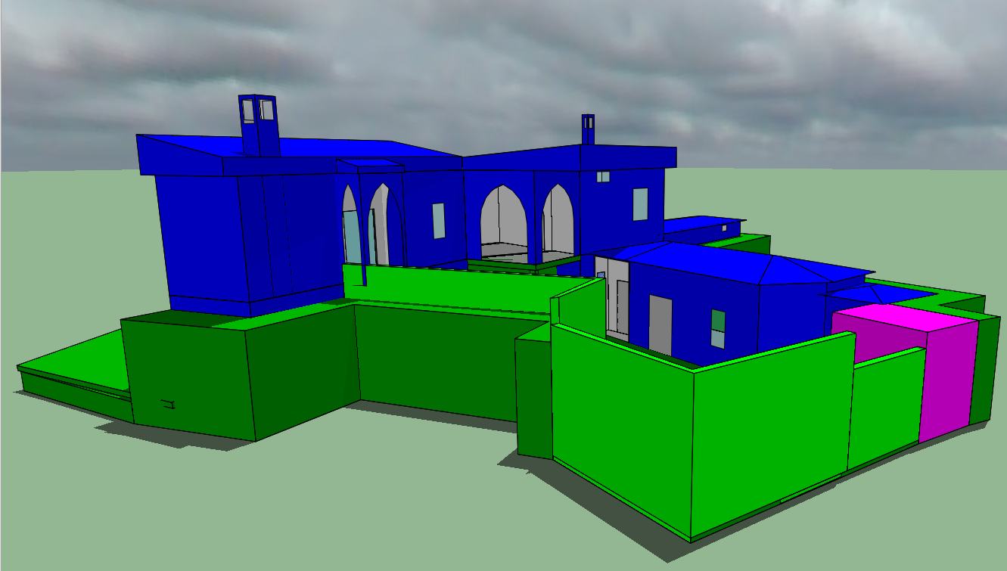
- (b)
Fig. 4.6. (a) Narrow vertical window openings located on the street side of the building envelope in mountainous regions; (b) wide vertical window openings covered by arcaded solarium spaces to protect inhabitants from direct solar radiation throughout the day.

As can be seen in Figures 4.6 (a) and (b), roof openings are used to enhance the natural stack effect when vertical opposite openings are difficult to place on the building envelope. It is also worth noting that there are no evident protrusions, and that smaller openings located above these windows and below the roof serve as vents in the summer and are closed during winter. Overhangs were later introduced as shading devices and to keep rainwater away from the walls and windows; for this reason, the thick, sometimes tapered walls were carefully designed to shade these openings in the summer but not to block sunlight in the winter. Notably, to avoid excessive sunlight luminosity in the indoor living spaces, wooden shutters were also used as a shading device [31]. It is assumed that the orientation of these windows followed contextual features, since site integration and minimum excavation determined the positioning and form of the house.
As it relates to considering the thermal efficiency of designing appropriate window openings by exploring the revival and applicability of bioclimatic design principles inherited from vernacular architecture, it is commonly believed that perpendicular air flow to the openings generates the greatest amount of pressure. Conversely, research has found that oblique wind directions increase indoor wind pressure and air flow circulation; 45° of the perpendicular has been shown to be the most effective [32]. By adding vertical projected elements that are the same size of the opening widths and oblique windows, it is possible to double the average wind speed into the indoor occupied spaces [33].
To summarise, the wide range of bioclimatic design principles that have evolved are specific to the inland, mountainous, semi-mountainous and coastal regions of Cyprus; but examples of Cypriot architecture that was adapted to specific locations and climates can be found all around the world. Research related to similar projects, in which vernacular practices were used as an example of how to implement these strategies onto modern building design applications must therefore be extended and reviewed; the traditional practices should not be completely replicated, but an analysis should be undertaken to determine which of those practices were effective and which could be improved by new methods. The empirical analysis in this study was intended to show that vernacular architecture can serve as a support for contemporary practices, thereby redefining our customary living, reducing environmental impacts and changing pre-set concepts of construction and design for residential buildings. To address changing climate conditions and the detrimental impact on occupant thermal comfort, finding effective solutions related to implementing both vernacular materials and bioclimatic design strategies and the effects thereof on building performance is the primary goal.

References
[1] Panayiotou, G., Charalambous, S., Vlochos, S., Kyriacou, O., Theofanous, E. & Flippou, T. (2013). Increase of the energy efficiency of 25 low- income households in Cyprus Increase of the energy efficiency of 25 low-income. doi:10.13140/2.1.4935.3607
[2] Santamouris, M., Sfakianaki, A., & Pavlou, K. (2010). On the efficiency of night ventilation techniques applied to residential buildings. Energy and Buildings, 42(8), 1309–1313. https://doi.org/10.1016/j.enbuild.2010.02.024
[3] Beccali, M., Strazzeri, V., Germanà, M. L., Melluso, V., & Galatioto, A. (2018, February 1). Vernacular and bioclimatic architecture and indoor thermal comfort implications in hot-humid climates: An overview. Renewable and Sustainable Energy Reviews. Elsevier Ltd. https://doi.org/10.1016/j.rser.2017.06.062
[4] Rowlands, S., & Kempen, V. (2009). Mass Housing in Europe, multiple faces of development, change and response, Palgrave Macmillan, London.
[5] Ringel, M., & Knodt, M. (2018). The governance of the European Energy Union: Efficiency, effectiveness and acceptance of the Winter Package 2016. Energy Policy, 112, 209–220. https://doi.org/10.1016/j.enpol.2017.09.047
[6] Soflaei, F., Shokouhian, M., & Zhu, W. (2017). Socio-environmental sustainability in traditional courtyard houses of Iran and China. Renewable and Sustainable Energy Reviews. Elsevier Ltd. https://doi.org/10.1016/j.rser.2016.09.130
[7] Taleghani, M., Tenpierik, M., van den Dobbelsteen, A., & Sailor, D. J. (2014). Heat in courtyards: A validated and calibrated parametric study of heat mitigation strategies for urban courtyards in the Netherlands. Solar Energy, 103, 108–124. https://doi.org/10.1016/j.solener.2014.01.033
[8] Benjamin, J., Rovere, A., Fontana, A., Furlani, S., Vacchi, M., Inglis, R. H., … Gehrels, R. (2017). Late Quaternary sea-level changes and early human societies in the central and eastern Mediterranean Basin: An interdisciplinary review. Quaternary International. Elsevier Ltd. https://doi.org/10.1016/j.quaint.2017.06.025
[9] Valinejadshoubi, M., Heidari, S., & Zamani, P. (2019). The impact of temperature difference of the sunny and shady yards on the natural ventilation of the vernacular buildings. Journal of Building Engineering, 26. https://doi.org/10.1016/j.jobe.2019.100880
[10] Malaktou, E., Philokyprou, M., Michael, A., & Savvides, A. (2016). Environmental behaviour of semi-open spaces in Mediterranean vernacular architecture. The case of rural traditional dwellings of Cyprus. Renewable Energy and Power Quality Journal, 1(14), 599–604. https://doi.org/10.24084/repqj14.406
[11] Baghaei Daemei, A., Haghgooy Osmavandani, P., & Samim Nikpey, M. (2018). Study on Vernacular Architecture Patterns to Improve Natural Ventilation Estimating in Humid Subtropical Climate. Civil Engineering Journal, 4(9), 2097. https://doi.org/10.28991/cej-03091142
[12] Alrashed, F., Asif, M., & Burek, S. (2017). The role of vernacular construction techniques and materials for developing zero-energy homes in various desert climates. Buildings, 7(1). https://doi.org/10.3390/buildings7010017
[13] Craig, S. (2019). The optimal tuning, within carbon limits, of thermal mass in naturally ventilated buildings. Building and Environment, 165. https://doi.org/10.1016/j.buildenv.2019.106373
[14] Mata, É., Wanemark, J., Nik, V. M., & Sasic Kalagasidis, A. (2019). Economic feasibility of building retrofitting mitigation potentials: Climate change uncertainties for Swedish cities. Applied Energy, 242, 1022–1035. https://doi.org/10.1016/j.apenergy.2019.03.042
[15] Pekdogan, T., & Basaran, T. (2017). Thermal performance of different exterior wall structures based on wall orientation. Applied Thermal Engineering, 112, 15–24. https://doi.org/10.1016/j.applthermaleng.2016.10.068
[16] Genova, E., Fatta, G., & Vinci, C. (2017). The Recurrent Characteristics of Historic Buildings as a Support to Improve their Energy Performances: The Case Study of Palermo. In Energy Procedia (Vol. 111, pp. 452–461). Elsevier Ltd. https://doi.org/10.1016/j.egypro.2017.03.207
[17] Negro, E., Cardinale, T., Cardinale, N., & Rospi, G. (2016). Italian Guidelines for Energy Performance of Cultural Heritage and Historical Buildings: The Case Study of the Sassi of Matera. In Energy Procedia (Vol. 97, pp. 7–14). Elsevier Ltd. https://doi.org/10.1016/j.egypro.2016.10.008
[18] Anastaselos, D., Oxizidis, S., Manoudis, A., & Papadopoulos, A. M. (2016). Environmental performance of energy systems of residential buildings: Toward sustainable communities. Sustainable Cities and Society, 20, 96–108. https://doi.org/10.1016/j.scs.2015.10.006
[19] Chatzidimitriou, A. (2012). Evaluation of the influence of design parameters on the microclimate of urban open areas and on thermal comfort during the summer period in Mediterranean climate. PhD Thesis. Aristotle University of Thessaloniki. Thessaloniki.
[20] Chatzidimitriou, A., N. Chrissomallidou, S. Yannas. (2006). Ground surface materials and microclimates in urban open spaces. PLEA 2006, Geneva.
[21] Brtez, S., H. Akbari. (1997). Long term performance of high albedo roof coatings. Energy and Buildings. Journal 25. pp. 159-167. Elsevier.
[22] Bougagioti, F., A. Oikonomou. (2003). Thermal behaviour of materials used in the skin of the city in Greece. PLEA 2003. Santiago.
[23] Claude, S., Ginestet, S., Bonhomme, M., Moulène, N., & Escadeillas, G. (2017). The Living Lab methodology for complex environments: Insights from the thermal refurbishment of a historical district in the city of Cahors, France. Energy Research and Social Science, 32, 121–130. https://doi.org/10.1016/j.erss.2017.01.018
[24] Congedo, P. M., Baglivo, C., & Centonze, G. (2020). Walls comparative evaluation for the thermal performance improvement of low-rise residential buildings in warm Mediterranean climate. Journal of Building Engineering, 28. https://doi.org/10.1016/j.jobe.2019.101059
[25] Cadima, P. (2000). Transitional Spaces: the potential of semi-outdoor spaces as a means for environmental control with special reference to Portugal. PhD Thesis. Environment and Energy Studies Programme. AA School of Architecture. Graduate School. London.
[26] Bougagioti, F. (2005). Measurements of surface temperatures of materials in urban open spaces in Athens, Greece. PLEA 2005. Beirut.
[27] Bougagioti, F. (2007). The effect of shading on the night-time radiant cooling of the materials used on horizontal city surfaces. PLEA 2007. Singapore.
[28] Akbari, H. (2007). Opportunities for saving energy and improving air quality in Urban Heat Islands in Advances in Advances in Passive Cooling, pp. 30-93. Earthscan. London.
[29] Dimoudi, A., M. Nikolopolou. (2003) Vegetation in the urban environment, microclimatic analysis and benefits. Energy and Buildings. Journal 35. pp. 69-76. Elsevier.
[30] Du, X., Bokel, R., & van den Dobbelsteen, A. (2019). Spatial configuration, building microclimate and thermal comfort: A modern house case. Energy and Buildings, 193, 185–200. https://doi.org/10.1016/j.enbuild.2019.03.038
[31] Subramanian, C. V., Ramachandran, N., & KUMAR, S. S. (2017). A review of passive cooling architectural design interventions for thermal comfort in residential buildings. Indian J. Sci. Res, 14(1), 163–172.
[32] Givoni, B. (1969). Man Climate & Architecture. (Second Edition). New York: Van Nostrand Reinhold Company.
[33] Thravalou, S., Philokyprou, M., & Michael, A. (2018). The impact of window control on thermal performance. investigating adaptable interventions in vernacular Mediterranean heritage. Journal of Architectural Conservation, 24(1), 41–59. https://doi.org/10.1080/13556207.2018.1456058

