Appendix A.1
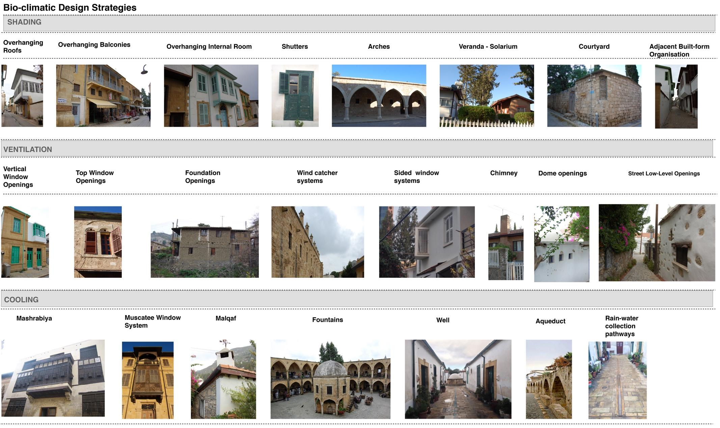
Fig. A.1. On-site photographic documentation of bioclimatic design systems in the South-eastern Mediterranean climate of Cyprus.
Appendix A.2
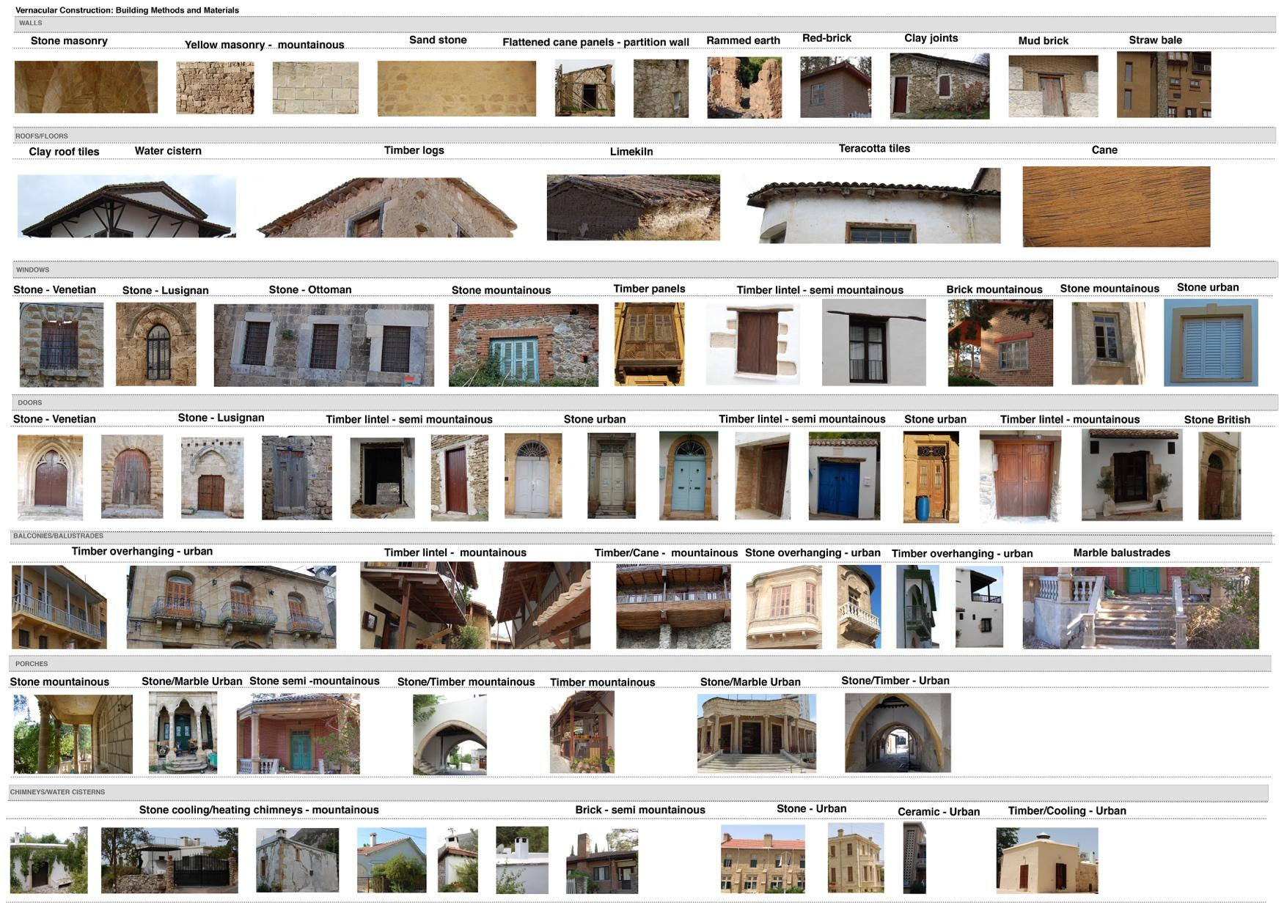
Fig. A.2. On-site photographic documentation of vernacular buildings’ construction elements in the South-eastern Mediterranean climate of Cyprus.

