5. Evaluation of Passive Evaporative Cooling Systems in Traditional and Modern Architecture
The previous section introduced the revival and applicability of bioclimatic design elements that are inherent to vernacular buildings. It scrutinised the importance of the construction materials and environmental design principles of these buildings in the hot and humid climate of Cyprus was scrutinised, the way in which these elements were used, the reasons why they were changed and the buildings with which they were replaced. This section introduces passive-cooling design strategies and establishes a definition for VPCs that is applicable to energy-conscious retrofitting interventions associated with the present research, which also identifies and explains traditional cooling systems implemented in vernacular buildings that consider different climatic characteristics of the built environment.

5.1 Overhanging Balcony Projection with Wooden Frame Shutter System
Passive evaporative cooling systems can mostly be found in hot–dry and hot–humid climate regions of the world [1]. This is a traditional Islamic building-system pattern that stretches from India to Cyprus and is often applied to residential buildings in order to optimise indoor thermal comfort under severe summer temperature conditions [2]. Figures 5.1 (a) and (b) demonstrate the application of these systems, which are directly related to the building typology and the architectural and urban characteristics of the region that have evolved for centuries. For example, wind-catcher systems, top-window openings and overhanging balconies with shading elements have been shown to be the most efficient passive strategies for such cooling systems, and these strategies are used and embedded in the culture according to different requirements and local traditions [3]. Most of the frontier examples that highlight these indigenous technologies are based on limited, local use of energy and construction materials that work in harmony with the natural environment, which have been assimilated, if not actually suppressed, during the rapid growth of the industrial world [4].
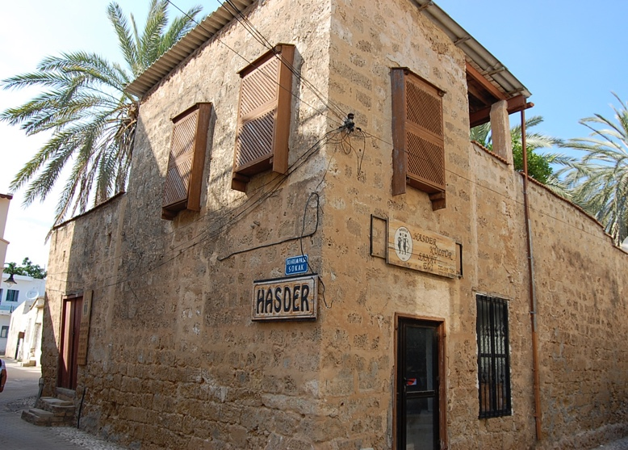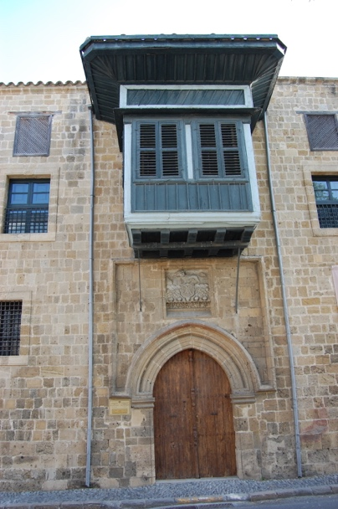
(a) (b)
Fig. 5.1 (a) Facade of a vernacular building that shows how porous ceramic and wind-escape produce internal air movement; the arrows indicate the direction of airflow, and arrow length corresponds with airspeed (b) Mashrabiya element for passive-cooling in a vernacular house in Cyprus.
As was previously stated, passive-evaporative cooling systems were the subject of this investigation; from this point onward, these systems will be tailored with the integration of porous ceramic material intended for natural ventilation of indoor environments in residential retrofitting efforts. This is a low-tech passive-cooling design solution that facilitates the circulation of humid, hot air from the outdoors, and the system must be placed adjacent to the perimeter walls, or alternately in contact with the roof [5]. Several pilot studies have tested the applicability of implementing porous ceramic in inefficiently constructed residential structures; in newly built residential buildings, however, only the rooms with access to external walls can use this particular cooling technique [6,7]; these studies are also highlighted mitigation techniques and effective low-tech passive-cooling design solutions that must be adopted in service areas, such as corridors, lobbies and general circulation spaces.
In order to investigate the integrity of porous ceramic systems into a residential building retrofitting scheme, as is shown in Figures 5.2 (a) and (b), a recent study that was undertaken by Schiano-Phan in 2008 to test the implementation of porous ceramic materials onto building envelopes discussed the low-tech design solution systems and the impact thereof on optimising occupant thermal comfort at home. To prove the hypothesis developed by previous scholars, it can therefore be asserted that in apartment blocks, the floor level has a direct bearing on the size of the porous ceramic system that is needed [8]. Certain floor-plan layout designs on the ground floors that are affected by heat gains because of high-albedo asphalt surfaces can potentially benefit from the installation of a porous ceramic system as a façade on the outer skin [9].
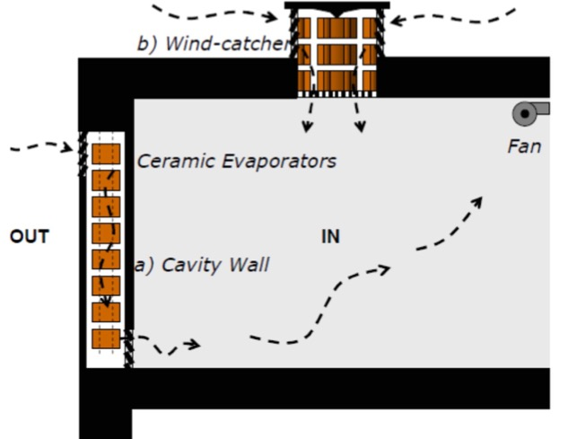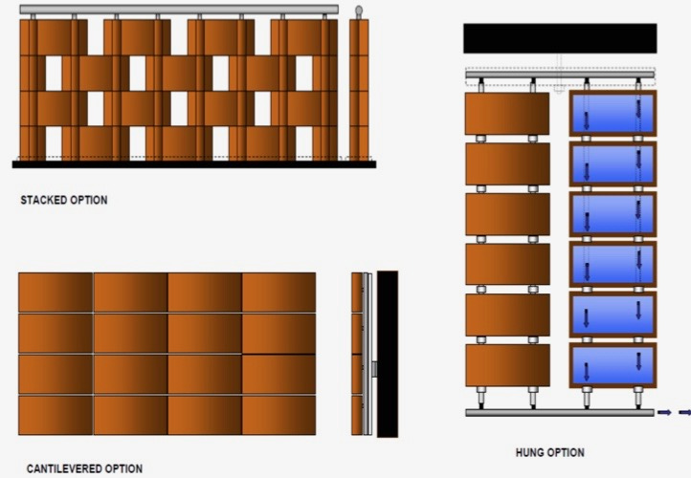
- (b)
Fig. 5.2 (a) Principles of operating the porous ceramic systems; (b) diagrams showing the integration of a porous ceramic system with a substitution of an existing perimeter wall: before (left) and after (right). (Image credits: Schiano-Phan, 2008)
Figure 5.2 (a) demonstrates the ingress of fresh air through a wet-cavity wall system, which induces particles to be filtered and circulates water into the occupied space. In the intermediate floors, as well as on the ground floor, the reduced availability of perimeter space is compensated by reduced envelope gains and reduced indoor cooling requirements. In order to identify the workflow of the wet-cavity wall system in the top floor apartments, where the roof can be used as an additional surface for the integration of the porous ceramic system to acclimatisation of indoor air environment [10]. Studies conducted by Schiano-Phan in 2010 [11] and Golzari in 2014 [12] concluded that mitigation techniques, such as night-time ventilation, solar control and improvements in the building envelope, resulted in a significant reduction of the cooling loads that can often be exclusively observed by a wall-integrated porous ceramic system.

5.2 Mashrabiya and Muscates Window System
In 1986, Fathy tested and investigated the modern applicability of a type of opening that is typically used as an external window in the vernacular architecture of Egypt and as traditional indoor partition elements in Saudi Arabia, as shown in Figure 5.3 (a). Many scholarly articles have been discussed the concept of mashrabiya, which has been extensively used in hot–arid and hot–humid regions, particularly in the Middle East and North Africa. Similar evaporative cooling strategies can also be seen in Mediterranean regions, as well as in Cyprus, as shown in Figure 5.3 (b) [12,13].
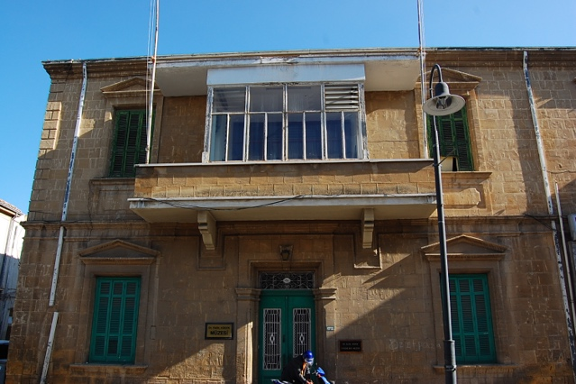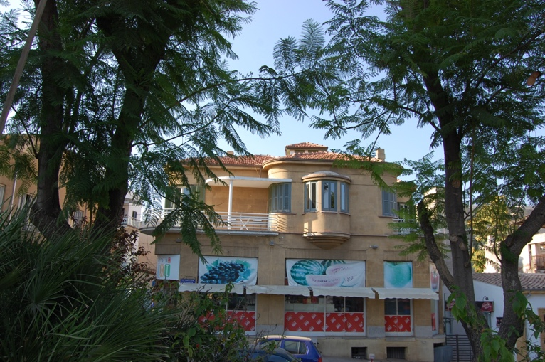
- (b)
Fig. 5.3 (a) Elevation of the sunken room of a modern villa, which illustrates the use of mashrabiya, a design that incorporates a complete climatic system, including malqaf (b) Malqaf element for passive-cooling in a vernacular house in Cyprus.
Figure 5.3 (a) shows that the mashrabiya is an opening with a wooden lattice screen, which performs different functions in order to provide privacy, ventilation, solar control and glare reduction and to cool the air by evaporation, consequently, decreases the relative humidity of the indoor spaces. Figure 5.3 (b) depicts a cantilevered space with a lattice opening in which small water jars are placed, so the area is cooled by evaporation as air moves through the opening. Several exemplar studies were carried out by Cain et al. [14] in the mid-1970s in the hot, arid region of Oman; the findings revealed the role of this traditional window-cooling method, which incorporates an evaporative cooling system through the use of porous water jars.

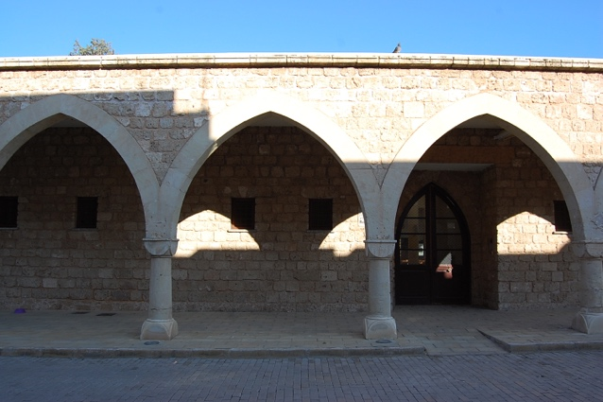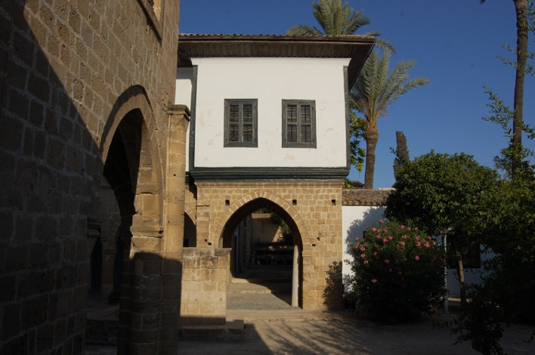
- (b)
Fig. 5.4 (a) The arcaded colonnades are a transitional space that generates ventilation between the indoor spaces and the courtyard; (b) malqaf element for passive cooling in a vernacular house in Cyprus.
Figures 5.4 (a) and (b) illustrate the three parts of the window detail: a lower part where a lattice screen allows an uncontrolled air flow, a middle part where a cantilevered lattice structure holds a porous ceramic water jar and internal wooden shutters are used to control air movement and an upper part where horizontal louvres allows hot air to escape. In principle, the window provides cooling air movement and solar control in one system, in much the same way that a modern air-conditioning unit would. In order to provide sufficient ventilation through indoor spaces and optimise the thermal comfort of occupants, especially in hot and humid regions, the above-mentioned traditional passive evaporative strategies would be applicable to test low-tech passive design systems in a residential building retrofitting scheme.

5.3 Wind Tower System
In hot–arid and hot–humid regions, wind towers are the most commonly known passive design systems that provide natural circulation and cool the ambient air throughout the indoor spaces. The most well-known exemplar passive-cooling systems are Iranian wind towers, which have openings at the top that face in all directions, or in some cases, only in the direction whence the wind is predominant [15]. Traces of this vernacular building system can also be seen in residential building designs in Cyprus, as shown in Figures 5.5 (a) and (b). Many scholarly articles have described the different types of wind towers; these can vary according to tower height, openings and different cross-sections for air-flow passages. Furthermore, the designs also vary according to the desired airflow rate, heat-transfer area, sensible heat-storage capacity and evaporative cooling surfaces.

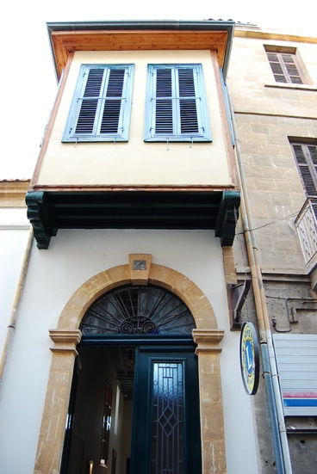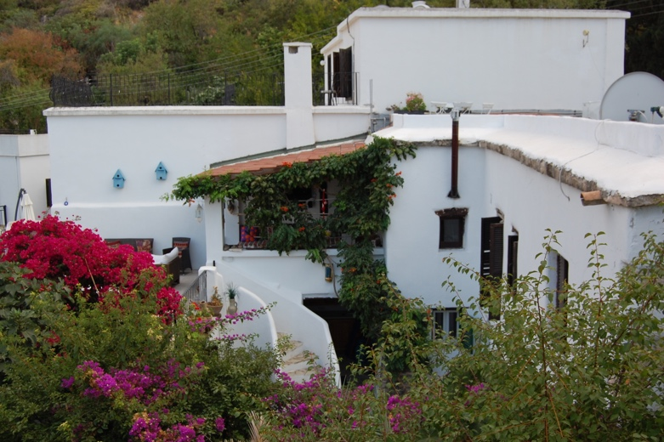
(a) (b)
Fig. 5.5 (a) Overhang balcony space projection that shows ventilation generated by wind escape; (b) wind-catcher system in a vernacular house in Cyprus.
Figure 5.5 (b) illustrates a cross-section of a wind tower system detail in the Dowlat Abad Garden in Yazd. This case-study building was extensively documented by Bahadori in 1979. In this wind tower, a small pool with a foundation is situated directly under the tower shaft; the high velocity wind speed allows air coming down the tower to initially be cooled, then evaporatively cooled by the pool and the fountain systems before collecting in indoor spaces [16]. At the same time, Figure 5.5 (b) shows another effective passive design strategy, which has access to an underground water stream: In principle, the underground water is usually cold, and this scheme can produce a cooling rate more effectively than other exemplar wind towers; the cooled natural ventilation is accessed by the underground stream through the shaft, and the wind tower was effectively built with respect to this shaft, as illustrated in Figure 5.5 (b).
As was stated above, natural ventilation and passive cooling measures are based on efficient traditional exemplar building systems. However, the applicability of the concrete-built residential buildings challenge determinant factors to translate interpretation between past and current efficiency systems in residential building retrofitting efforts. For this reason, the present study highlights the role of designing the provision of effective natural ventilation under the local wind direction as a major factor that is dependent on the orientation of modern high-rise residential buildings. Experimental base-case ventilation strategies were also tested by Giovanni et al. in 1991; their findings demonstrated that oblique winds at angles between 30° and 120° to the wall can provide effective cross-ventilation if there are openings in the windward and leeward walls. Determining a building’s relationship to the prevailing wind direction should be a major consideration in order to properly decide upon the location of the main rooms, the living room and sleeping rooms during the early design stage of residential buildings. As such, the above-mentioned findings could also be applicable to minimise or avoid the overheating risks of occupied spaces while measuring the existing energy performance of a residential building.

References
[1] Givoni B. (1994). In Passive and Low Energy Cooling of Buildings, p. 33, Van Nostrand Reinhold.
[2] Mirahmadi, F., & Altan, H. (2018). A solution for future designs using techniques from vernacular architecture in southern Iran. Sustainable Buildings, 3, 1. https://doi.org/10.1051/sbuild/2017007
[3] Case, C. (2017). Performance of Passive Design Architecture Application in Hot and Dry Performance of Passive Design Architecture Application in Hot and Dry Climate. Case study: Cairo, Egypt, (July).
[4] Sahebzadeh, S., Heidari, A., Kamelnia, H., & Baghbani, A. (2017). Sustainability features of Iran’s vernacular architecture: A comparative study between the architecture of hot-arid and hot-arid-windy regions. Sustainability (Switzerland), 9(5). https://doi.org/10.3390/su9050749
[5] Al Tawayha, F., Braganca, L., & Mateus, R. (2019). Contribution of the vernacular architecture to the sustainability: A comparative study between the contemporary areas and the old quarter of a Mediterranean city. Sustainability (Switzerland), 11(3). https://doi.org/10.3390/su11030896
[6] Bencheikh, D., & Bederina, M. (2019). Assessing the duality of thermal performance and energy efficiency of residential buildings in hot arid climate of Laghouat, Algeria. International Journal of Energy and Environmental Engineering. https://doi.org/10.1007/s40095-019-00318-z
[7] Schiano-Phan, R. (2004). The development of passive downdraught evaporative cooling systems using porous ceramic evaporators and their application in residential buildings. PhD thesis, British Library, London.
[8] Schianao-Phan, R. (2012). Post-occupancy evaluation of non-domestic buildings using passive downdraught evaporative cooling in south-west USA. Architectural Science Review, 55(4), 1-21.
[9] Schiano-Phan, R. (2009). The use of porous ceramic for passive evaporative cooling in buildings. Available from: http://www.phdc.eu/uploads/media/PHDC_Cooling_with_porous_ceramic_01-06-09.pdf.
[10] Ibraheem, O. and Ford, B. (2012). The feasibility of passive down-draught evaporative cooling for high-rise office buildings in Cairo. Architectural Science Review, 55(4), 315-327.
[11] Schiano-Phan, R. (2010). Environmental retrofit: building integrated passive cooling in housing, Architectural Research Quarterly, Volume 14, Issue 02, pp 139-151. http://journals.cambridge.org/abstract_S1359135510000758
[12] Golzari, N. (2014). Re-reading affordable technologies: the role of techno cultural elements and invisible technologies in sustainable design for the middle east. PhD thesis, University of Westminster.
[13] Al-Azri, N., Zurigatb, YH. & Al-Rawahia, N., 2013. Selection and assessment of passive cooling techniques for residential buildings in Oman using a bioclimatic approach. The Journal of Engineering Research, 10(2), 53-65.
[14] Gupta, N. (2017). Exploring passive cooling potentials in Indian vernacular architecture. Journal of Buildings and Sustainability, 2(1), 1–11.
[15] Jomehzadeh, F., Nejat, P., Calautit, J. K., Yusof, M. B. M., Zaki, S. A., Hughes, B. R., & Yazid, M. N. A. W. M. (2017). A review on windcatcher for passive cooling and natural ventilation in buildings, Part 1: Indoor air quality and thermal comfort assessment. Renewable and Sustainable Energy Reviews. Elsevier Ltd. https://doi.org/10.1016/j.rser.2016.11.254
[16] Fernandes, J., Mateus, R., Gervásio, H., Silva, S. M., & Bragança, L. (2019). Passive strategies used in Southern Portugal vernacular rammed earth buildings and their influence in thermal performance. Renewable Energy, 142, 345–363. https://doi.org/10.1016/j.renene.2019.04.098

Image Credits
Figures 5.2 (a) & (b): The permission is granted from Dr. Rosa Schiano-Phan, Reader in Architecture and Environmental Design (AED), School of Architecture and Cities at the University of Westminster.

